**VISVESVARAYA TECHNOLOGICAL UNIVERSITY**

**“JnanaSangama”, Belgaum -590014, Karnataka.**



**DATA STRUCTURE LAB RECORD**

***Submitted by***

**PRANAV KUMAR**

**(1BM19CS114)**

***Under the Guidance of***

|  |  |
| --- | --- |
| **Prof. SHEETAL VA**  **Assistant Professor, BMSCE** |  |

***in partial fulfillment for the award of the degree of***

**BACHELOR OF ENGINEERING**

***in***

**COMPUTER SCIENCE AND ENGINEERING**



**B.M.S. COLLEGE OF ENGINEERING**

**(Autonomous Institution under VTU)**

**BENGALURU-560019**

**Sep-2020 to Jan-2021**

**B. M. S. College of Engineering,**

**Bull Temple Road, Bangalore 560019**

(Affiliated To Visvesvaraya Technological University, Belgaum)

**Department of Computer Science and Engineering**



**CERTIFICATE**

This is to certify that the LAB RECORD carried out by  **Pranav Kumar (1BM19CS114)** who is the bonafide students of **B. M. S. College of Engineering.** It is in partial fulfillment for the award of **Bachelor of Engineering in Computer Science and Engineering** of the Visveswaraiah Technological University, Belgaum during the year 2020-2021. The lab report has been approved as it satisfies the academic requirements in respect of **DATA STRUCTURE LAB RECORD (19CS3PCDST)** work prescribed for the said degree.

Signature of the Guide                 Signature of the HOD

Prof. Prof. Sheelal VA Dr. Umadevi V

Assistant Professor Associate Prof.& Head, Dept. of CSE

BMSCE, Bengaluru BMSCE, Bengaluru

External Viva

Name of the Examiner                                                                                       Signature with date

1._____________________________ ________________________

2. _____________________________ _________________________

Lab Program-1

Write a program to simulate the working of stack using an array with the following :

a) Push b) Pop c) Display

The program should print appropriate messages for stack overflow, stack underflow

**#include<stdio.h>**

**#include<stdlib.h>**

**#define SIZE 5**

**int top=-1,s[SIZE];**

**void push(){**

**if(top>=5){**

**printf("\nStack overflow");**

**return;**

**}**

**int item;**

**printf("\nEnter the item to be inserted");**

**scanf("%d",&item);**

**s[++top]=item;**

**}**

**void display(){**

**int i=0;**

**printf("\nElements in the stack is");**

**for(i;i<=top;i++){**

**printf("\n%d",s[i]);**

**}**

**}**

**void pop(){**

**if (top<=-1){**

**printf("Stack Underflow \n");**

**return;**

**}**

**printf("\nPopped elements is: ",s[top--]);**

**}**

**int main(){**

**int a=0;**

**while (a!=4){**

**printf("\nChoose a option \n1)Insert \n2)Pop \n3)Display \n4)Exit\n");**

**scanf("\n%d",&a);**

**switch(a){**

**case 1: push();**

**break;**

**case 2: pop();**

**break;**

**case 3: display();**

**break;**

**case 4:printf("\nExited...");**

**exit(0);**

**break;**

**default:**

**printf("\nWrong input \nPlease Enter again");**

**}**

**}**

**return 0;**

**}**

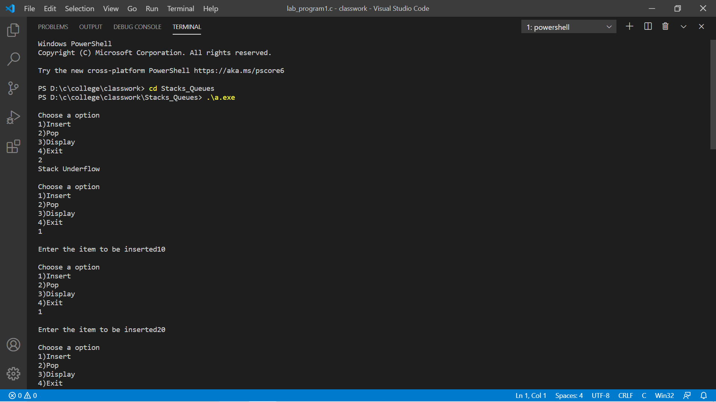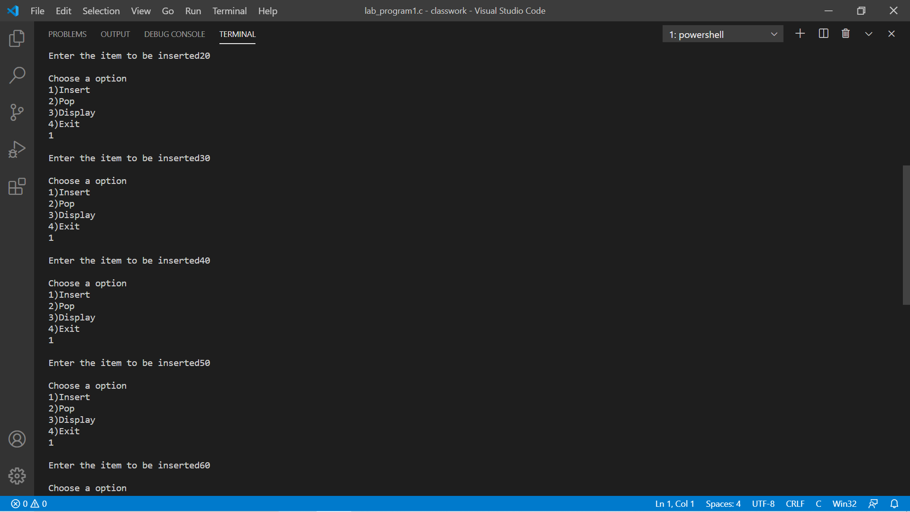

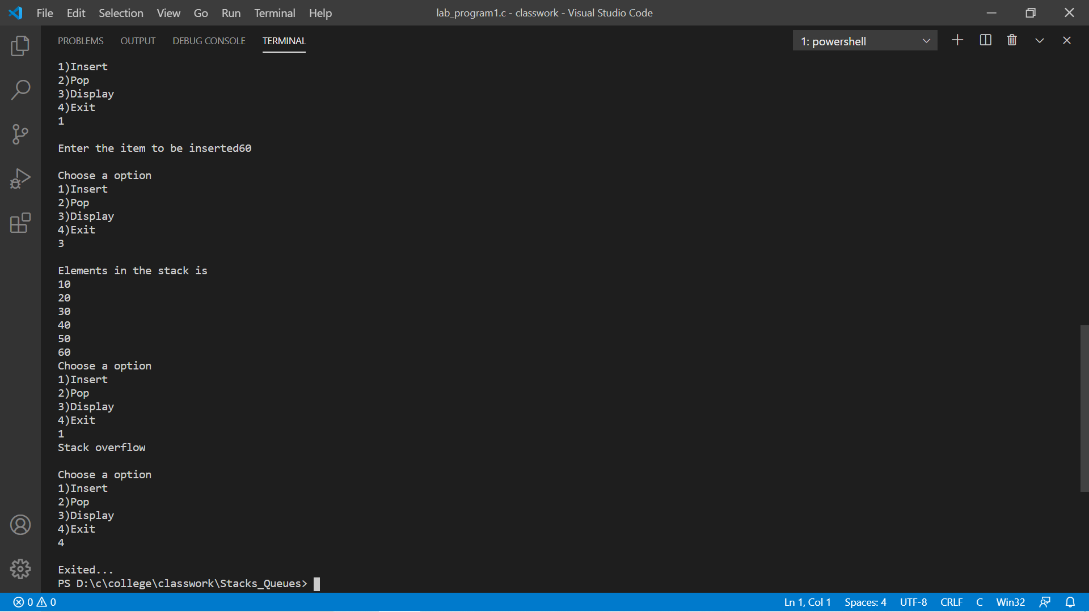

Program-2

WAP to convert a given valid parenthesized infix arithmetic expression to postfix

expression. The expression consists of single character operands and the binary operators

+ (plus), - (minus), * (multiply) and / (divide).

#include <stdio.h>

#include <string.h>

#include <stdlib.h>

int F(char symbol)

{

switch (symbol)

{

case '+':

case '-':

return 2;

case '*':

case '/':

return 4;

case '^':

case '$':

return 5;

case '(':

return 0;

case '#':

return -1;

default:

return 8;

}

}

int G(char symbol)

{

switch (symbol)

{

case '+':

case '-':

return 1;

case '*':

case '/':

return 3;

case '^':

case '$':

return 6;

case '(':

return 9;

case ')':

return 0;

default:

return 7;

}

}

void infix_postfix(char infix[], char postfix[])

{

int top, i, j;

char s[30], symbol;

top = -1;

s[++top] = '#';

j = 0;

for (i = 0; i < strlen(infix); i++)

{

symbol = infix[i];

while (F(s[top]) > G(symbol))

{

postfix[j] = s[top--];

j++;

}

if (F(s[top]) != G(symbol))

s[++top] = symbol;

else

top--;

}

while (s[top] != '#')

{

postfix[j++] = s[top--];

}

postfix[j] = '\0';

}

void main()

{

int op, i = 0;

char infix[20];

char postfix[20];

printf("\nEnter the number of the operations to be performed");

scanf("%d", &op);

for (i; i < op; i++)

{

printf("Enter the valid infix expression ");

scanf("%s", infix);

infix_postfix(infix, postfix);

printf("The postfix expression is \n");

printf("%s\n", postfix);

}

}

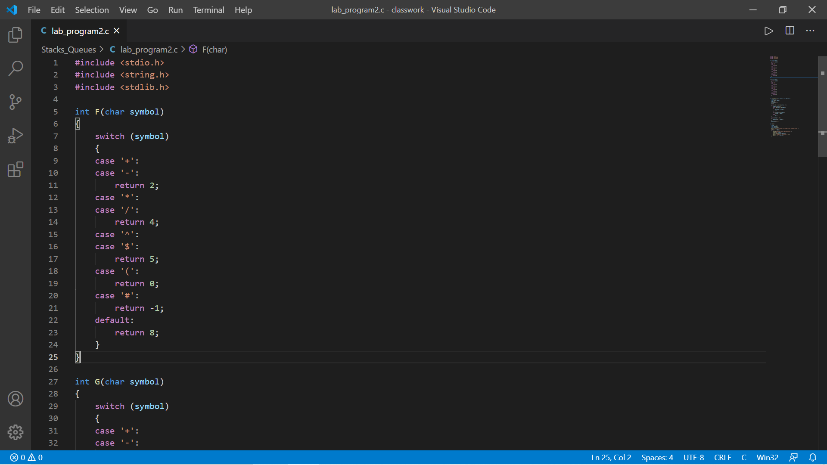

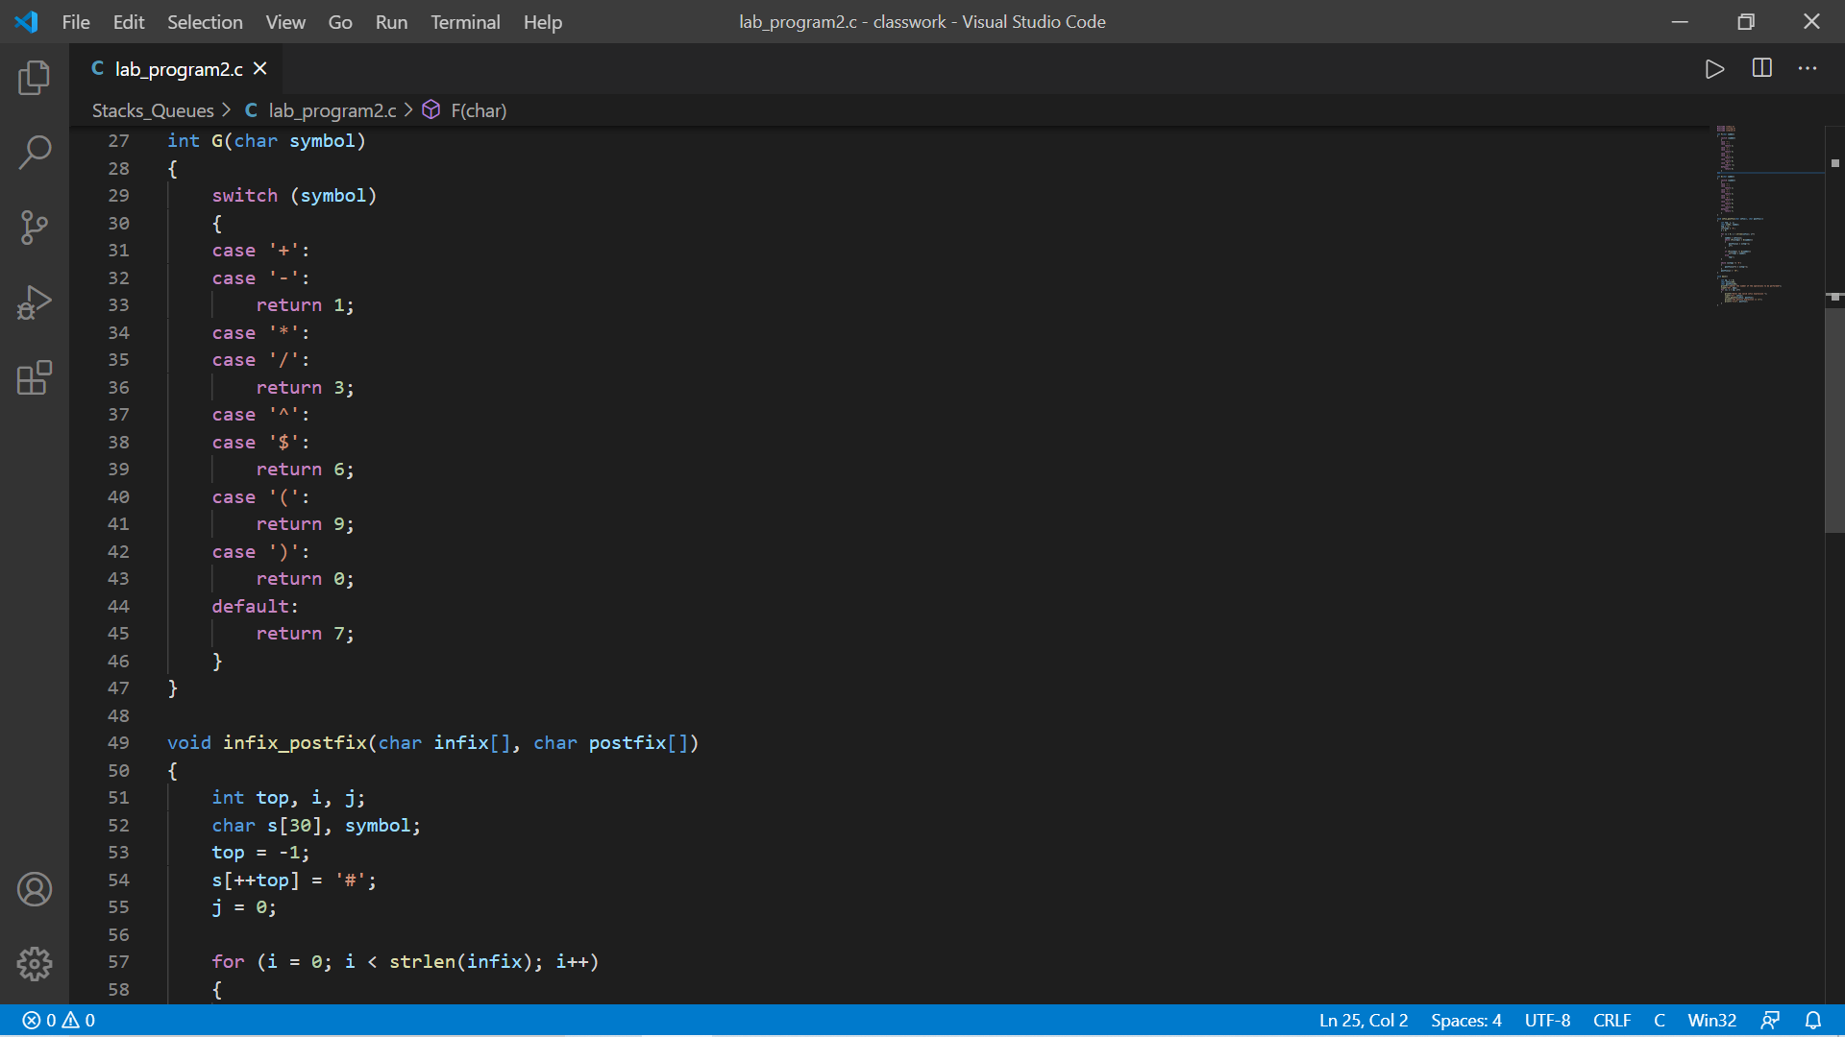

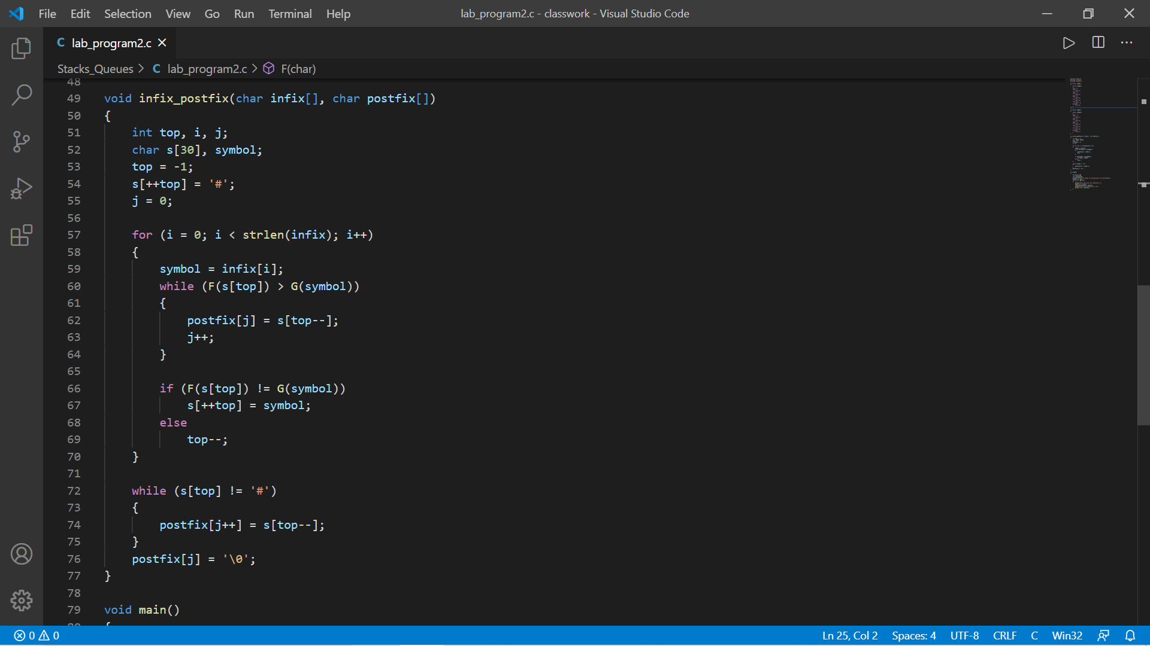

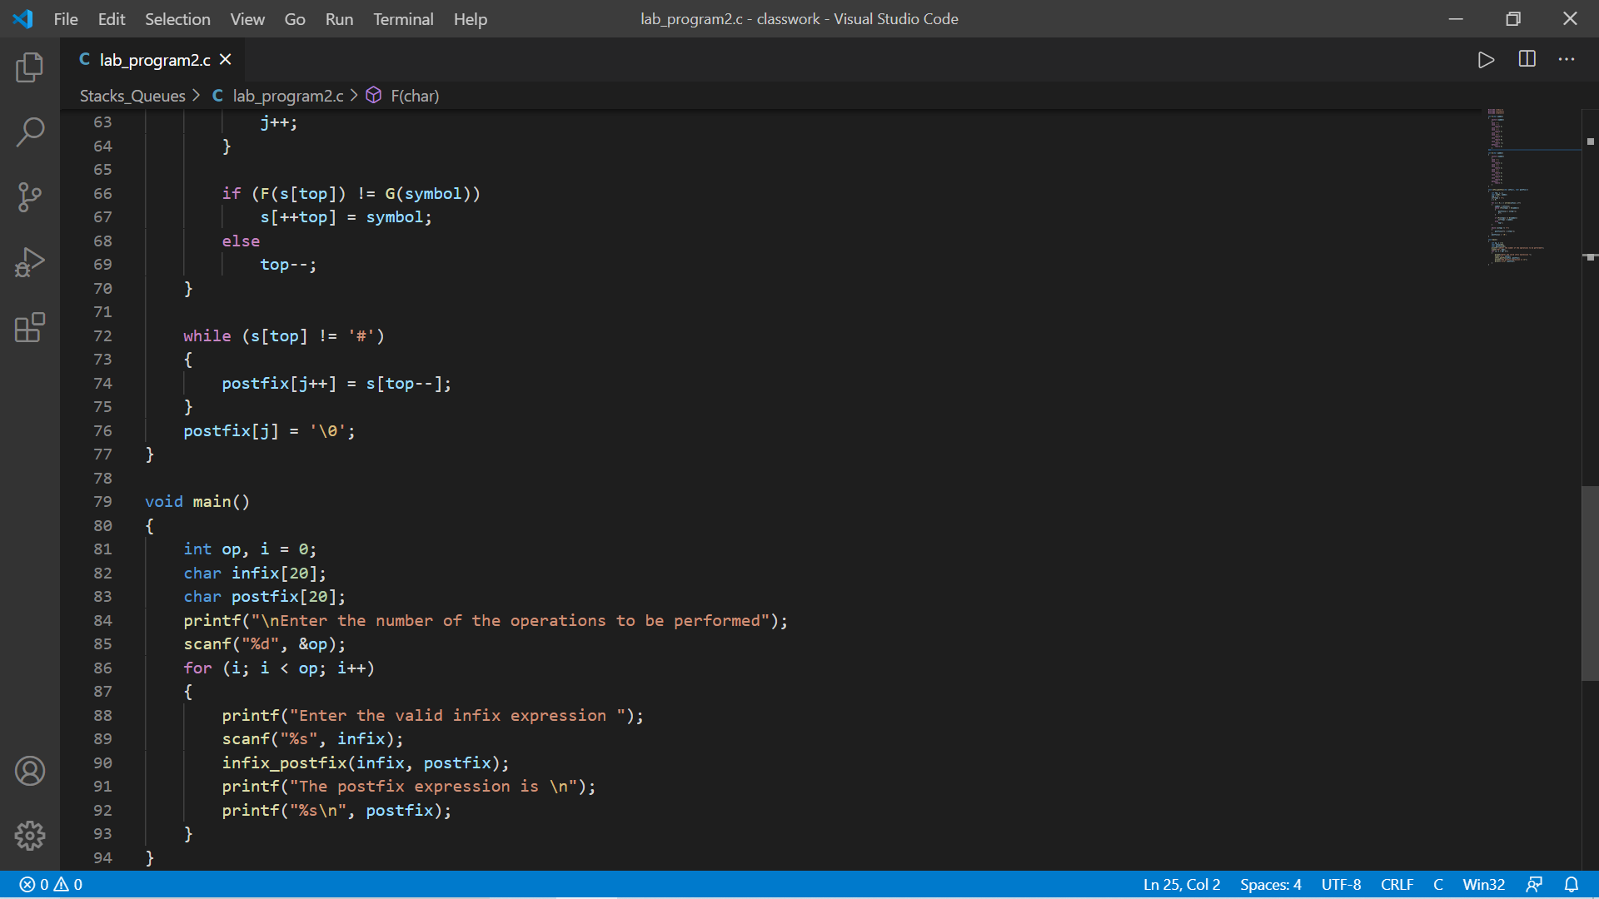

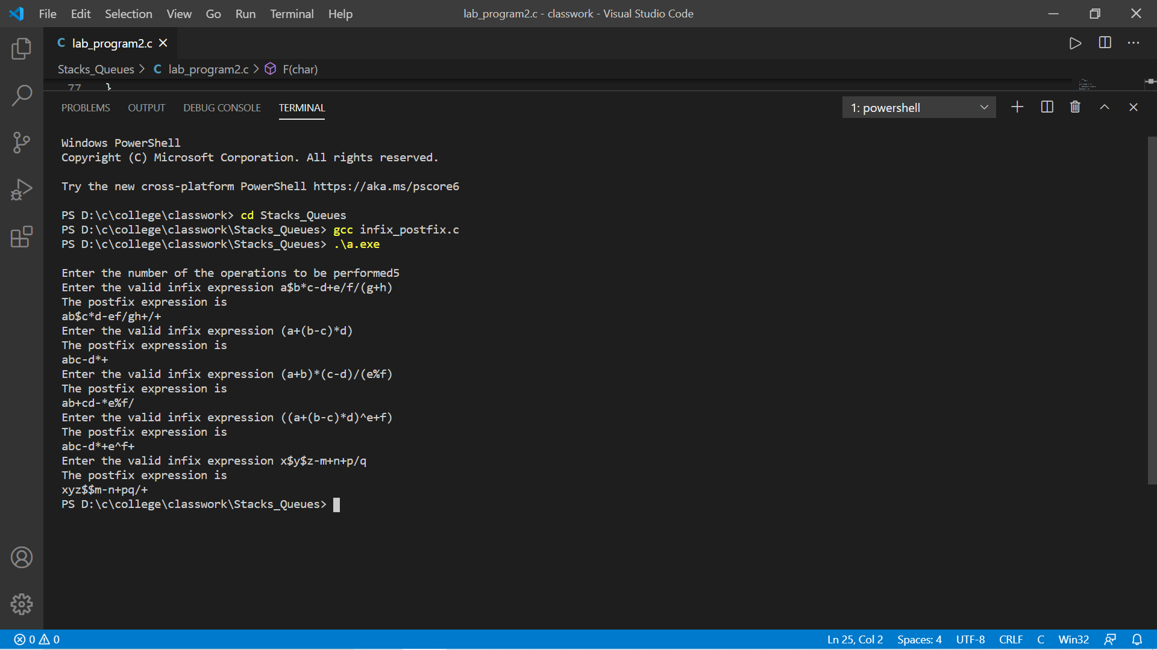

Program-3

#include <stdio.h>

#define SIZE 5

int q[SIZE - 1], f = 0, r = -1;

void insert();

void pop();

void display();

int main()

{

int a = 0;

while (a != 4)

{

printf("\nChoose a option \n1)Insert \n2)Pop \n3)Display \n4)Exit\n");

scanf("\n%d", &a);

switch (a)

{

case 1:

insert();

break;

case 2:

pop();

break;

case 3:

display();

break;

case 4:

printf("\nExited...");

break;

default:

printf("\nWrong input \nPlease Enter again");

}

}

return 0;

}

void insert()

{

int item;

if (r == SIZE - 1){

printf("\nQueue Overflow");

return;

}

printf("\nEnter item to be inserted:");

scanf("\n%d", &item);

q[++r] = item;

}

void pop()

{

if (r == -1){

printf("\nQueue Underflow");

return ;

}

printf("\nPopped item is: %d", q[f++]);

}

void display()

{

int i = 0;

printf("\nElements in the queue is");

for (i = f; i <= r; i++)

{

printf("\n%d", q[i]);

}

}

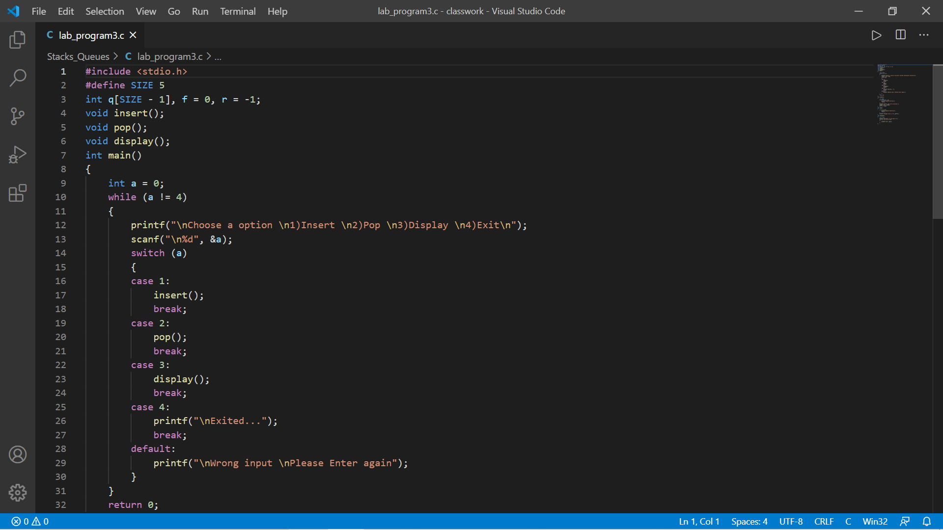

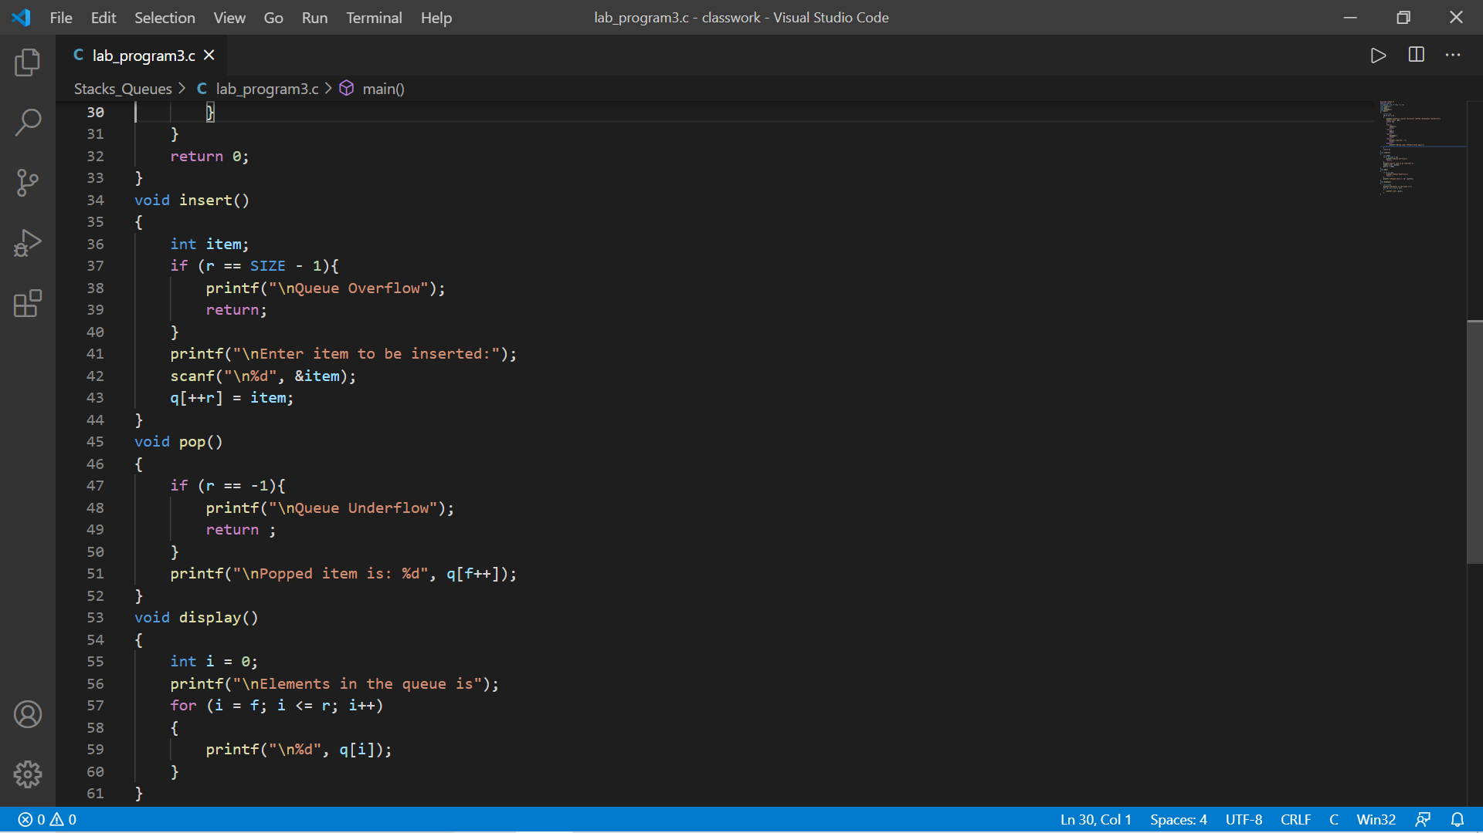

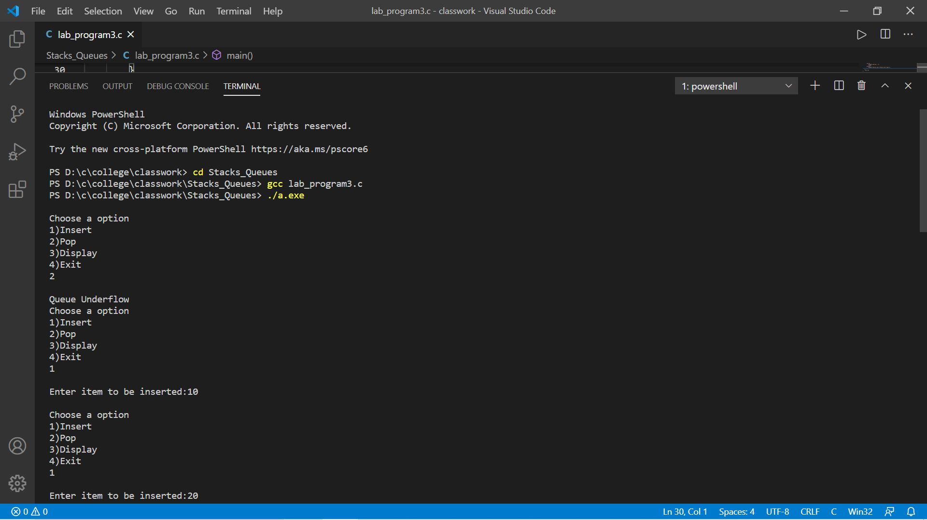

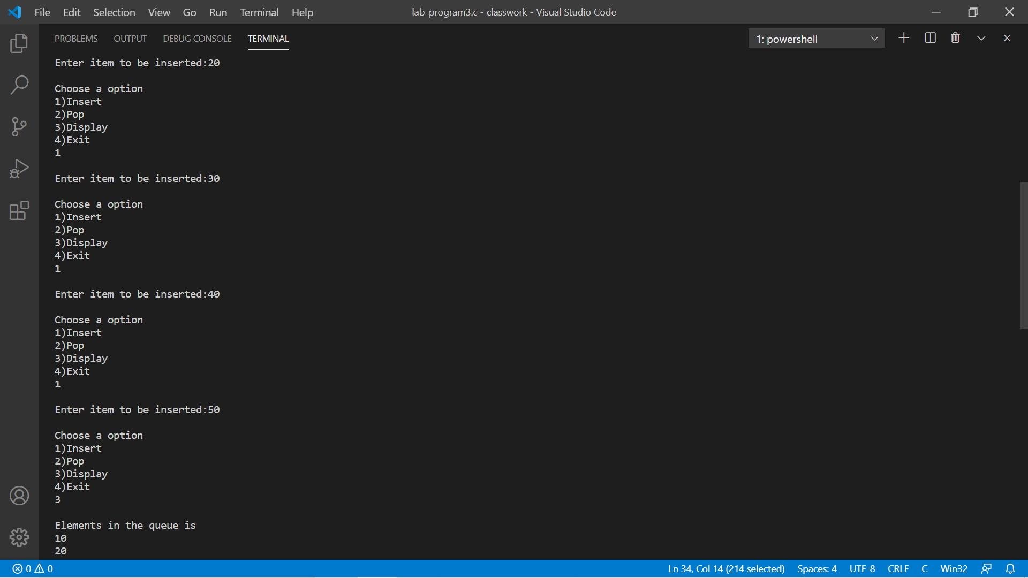

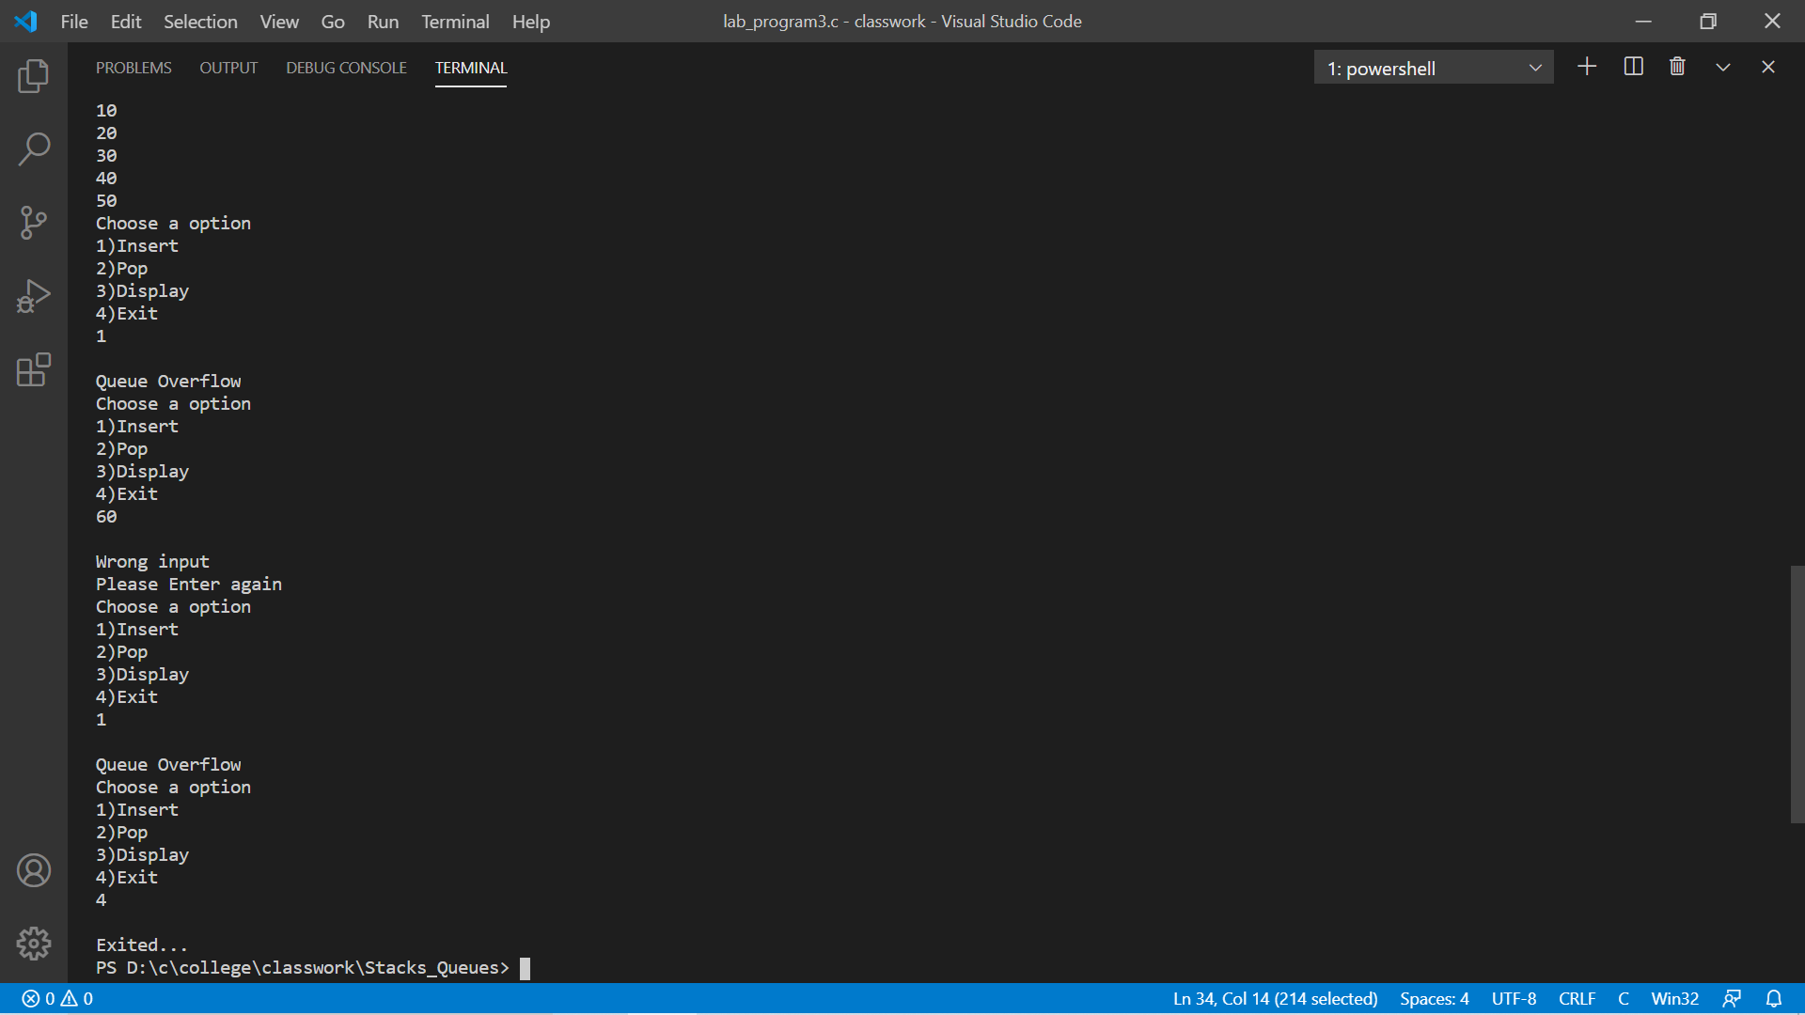

**Program-4**

**#include<stdio.h>**

**#include<stdlib.h>**

**#include<process.h>**

**#define que_size 3**

**int item,front=0,rear=-1,q[que_size],count=0;**

**void insertrear()**

**{**

**if(count==que_size)**

**{**

**printf("queue overflow");**

**return;**

**}**

**rear=(rear+1)%que_size;**

**q[rear]=item;**

**count++;**

**}**

**int deletefront()**

**{**

**if(count==0) return -1;**

**item = q[front];**

**front=(front+1)%que_size;**

**count=count-1;**

**return item;**

**}**

**void displayq()**

**{**

**int i,f;**

**if(count==0)**

**{**

**printf("queue is empty");**

**return;**

**}**

**f=front;**

**int c=count;**

**printf("\ncontents of queue \n");**

**while(c!=0){**

**printf("\nElement is: %d",q[f]);**

**f=((f+1)%que_size);**

**c--;**

**}**

**}**

**void main()**

**{**

**int choice;**

**for(;;)**

**{**

**printf("\n1.Insert rear \n2.Delete front \n3.Display \n4.exit \n ");**

**printf("Enter the choice : ");**

**scanf("%d",&choice);**

**switch(choice)**

**{**

**case 1:printf("Enter the item to be inserted :");**

**scanf("%d",&item);**

**insertrear();**

**break;**

**case 2:item=deletefront();**

**if(item==-1)**

**printf("queue is empty\n");**

**else**

**printf("item deleted is %d \n",item);**

**break;**

**case 3:displayq();**

**break;**

**default:exit(0);**

**}**

**}**

**}**

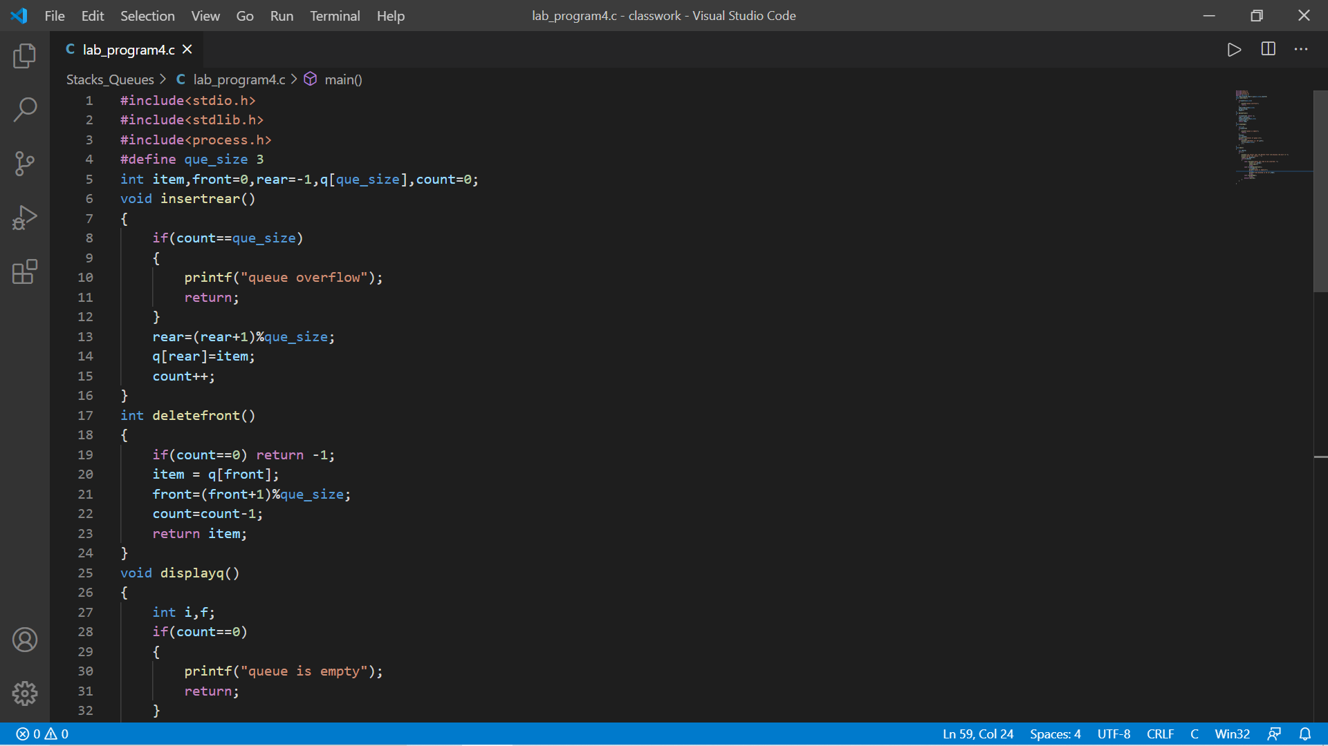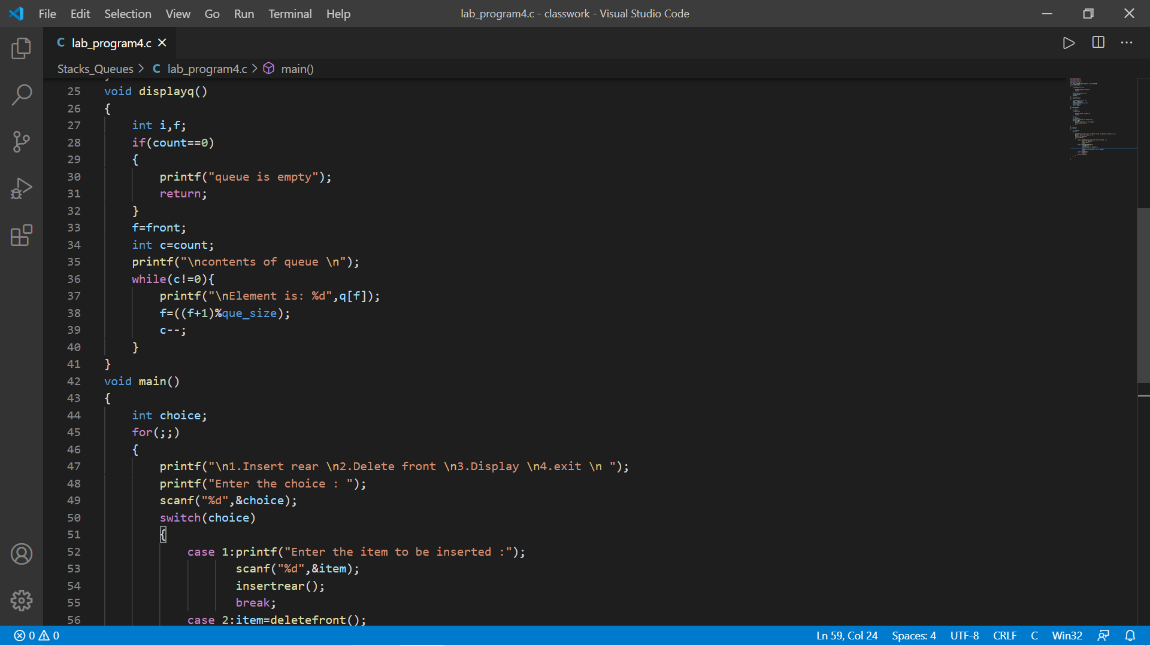

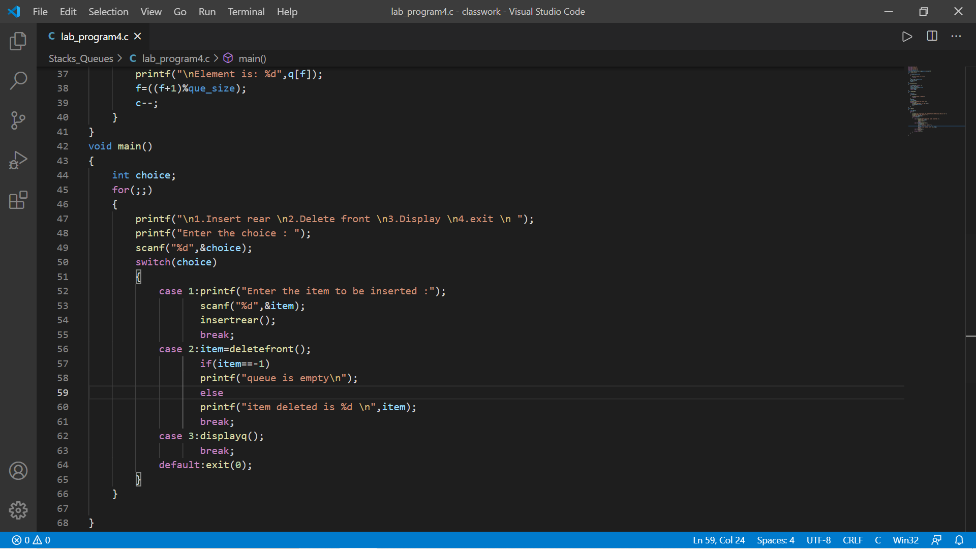

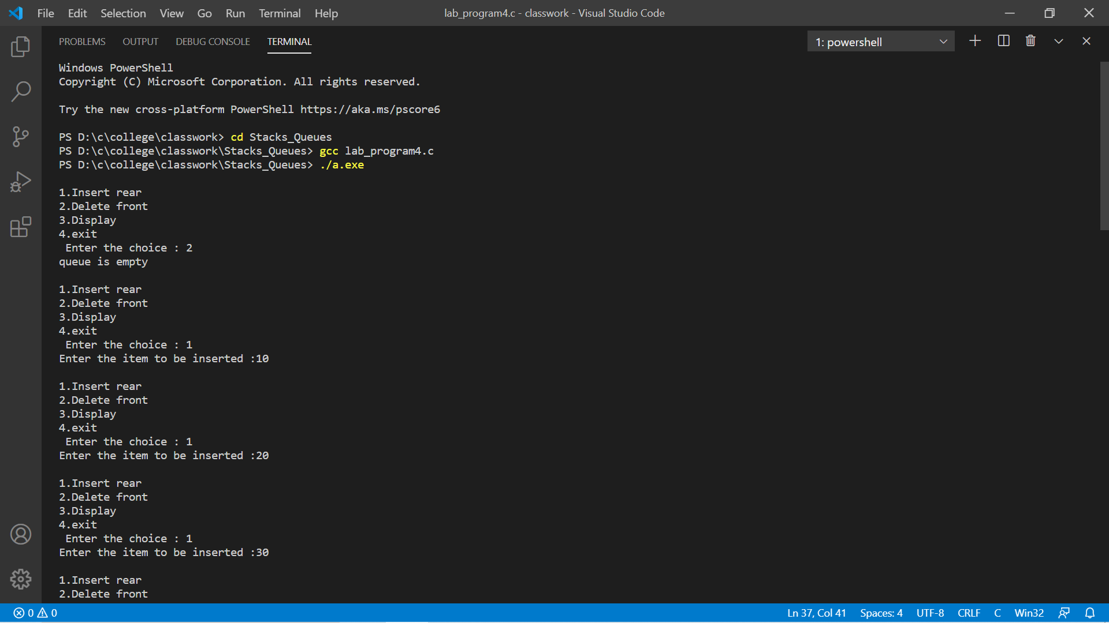

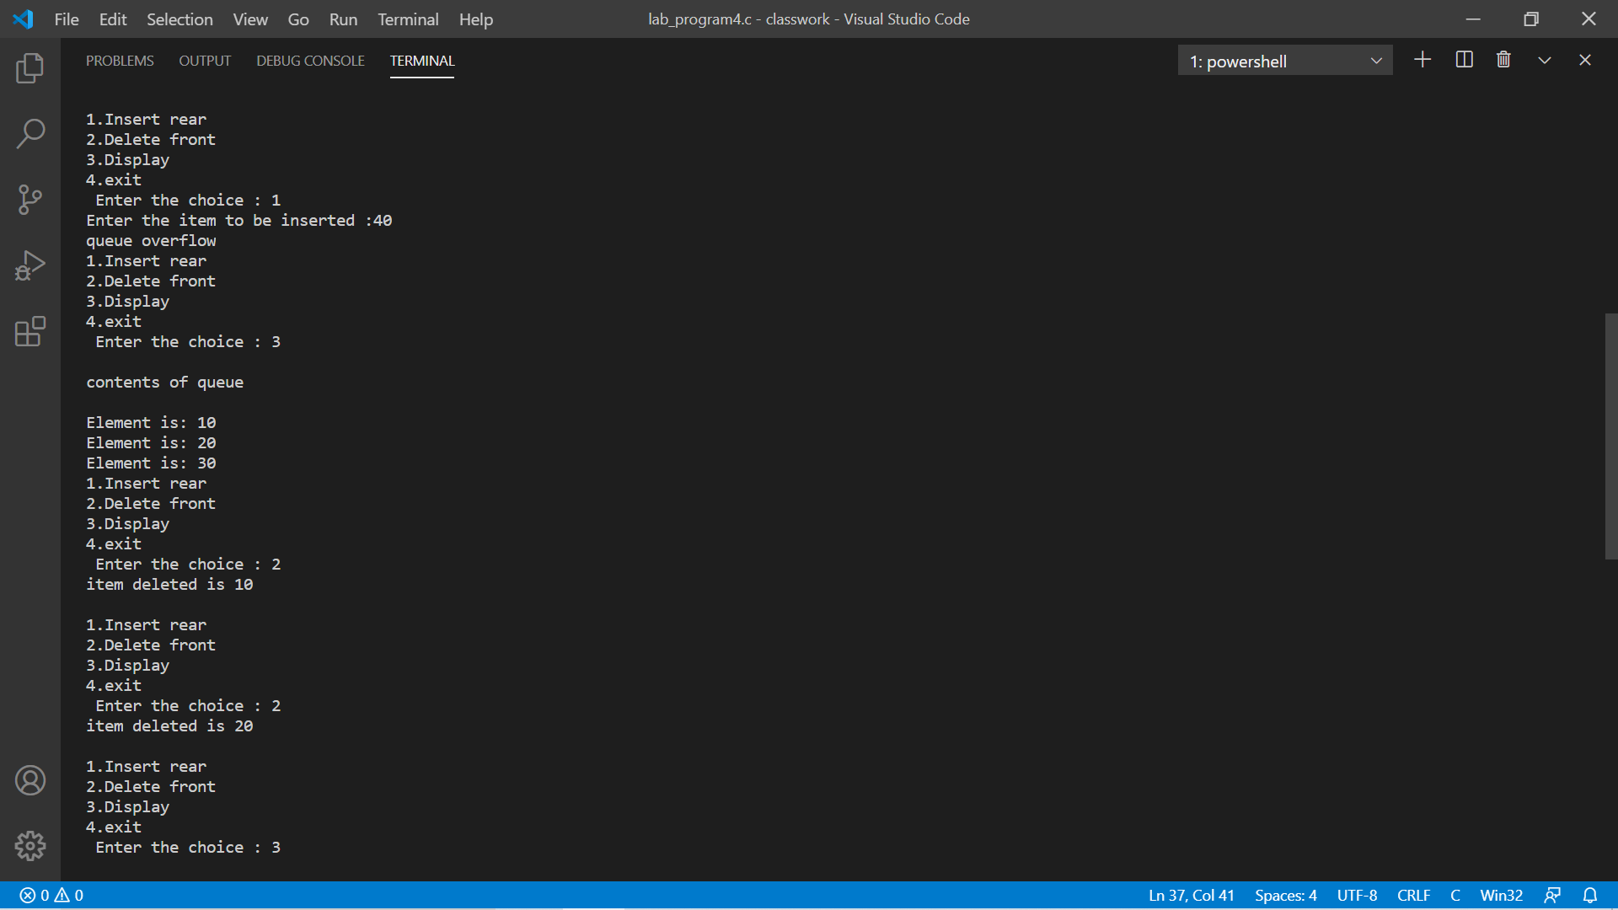

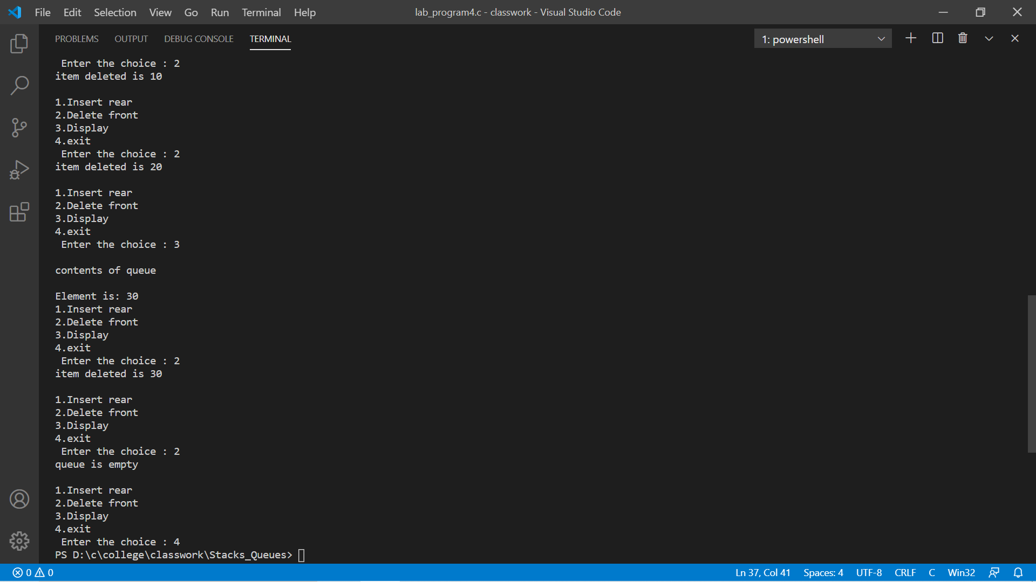

Program-5

#include<stdio.h>

#include<stdlib.h>

#include<process.h>

#define que_size 3

int item,front=0,rear=-1,q[que_size],count=0;

void insertrear()

{

if(count==que_size)

{

printf("queue overflow");

return;

}

rear=(rear+1)%que_size;

q[rear]=item;

count++;

}

int deletefront()

{

if(count==0) return -1;

item = q[front];

front=(front+1)%que_size;

count=count-1;

return item;

}

void displayq()

{

int i,f;

if(count==0)

{

printf("queue is empty");

return;

}

f=front;

int c=count;

printf("\ncontents of queue \n");

while(c!=0){

printf("\nElement is: %d",q[f]);

f=((f+1)%que_size);

c--;

}

}

void main()

{

int choice;

for(;;)

{

printf("\n1.Insert rear \n2.Delete front \n3.Display \n4.exit \n ");

printf("Enter the choice : ");

scanf("%d",&choice);

switch(choice)

{

case 1:printf("Enter the item to be inserted :");

scanf("%d",&item);

insertrear();

break;

case 2:item=deletefront();

if(item==-1)

printf("queue is empty\n");

else

printf("item deleted is %d \n",item);

break;

case 3:displayq();

break;

default:exit(0);

}

}

}

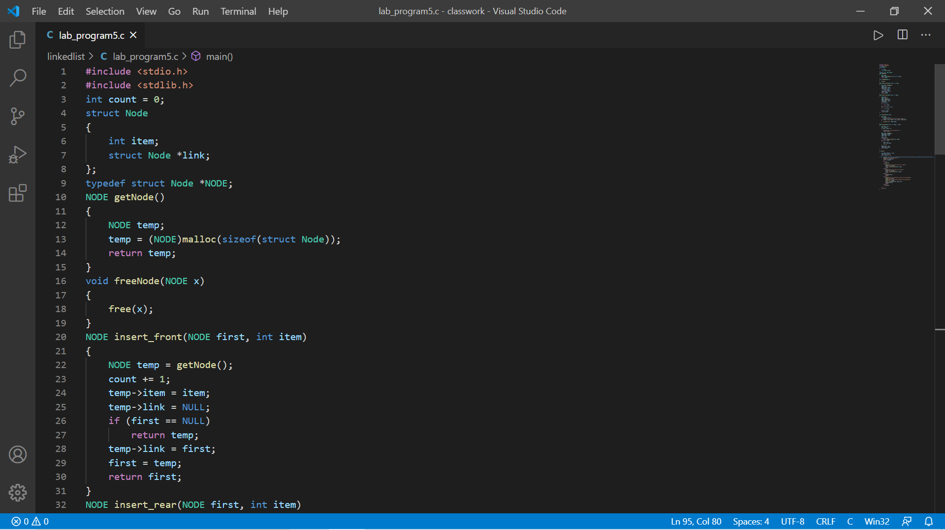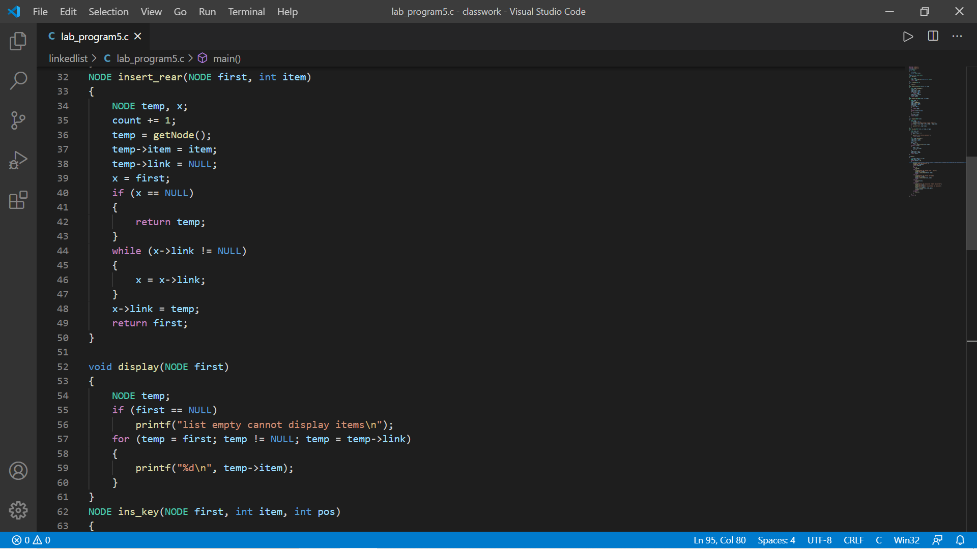

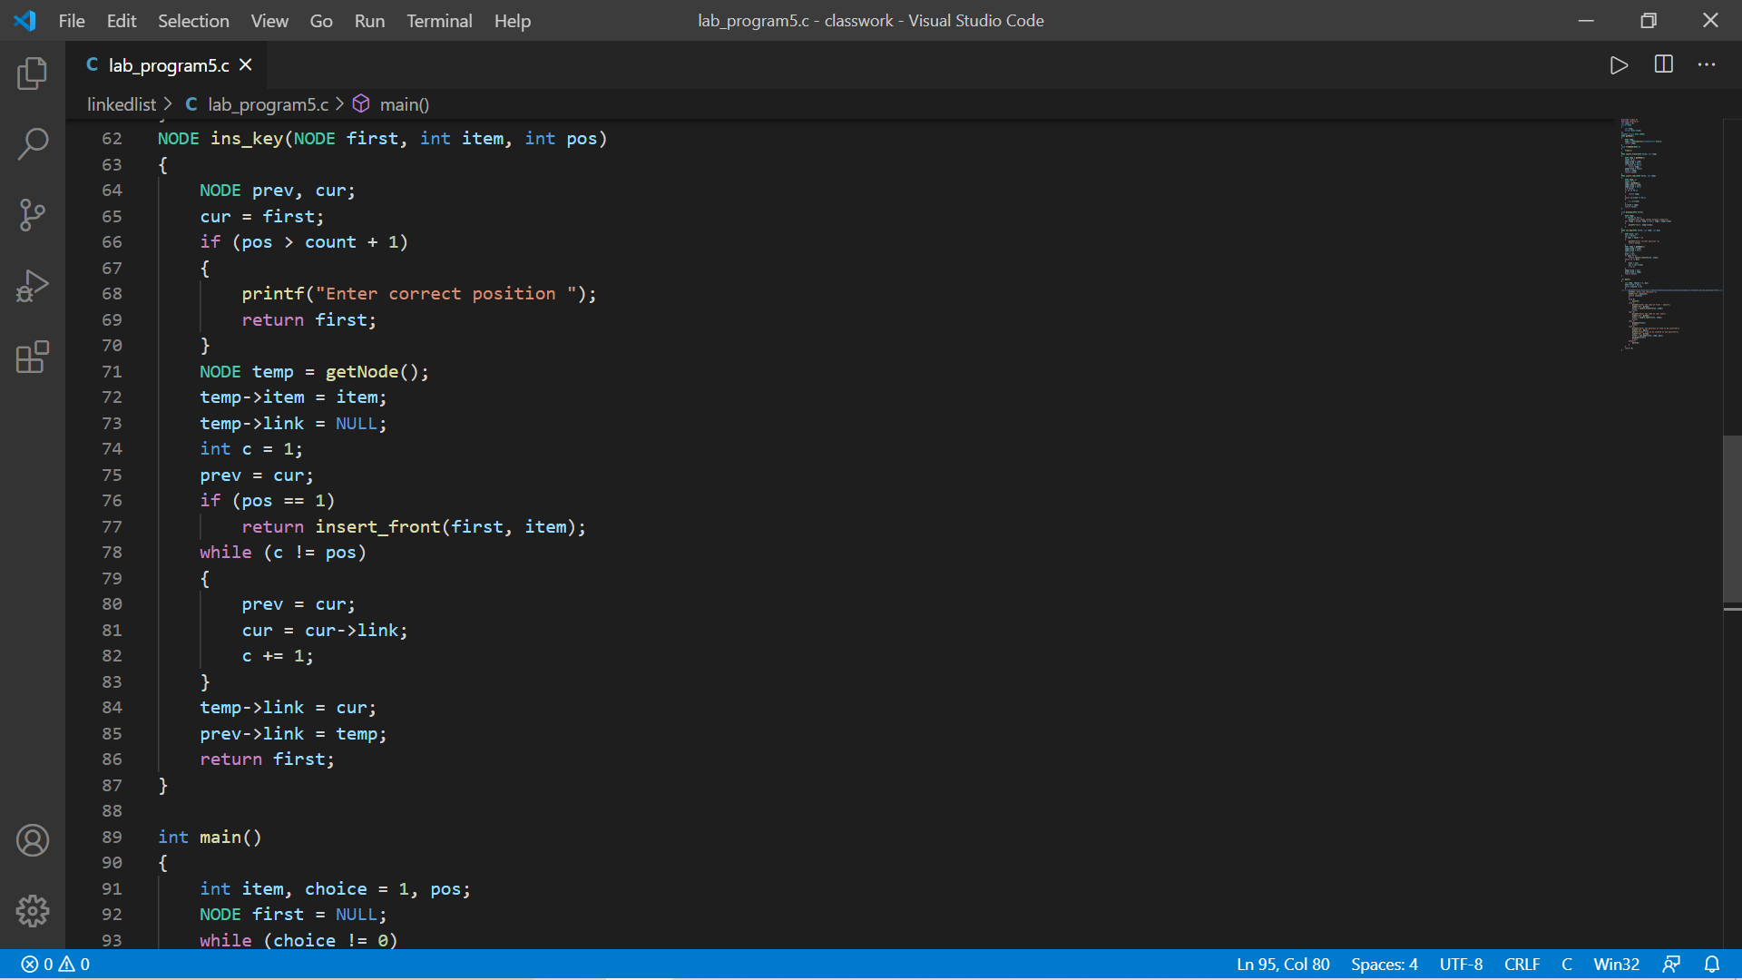

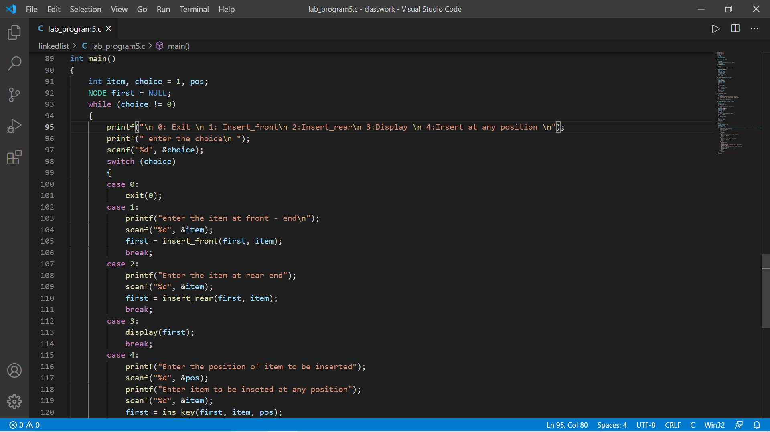

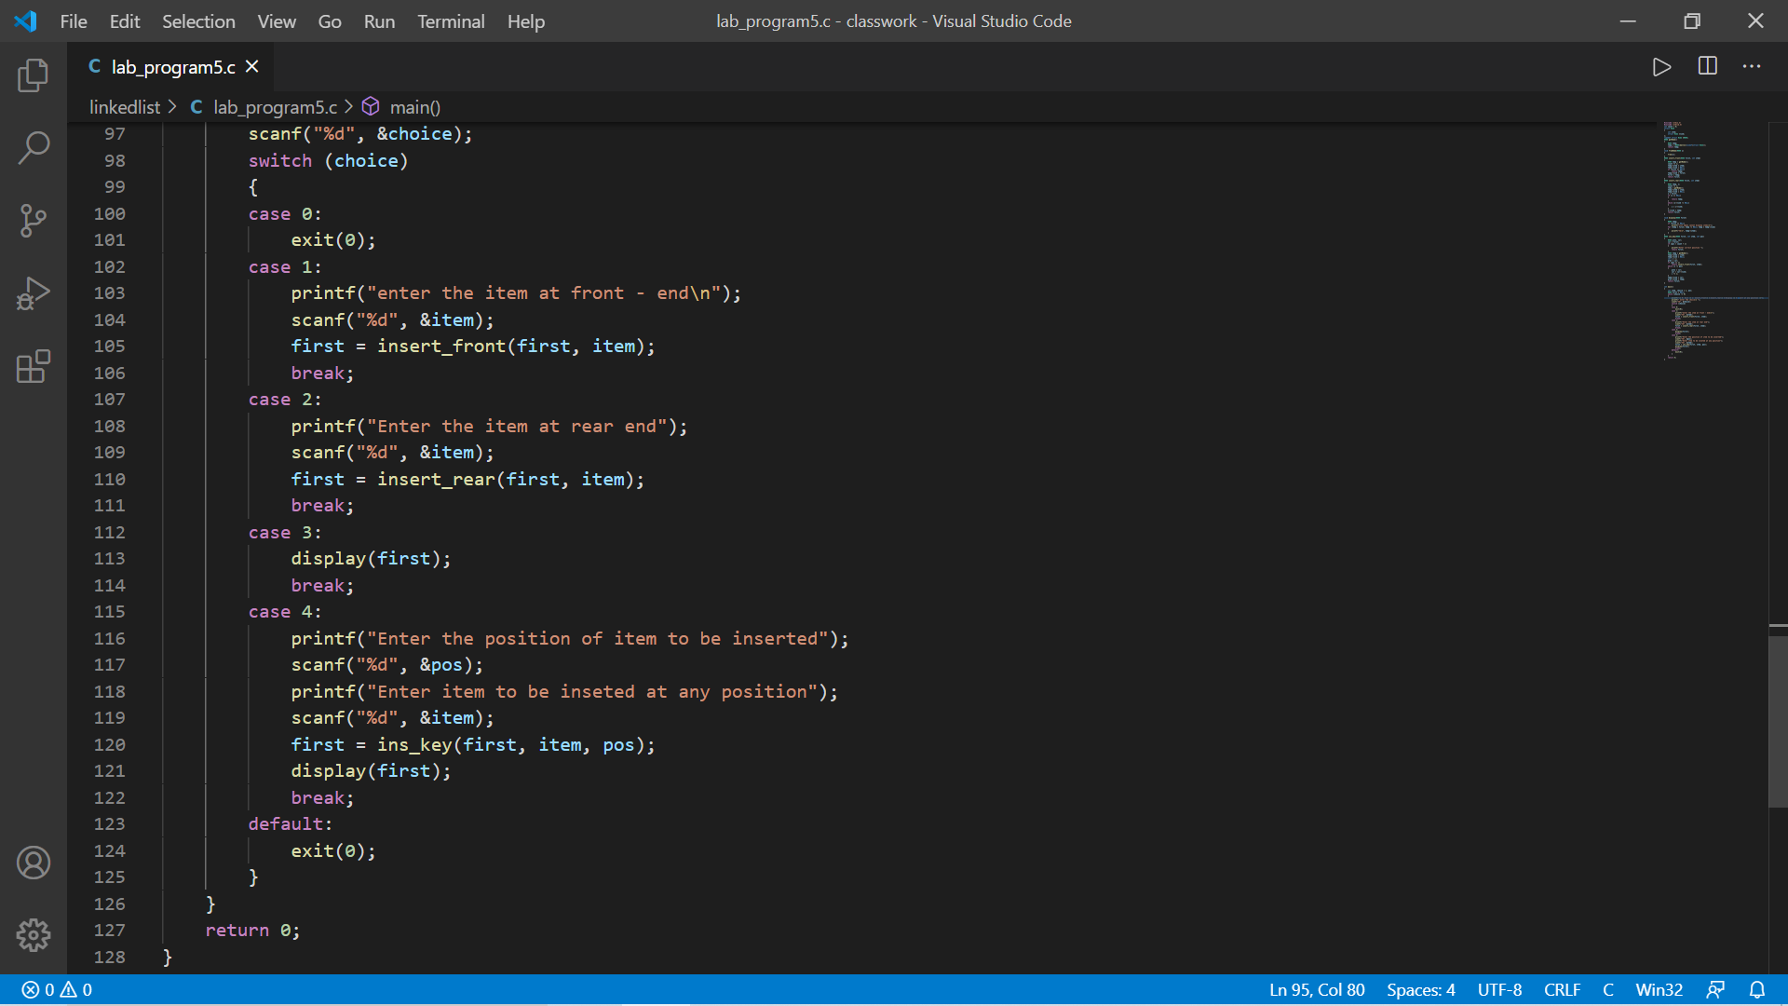

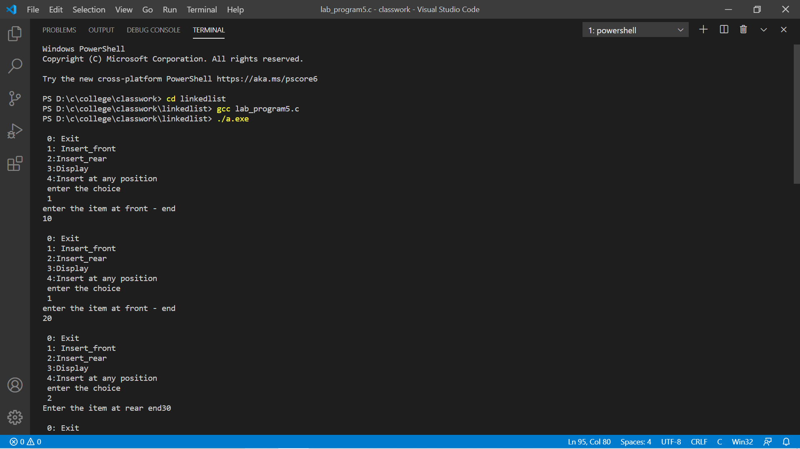

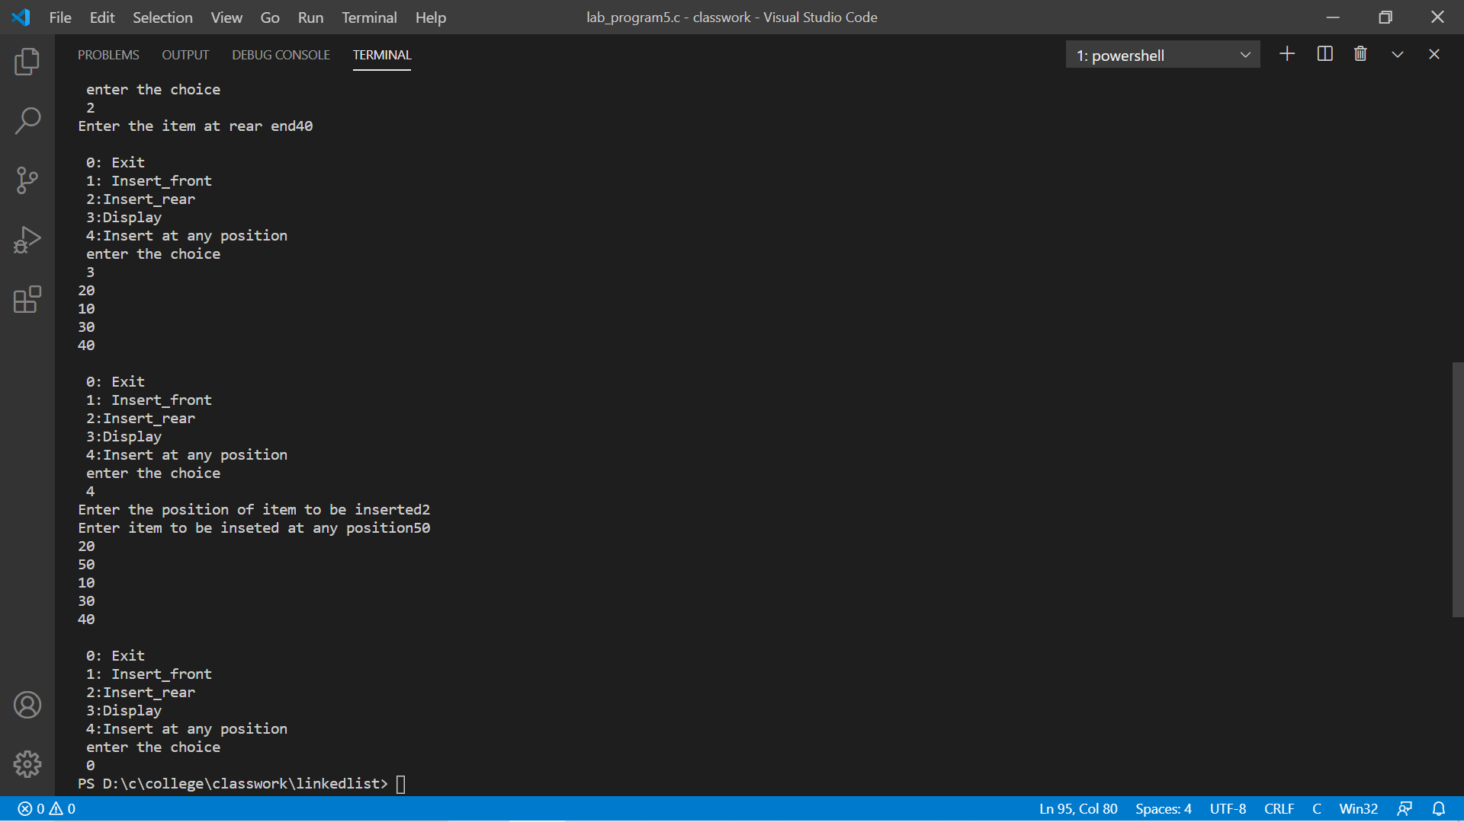

Program-6

#include <stdio.h>

#include <stdlib.h>

int count = 0;

struct Node

{

int item;

struct Node *link;

};

typedef struct Node *NODE;

NODE getNode()

{

NODE temp;

temp = (NODE)malloc(sizeof(struct Node));

return temp;

}

void freeNode(NODE x)

{

free(x);

}

NODE insert_front(NODE first, int item)

{

NODE temp = getNode();

count += 1;

temp->item = item;

temp->link = NULL;

if (first == NULL)

return temp;

temp->link = first;

first = temp;

return first;

}

NODE insert_rear(NODE first, int item)

{

NODE temp, x;

count += 1;

temp = getNode();

temp->item = item;

temp->link = NULL;

x = first;

if (x == NULL)

{

return temp;

}

while (x->link != NULL)

{

x = x->link;

}

x->link = temp;

return first;

}

NODE delete_rear(NODE first)

{

if (first == NULL)

{

printf("list is empty\n");

return first;

}

NODE cur, prev;

count -= 1;

if (first == NULL)

{

printf("List is empty");

return first;

}

if (first->link == NULL)

{

printf("item deleted is %d\n", first->item);

free(first);

return NULL;

}

prev = NULL;

cur = first;

while (cur->link != NULL)

{

prev = cur;

cur = cur->link;

}

printf("Item deleted at rearend is %d\n", cur->item);

free(cur);

prev->link = NULL;

return first;

}

NODE deletefront(NODE first)

{

if (first == NULL)

{

printf("list is empty\n");

return first;

}

NODE temp;

count -= 1;

temp = first;

temp = temp->link;

free(first);

first = temp;

return first;

}

void display(NODE first)

{

NODE temp;

if (first == NULL)

printf("list empty cannot display items\n");

for (temp = first; temp != NULL; temp = temp->link)

{

printf("%d\n", temp->item);

}

}

NODE del_key(NODE first, int key)

{

NODE prev;

NODE temp = first;

prev = first;

while (temp->item != key)

{

if (temp->link == NULL)

{

prev->link = NULL;

printf("\n No result found \n");

return first;

}

prev = temp;

temp = temp->link;

}

prev->link = temp->link;

count -= 1;

freeNode(temp);

return first;

}

void main()

{

int item, choice = 1, pos;

NODE first = NULL;

while (choice != 0)

{

printf("\n 0: Exit \n 1: Insert_front\n 2: Delete_front\n 3: Insert_rear\n 4: Delete_rear\n 5: Display_list\n 6: Delete at specific position\n");

printf(" enter the choice\n ");

scanf("%d", &choice);

switch (choice)

{

case 0:

exit(0);

case 1:

printf("enter the item at front - end\n");

scanf("%d", &item);

first = insert_front(first, item);

break;

case 2:

first = deletefront(first);

display(first);

break;

case 3:

printf("Enter the item at rear end");

scanf("%d", &item);

first = insert_rear(first, item);

break;

case 4:

first = delete_rear(first);

display(first);

break;

case 5:

display(first);

break;

case 6:

printf("Deleted A specific key");

scanf("%d", &item);

first = del_key(first, item);

display(first);

break;

default:

exit(0);

}

}

}

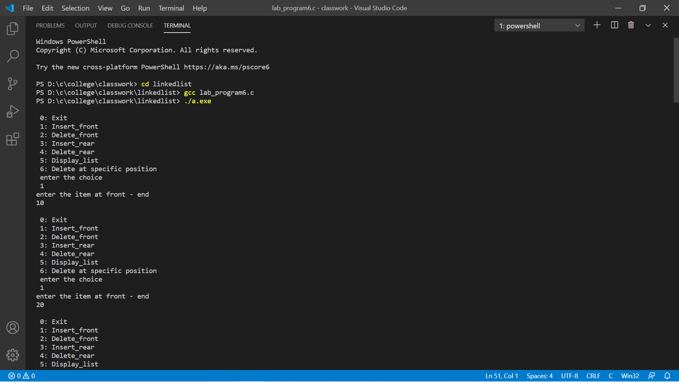

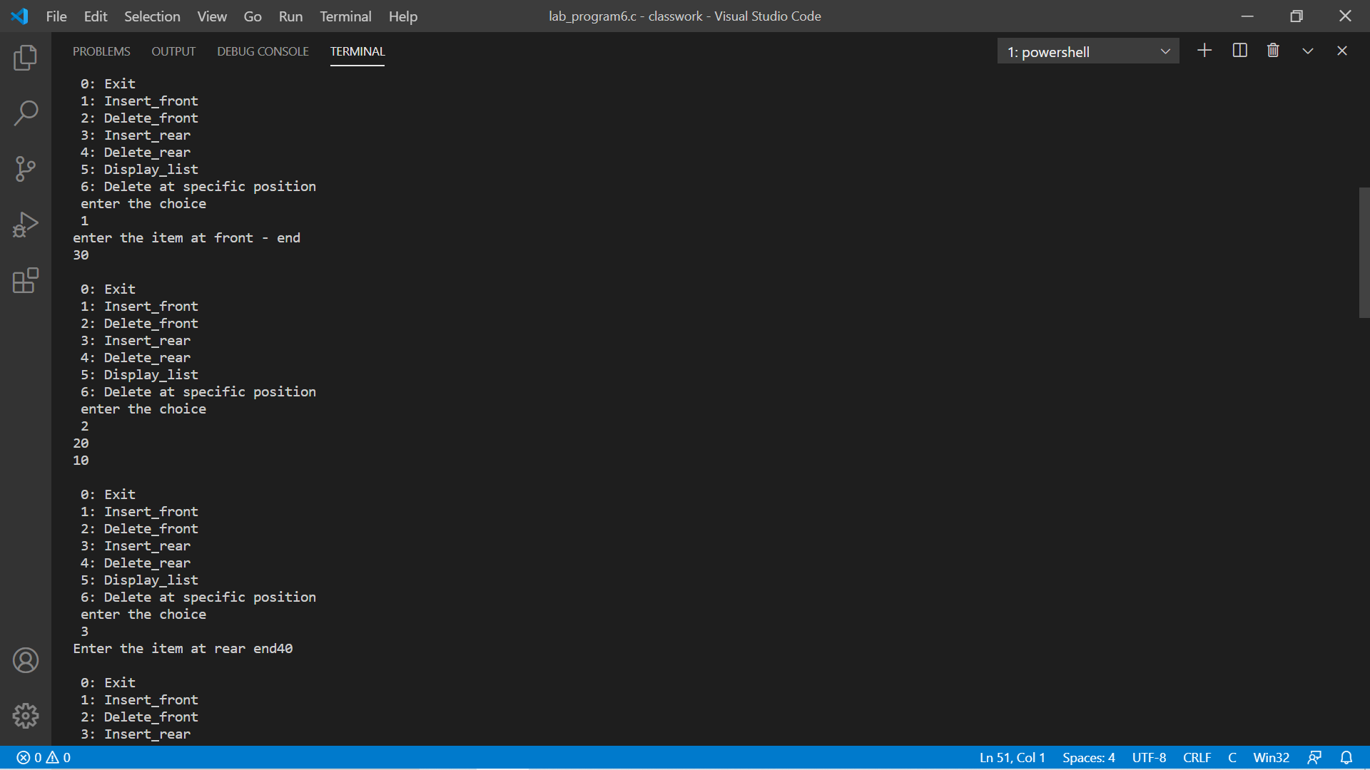

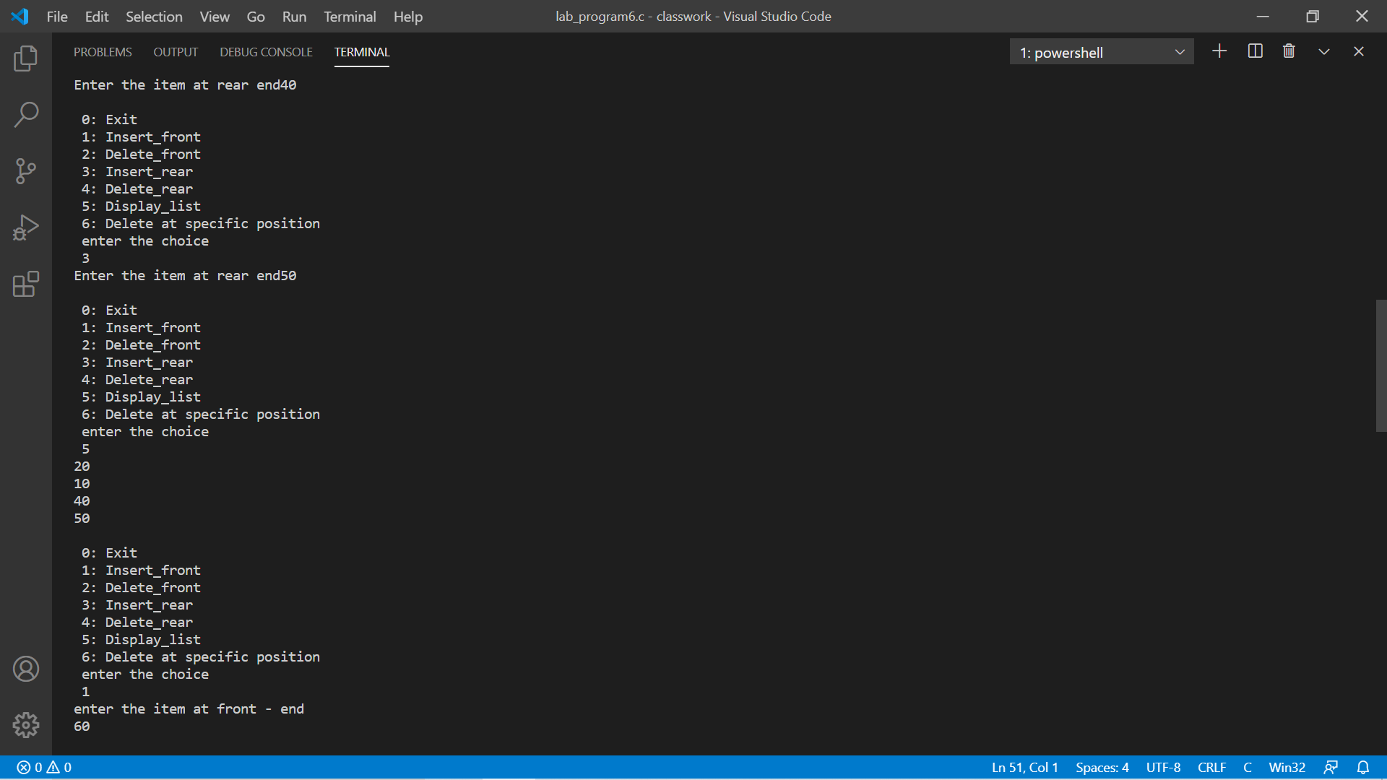

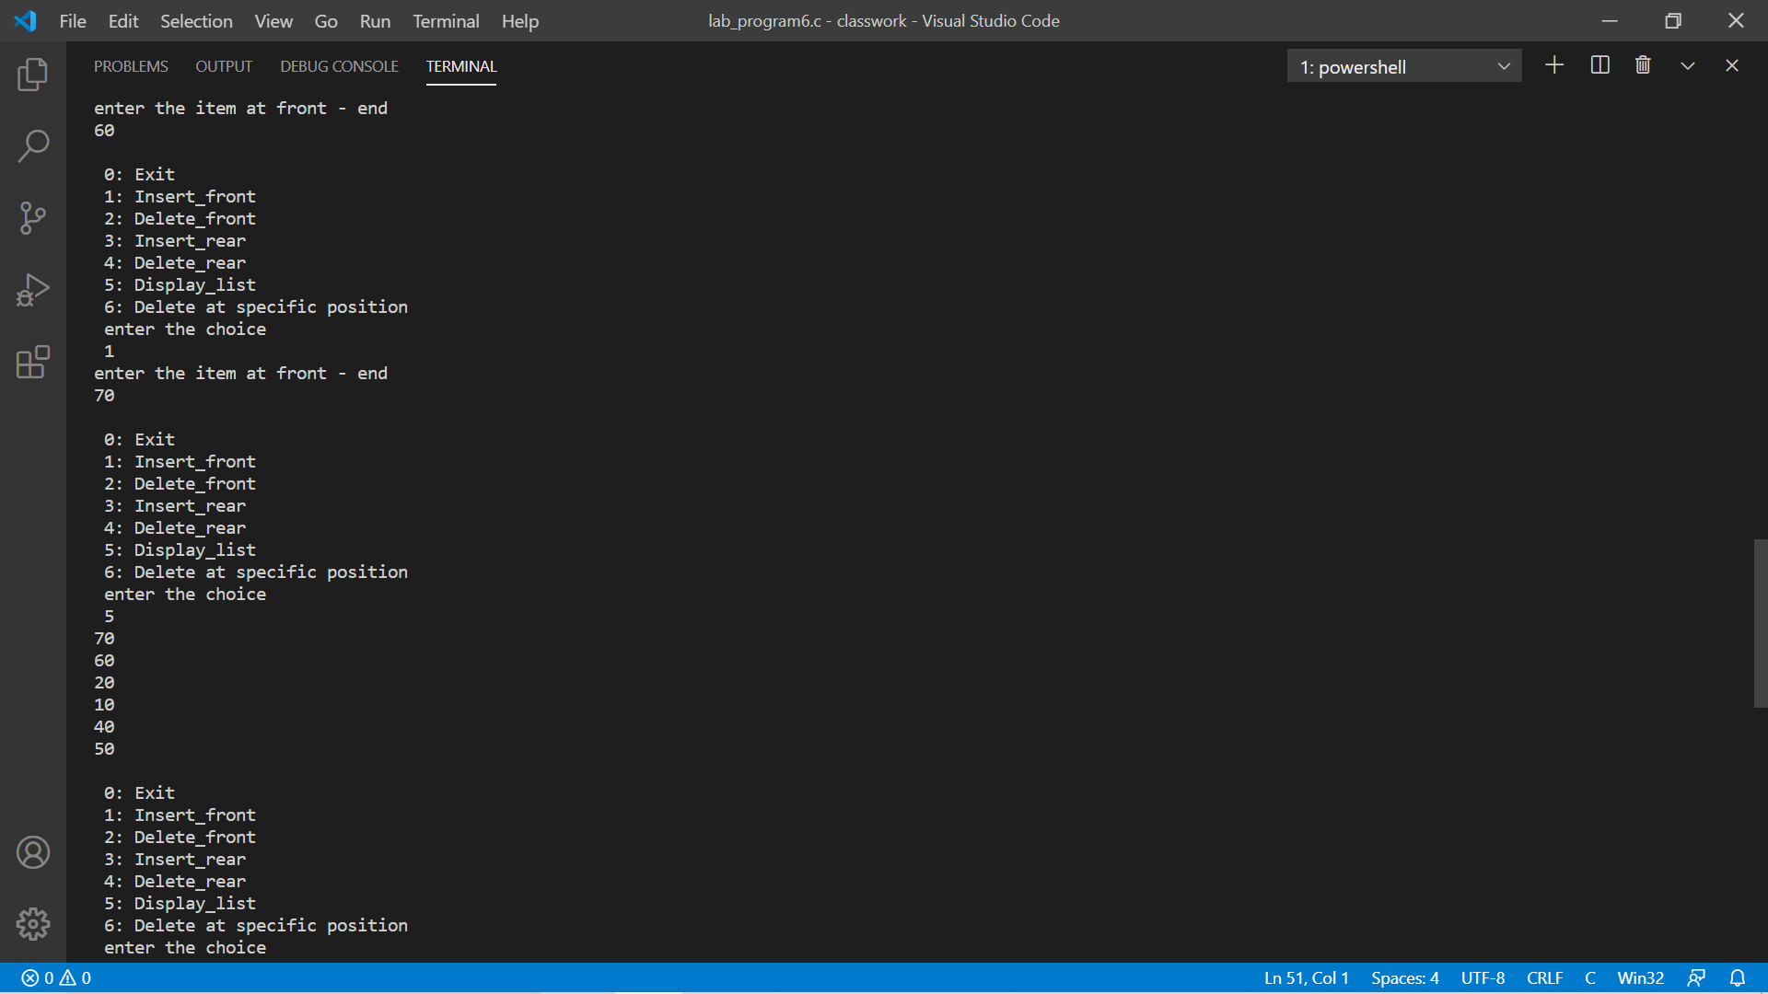

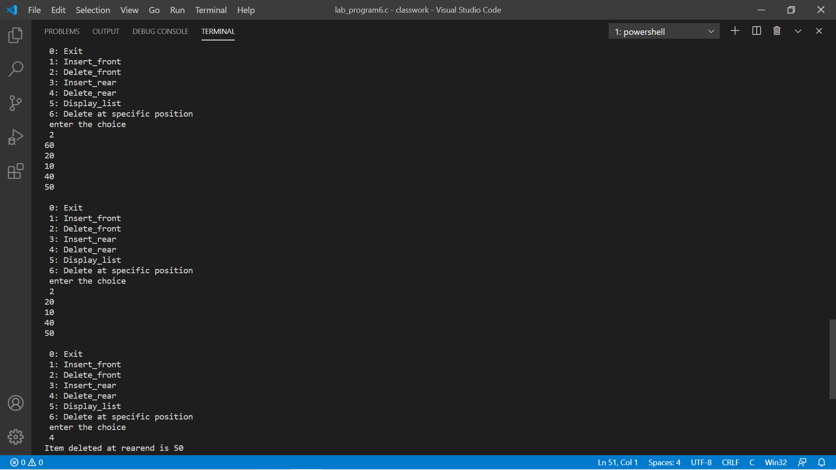

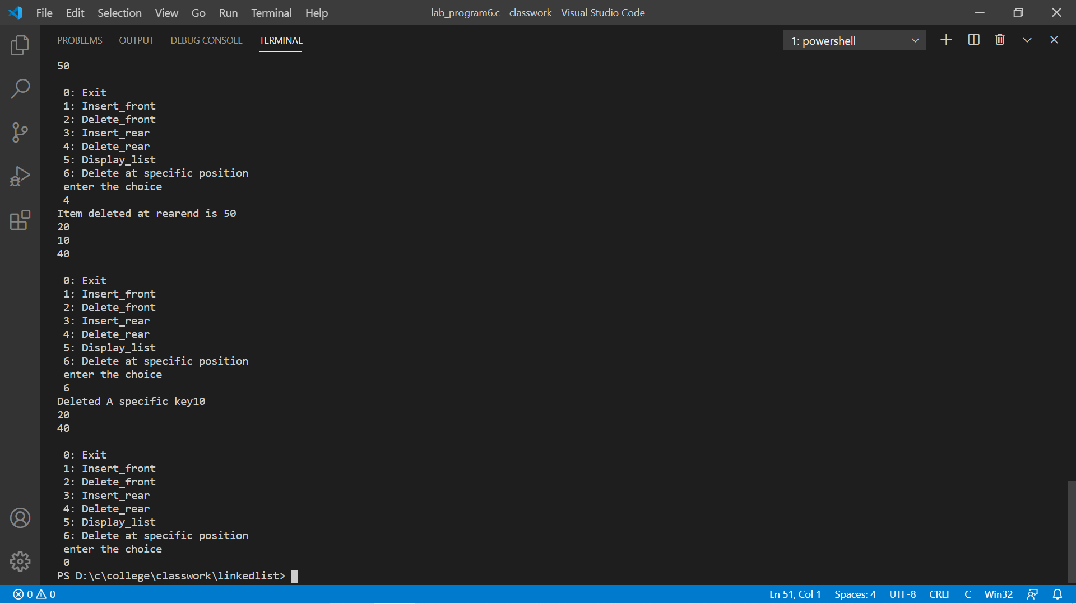

Program-7

#include <stdio.h>

#include <stdlib.h>

int count = 0;

struct Node

{

int item;

struct Node *link;

};

typedef struct Node *NODE;

NODE getNode()

{

NODE temp;

temp = (NODE)malloc(sizeof(struct Node));

return temp;

}

void freeNode(NODE x)

{

free(x);

}

NODE insert_front(NODE first, int item)

{

NODE temp = getNode();

count += 1;

temp->item = item;

temp->link = NULL;

if (first == NULL)

return temp;

temp->link = first;

first = temp;

return first;

}

NODE reverse(NODE first)

{

NODE cur, temp;

cur = NULL;

while (first != NULL)

{

temp = first;

first = first->link;

temp->link = cur;

cur = temp;

}

return cur;

}

NODE insert_rear(NODE first, int item)

{

NODE temp, x;

count += 1;

temp = getNode();

temp->item = item;

temp->link = NULL;

x = first;

if (x == NULL)

{

return temp;

}

while (x->link != NULL)

{

x = x->link;

}

x->link = temp;

return first;

}

NODE delete_rear(NODE first)

{

if (first == NULL)

{

printf("list is empty\n");

return first;

}

NODE cur, prev;

count -= 1;

if (first == NULL)

{

printf("List is empty");

return first;

}

if (first->link == NULL)

{

printf("item deleted is %d\n", first->item);

free(first);

return NULL;

}

prev = NULL;

cur = first;

while (cur->link != NULL)

{

prev = cur;

cur = cur->link;

}

printf("Item deleted at rearend is %d\n", cur->item);

free(cur);

prev->link = NULL;

return first;

}

NODE deletefront(NODE first)

{

if (first == NULL)

{

printf("list is empty\n");

return first;

}

NODE temp;

count -= 1;

temp = first;

temp = temp->link;

free(first);

first = temp;

return first;

}

void display(NODE first)

{

NODE temp;

if (first == NULL)

printf("list empty cannot display items\n");

for (temp = first; temp != NULL; temp = temp->link)

{

printf("%d\n", temp->item);

}

}

NODE Sorting(NODE first)

{

int temp;

NODE cur = first;

if (cur->link == NULL)

{

return cur;

}

NODE index;

while (cur != NULL)

{

index = cur->link;

while (index != NULL)

{

if (cur->item > index->item)

{

temp = cur->item;

cur->item = index->item;

index->item = temp;

}

index = index->link;

}

cur = cur->link;

}

return first;

}

void concatenate(NODE a, NODE b)

{

if (a != NULL && b != NULL)

{

if (a->link == NULL)

a->link = b;

else

concatenate(a->link, b);

}

else

{

printf("Either a or b is NULL\n");

}

}

void main()

{

int item, choice = 1, pos,n,i= 0;

NODE first = NULL;

NODE first2 = NULL;

while (choice != 0)

{

printf("\n 0: Exit \n 1: Insert_front\n 2: Delete_front\n 3: Insert_rear\n 4: Delete_rear\n 5: Display_list\n 6: Reverse\n 7: Sorting \n 8: Concat \n");

printf(" enter the choice\n ");

scanf("%d", &choice);

switch (choice)

{

case 0:

exit(0);

case 1:

printf("enter the item at front - end\n");

scanf("%d", &item);

first = insert_front(first, item);

break;

case 2:

first = deletefront(first);

display(first);

break;

case 3:

printf("Enter the item at rear end");

scanf("%d", &item);

first = insert_rear(first, item);

break;

case 4:

first = delete_rear(first);

display(first);

break;

case 5:

display(first);

break;

case 6:

first = reverse(first);

display(first);

break;

case 7:

printf("\n Sorting the list \n");

first = Sorting(first);

display(first);

break;

case 8:

printf("\nEnter the number of elements in the new list");

scanf("%d", &n);

while (i < n)

{

printf("enter the item at front - end\n");

scanf("%d", &item);

first2 = insert_front(first2, item);

i++;

}

printf("Before sorting\n");

display(first2);

Sorting(first2);

printf("After sorting\n");

display(first2);

concatenate(first,first2);

printf("After Concatenating\n");

display(first);

break;

default:

exit(0);

}

}

}

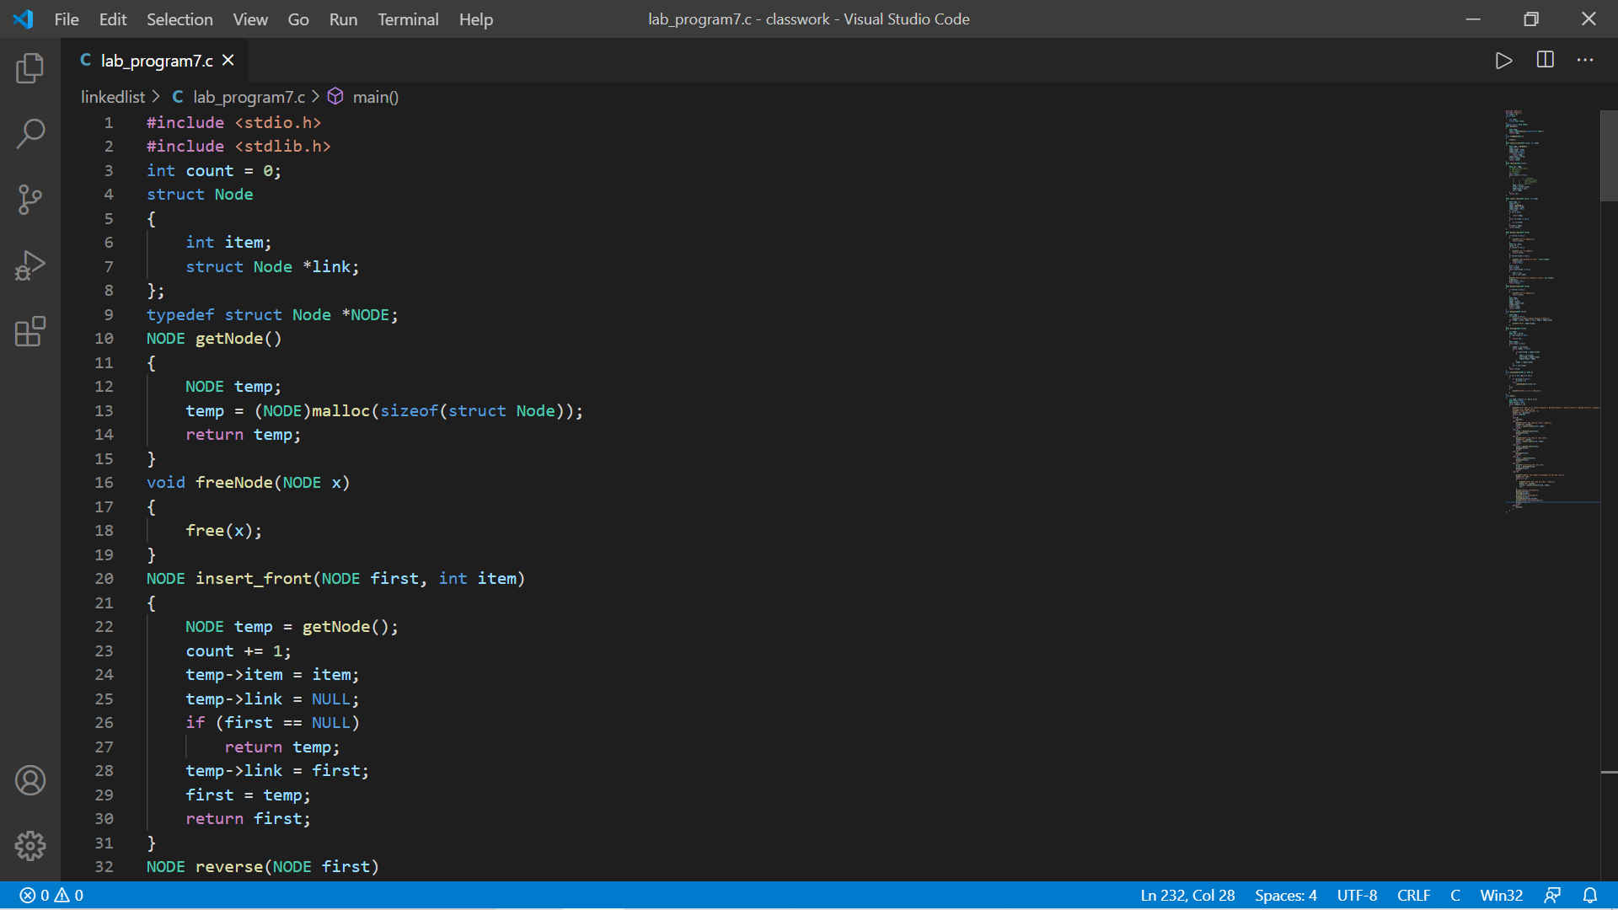

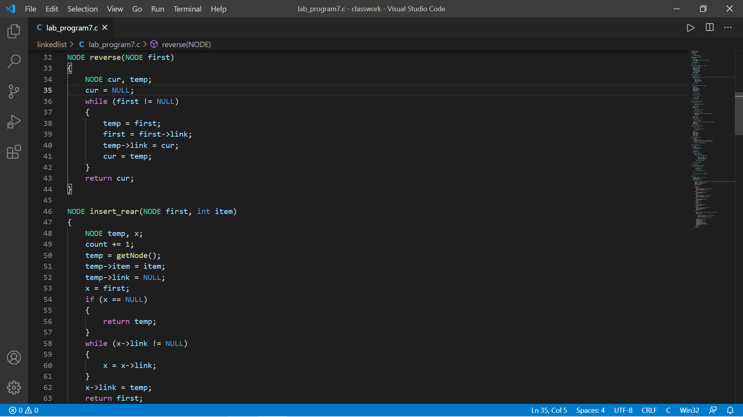

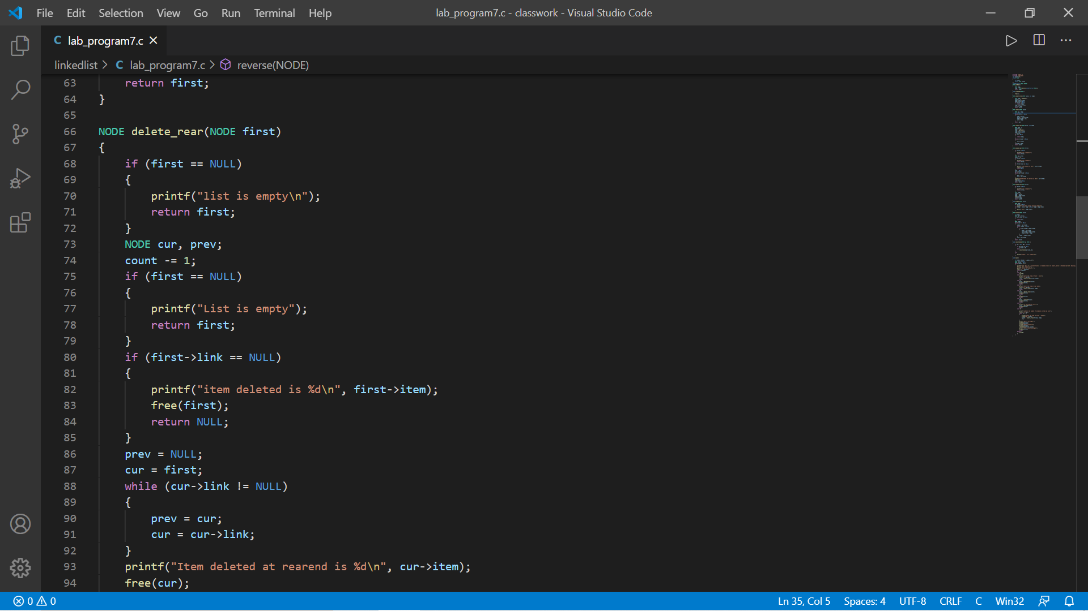

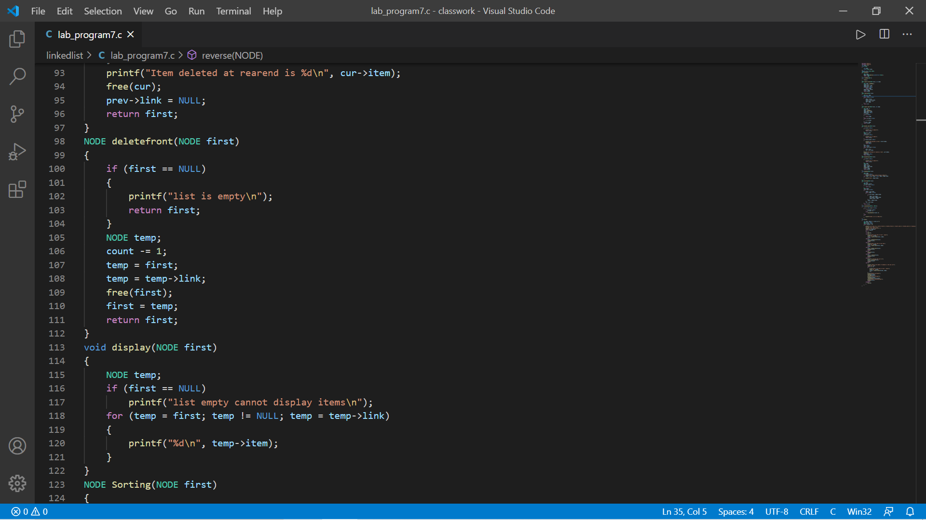

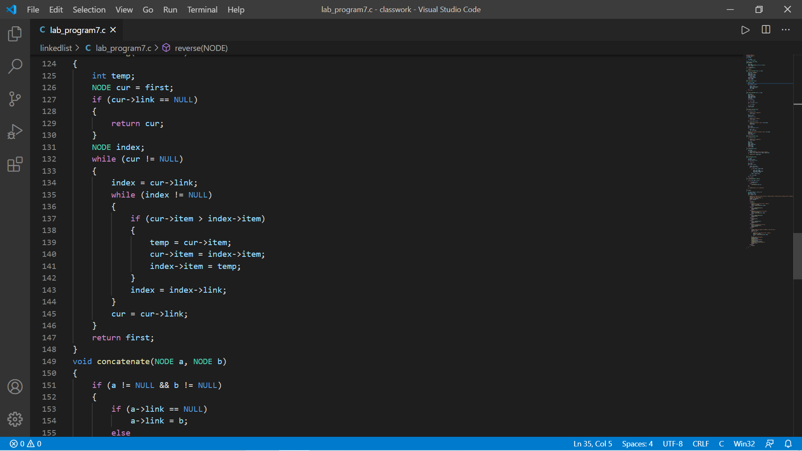

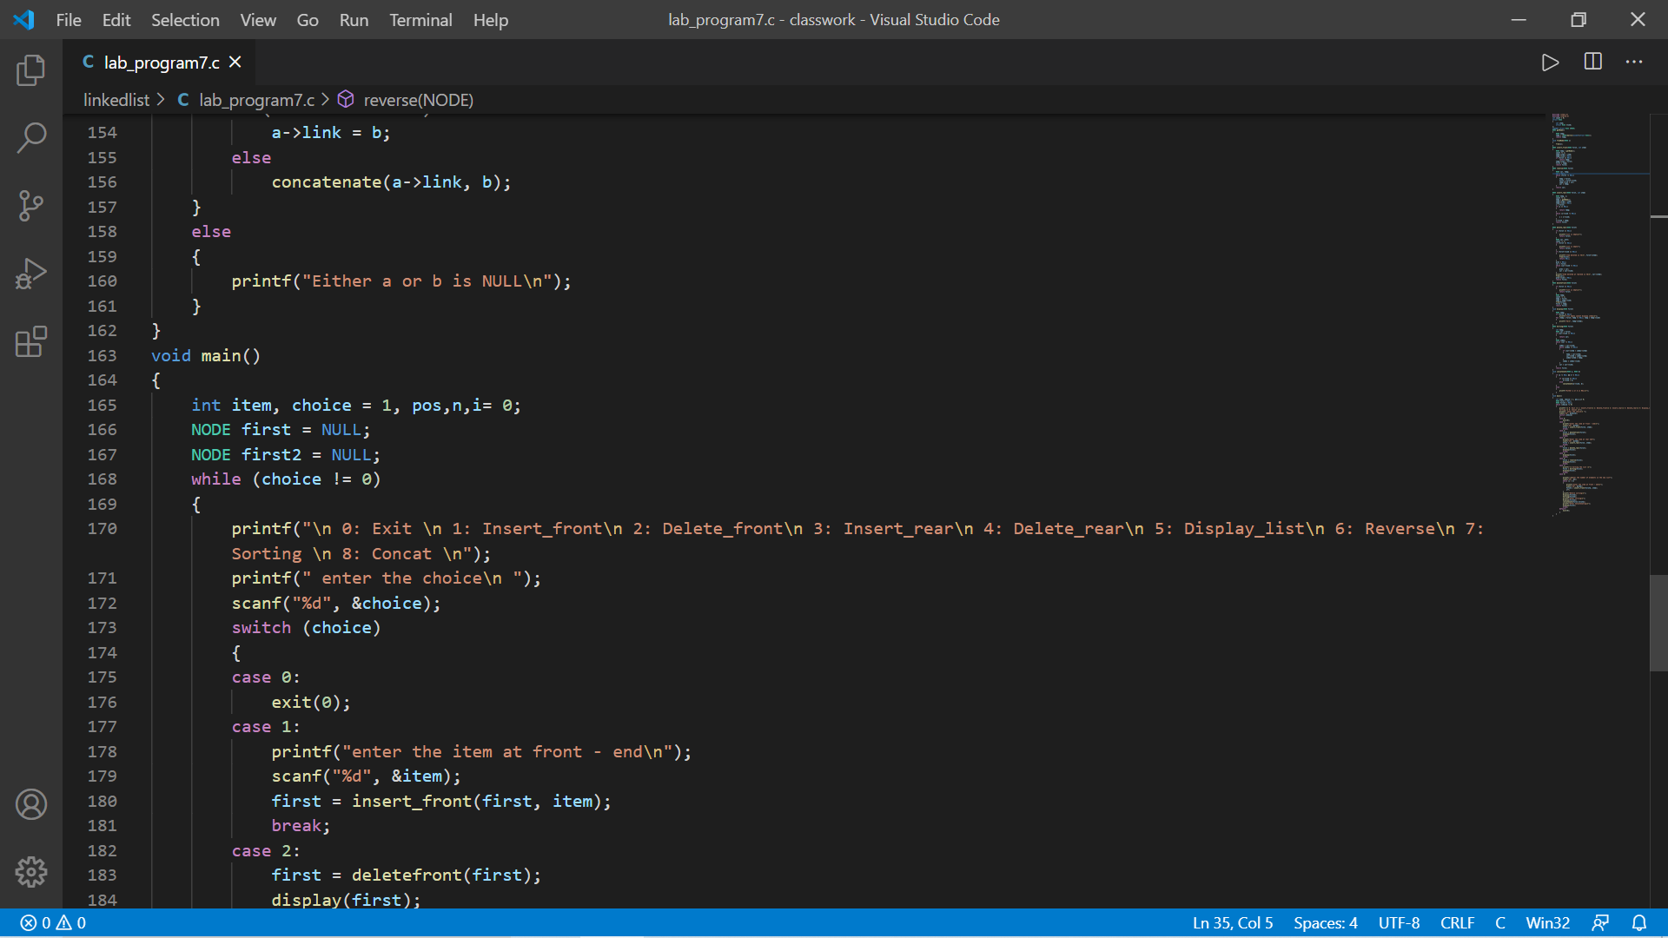

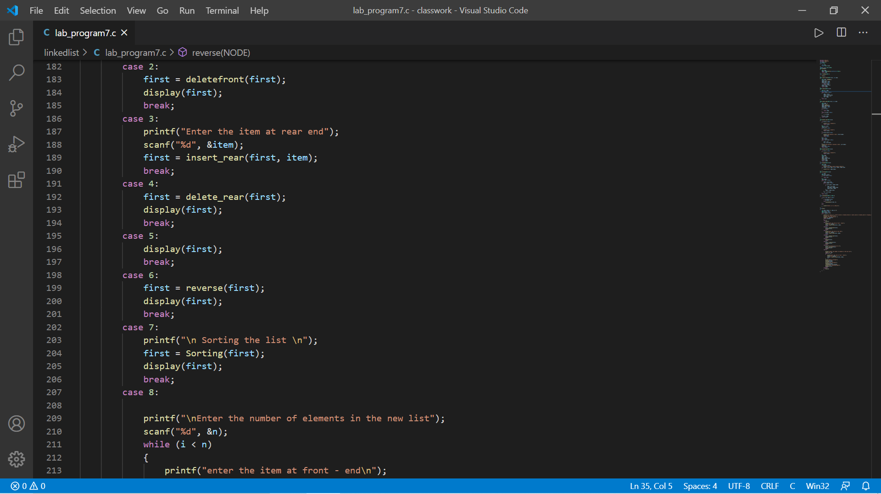

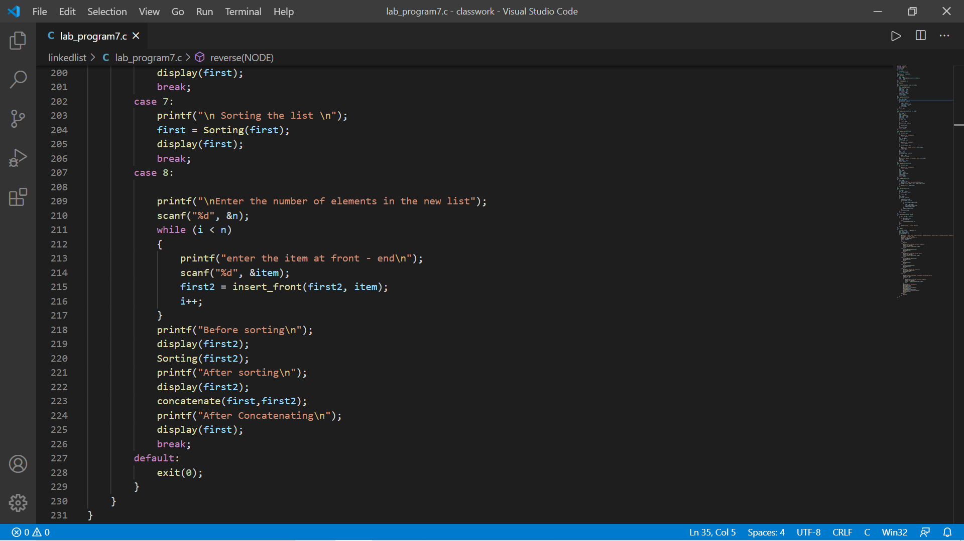

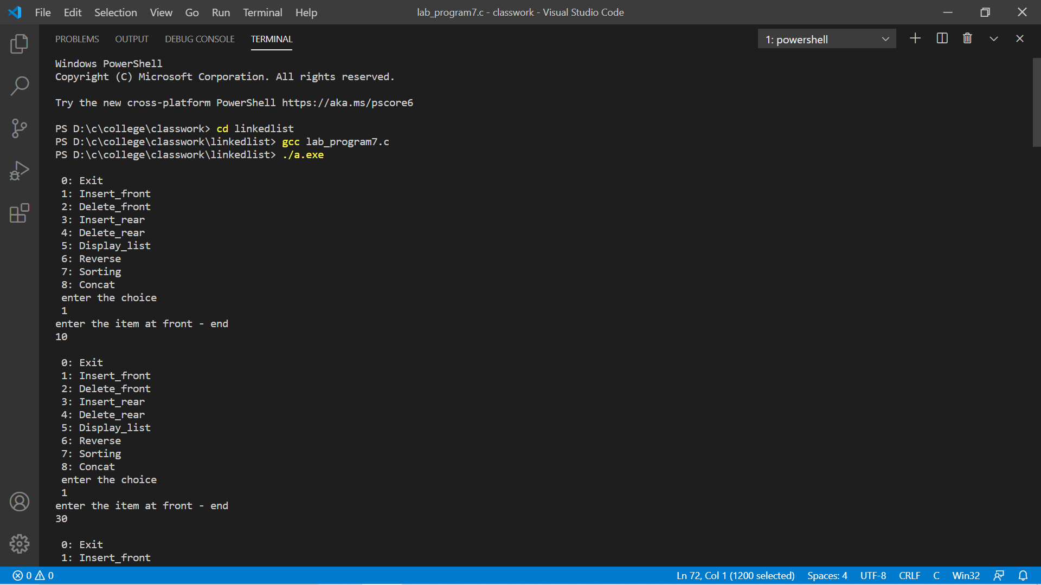

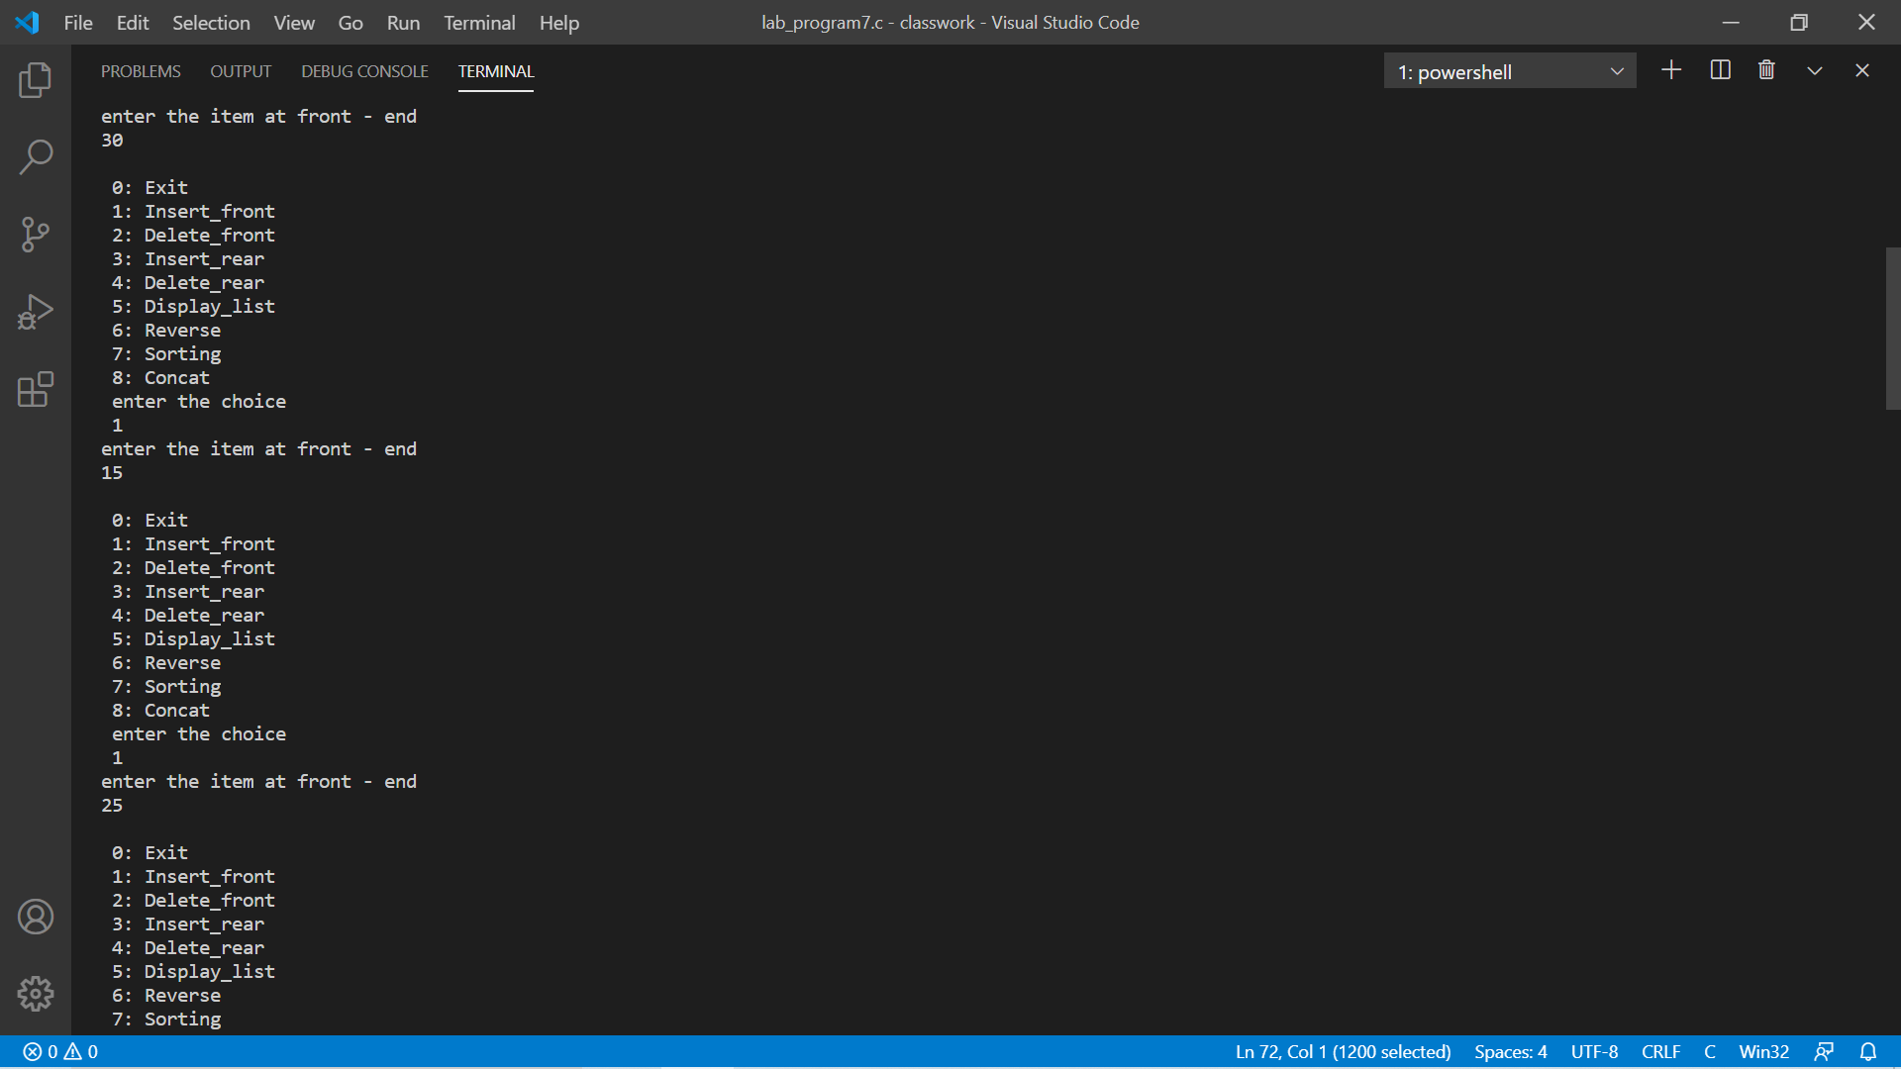

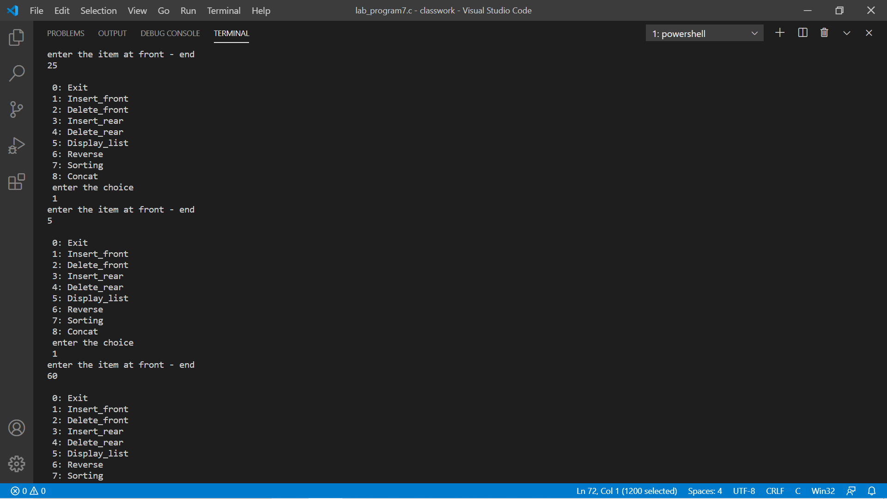

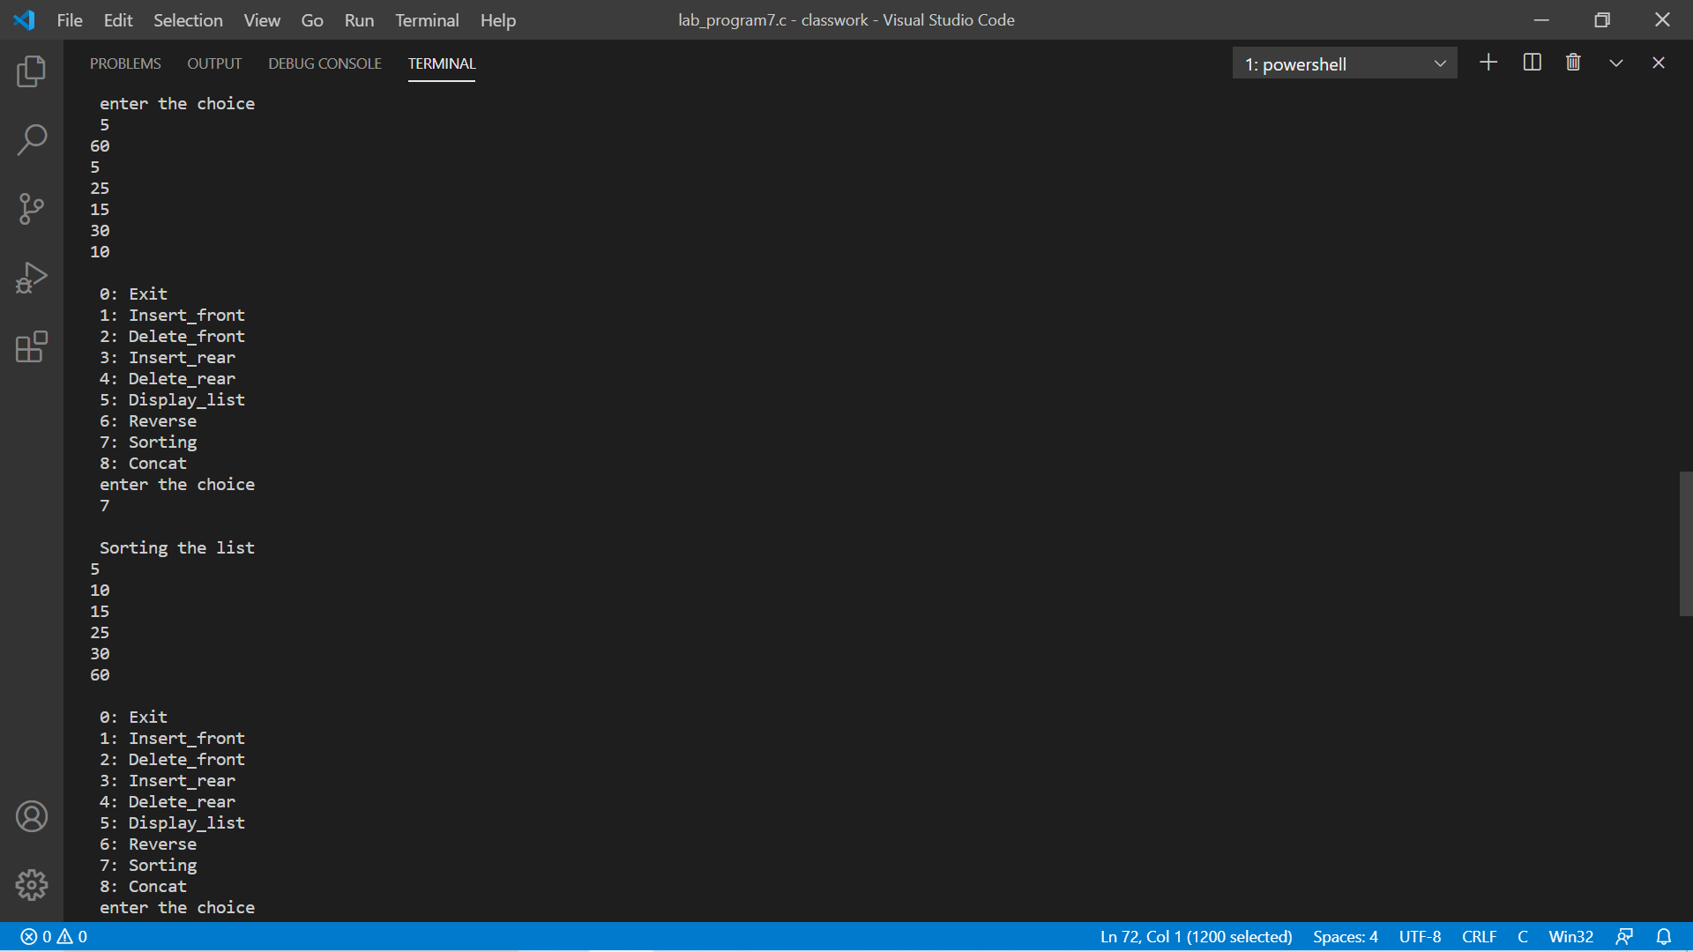

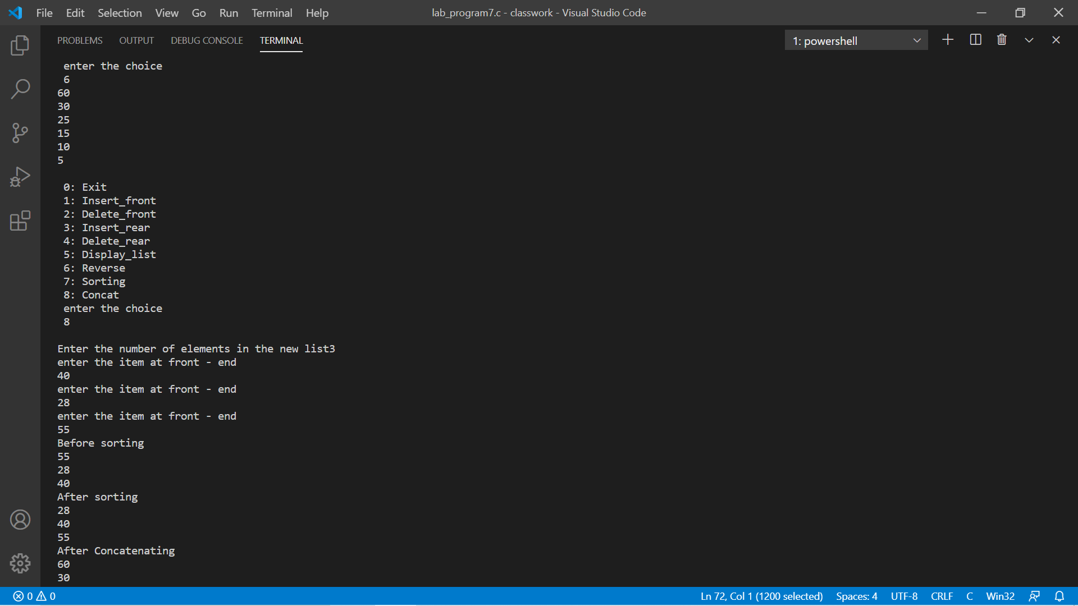

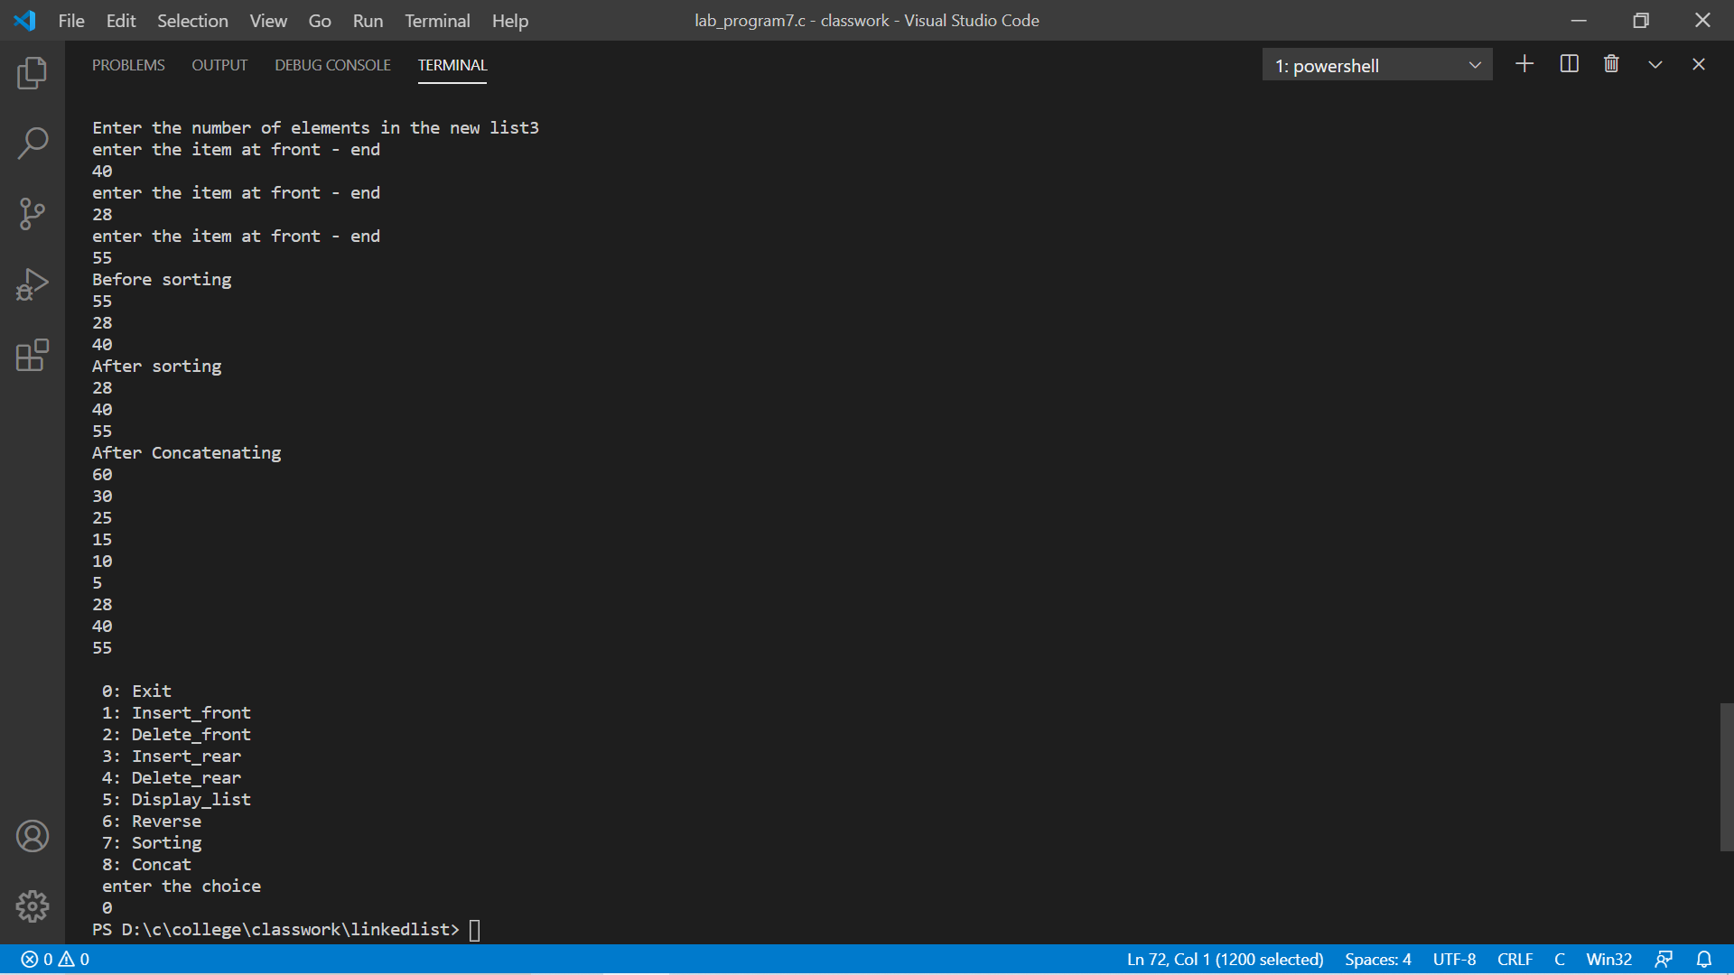

Program-8 (stacks)

#include<stdio.h>

#include<conio.h>

#include<stdlib.h>

struct node

{

int item;

struct node *link;

};

typedef struct node *NODE;

NODE getNode()

{

NODE x;

x=(NODE)malloc(sizeof(struct node));

if(x==NULL)

{

printf("mem full\n");

exit(0);

}

return x;

}

void freenode(NODE x)

{

free(x);

}

NODE insert_front(NODE first, int item)

{

NODE temp = getNode();

temp->item = item;

temp->link = NULL;

if (first == NULL)

return temp;

temp->link = first;

first = temp;

return first;

}

NODE delete_front(NODE first)

{ if (first==NULL)

{

printf("Stack is empty\n");

return first;

}

NODE temp;

temp = first;

printf("Popped element is %d \n",first->item);

first = first->link;

free(temp);

return first;

}

void display(NODE first)

{

NODE temp;

if(first==NULL)

printf("Stack empty cannot display items\n");

for(temp=first;temp!=NULL;temp=temp->link)

{

printf("%d\n",temp->item);

}

}

void main()

{

int item,choice,pos;

NODE first=NULL;

for(;;)

{

printf("\n 1:PUSH \n 2:POP\n 3:Display\n 4:Exit\n");

printf("Enter the choice\n");

scanf("%d",&choice);

switch(choice)

{

case 1:printf("Enter the item to push\n");

scanf("%d",&item);

first=insert_front(first,item);

break;

case 2:first=delete_front(first);

break;

case 3:display(first);

break;

case 4:exit(0);

default:printf("\n Invalid Input");

break;

}

}

}

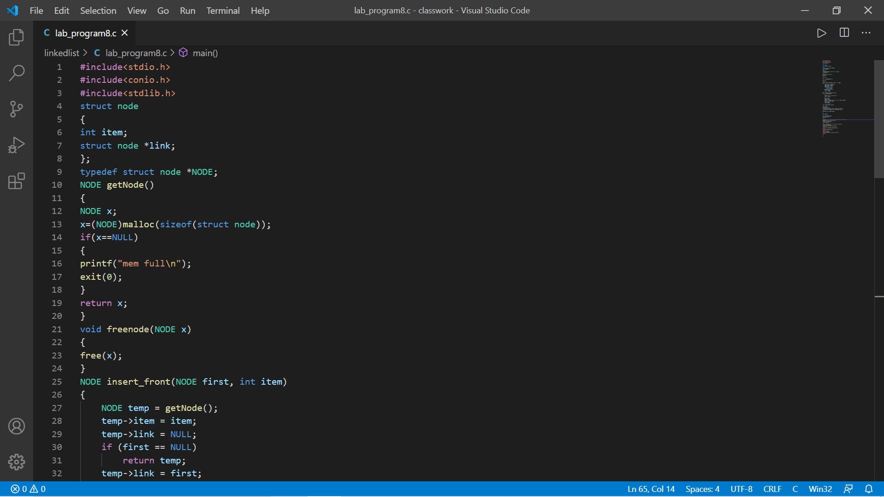

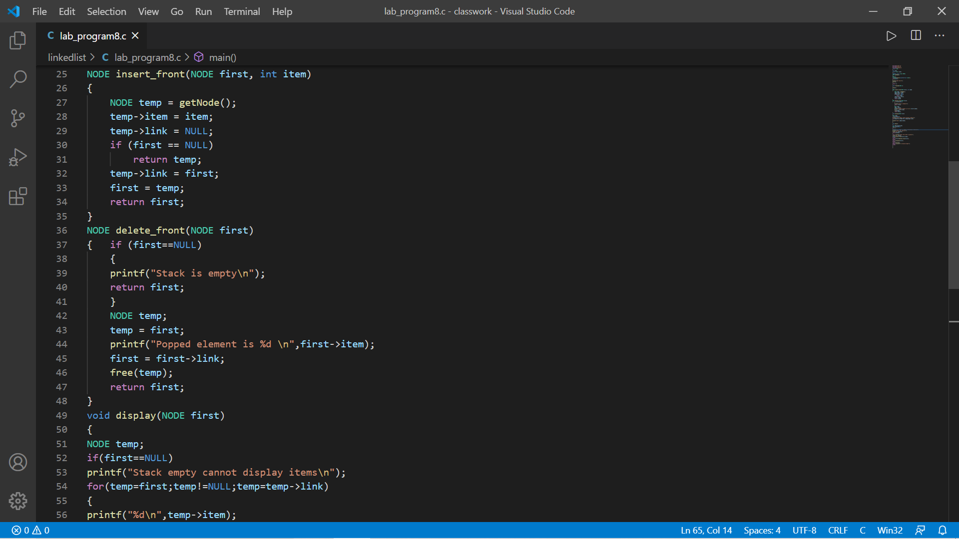

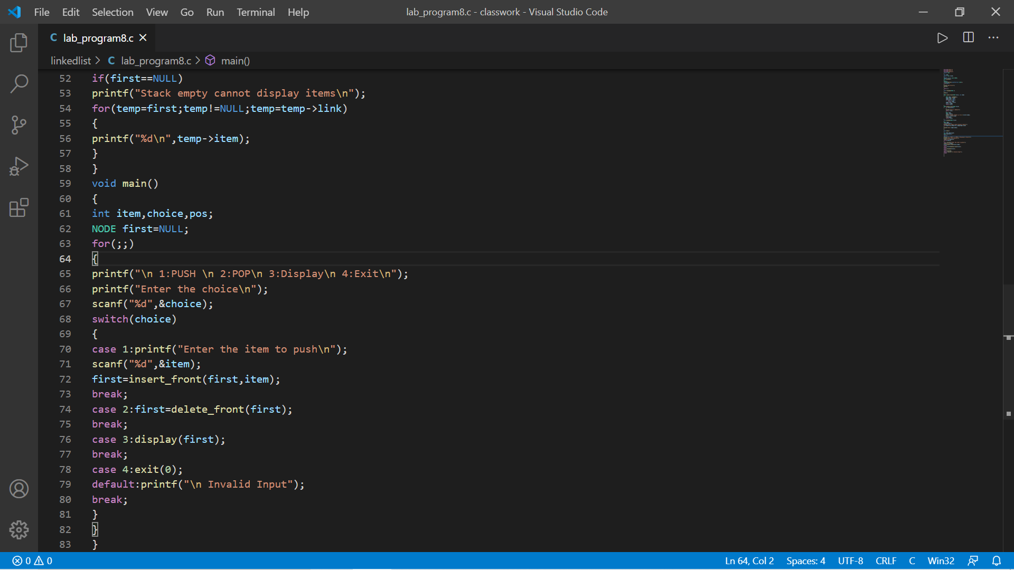

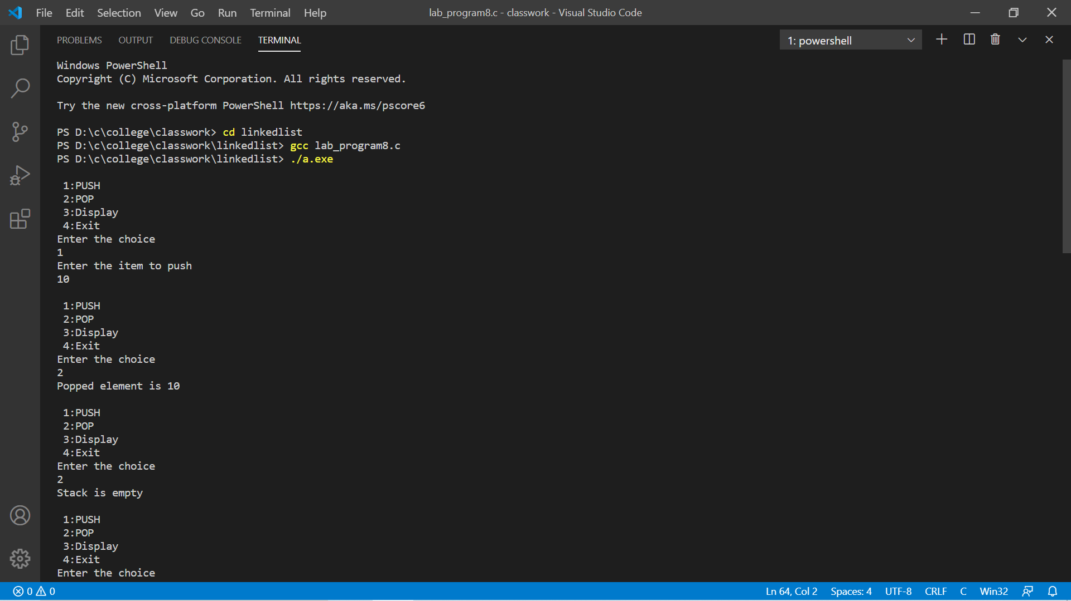

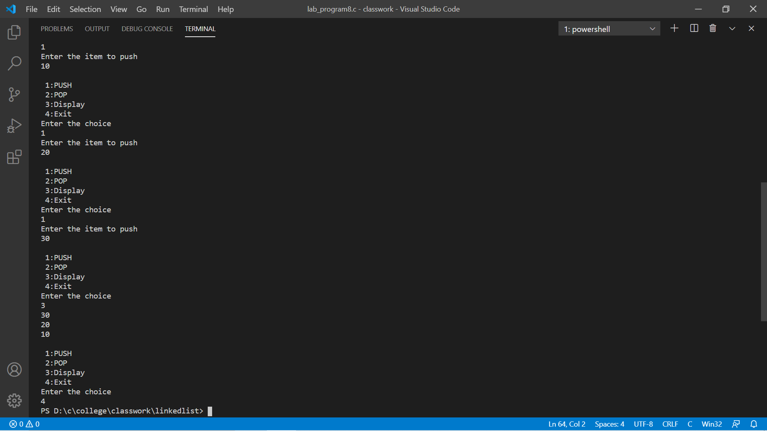

Prgram-8 (Queue)

#include<stdio.h>

#include<stdlib.h>

struct node{

int item;

struct node* link;

};

typedef struct node* NODE;

NODE getNode(){

NODE temp;

temp=(NODE) malloc(sizeof(NODE));

return temp;

}

void freeNode(NODE temp){

free(temp);

}

NODE insert_front(NODE first, int item)

{

NODE temp = getNode();

temp->item = item;

temp->link = NULL;

if (first==NULL)

return temp;

temp->link=first;

first = temp;

return first;

}

NODE insert_rear(NODE first, int item)

{

NODE temp, x;

temp = getNode();

temp->item = item;

temp->link = NULL;

x = first;

if (x == NULL)

{

return temp;

}

while (x->link != NULL)

{

x = x->link;

}

x->link = temp;

return first;

}

NODE delete_rear(NODE first){

NODE cur,prev;

if (first==NULL){

printf("List is empty");

return first;

}

if (first->link==NULL){

printf("item deleted is %d\n",first->item);

free(first);

return NULL;

}

prev=NULL;

cur=first;

while(cur->link!=NULL){

prev=cur;

cur=cur->link;

}

printf("Item deleted at rearend is %d",cur->item);

free(cur);

prev->link=NULL;

return first;

}

NODE deletefront(NODE first)

{ if (first==NULL)

{

printf("list is empty\n");

return first;

}

NODE temp;

temp = first;

printf("Element deleted at front-end is %d \n",first->item);

first = first->link;

free(temp);

return first;

}

void display(NODE first)

{

NODE temp;

if(first==NULL)

printf("list empty cannot display items\n");

for(temp=first;temp!=NULL;temp=temp->link)

{

printf("%d\n",temp->item);

}

}

void main()

{

int item, choice, pos;

NODE first = NULL;

for (;;)

{

printf("\n 0: Exit \n 1: Insert_front\n 2: Delete_front\n 3: Insert_rear\n 4: Delete_rear\n 5: Display_list\n");

printf(" enter the choice\n ");

scanf("%d",&choice);

switch (choice)

{

case 0: exit(0);

case 1:

printf("enter the item at front - end\n");

scanf("%d",&item);

first = insert_front(first, item);

break;

case 2:

first = deletefront(first);

break;

case 3:

printf("Enter the item at rear end");

scanf("%d",&item);

first = insert_rear(first, item);

break;

case 4:

first = delete_rear(first);

break;

case 5:

display(first);

break;

default:

exit(0);

break;

}

}

}

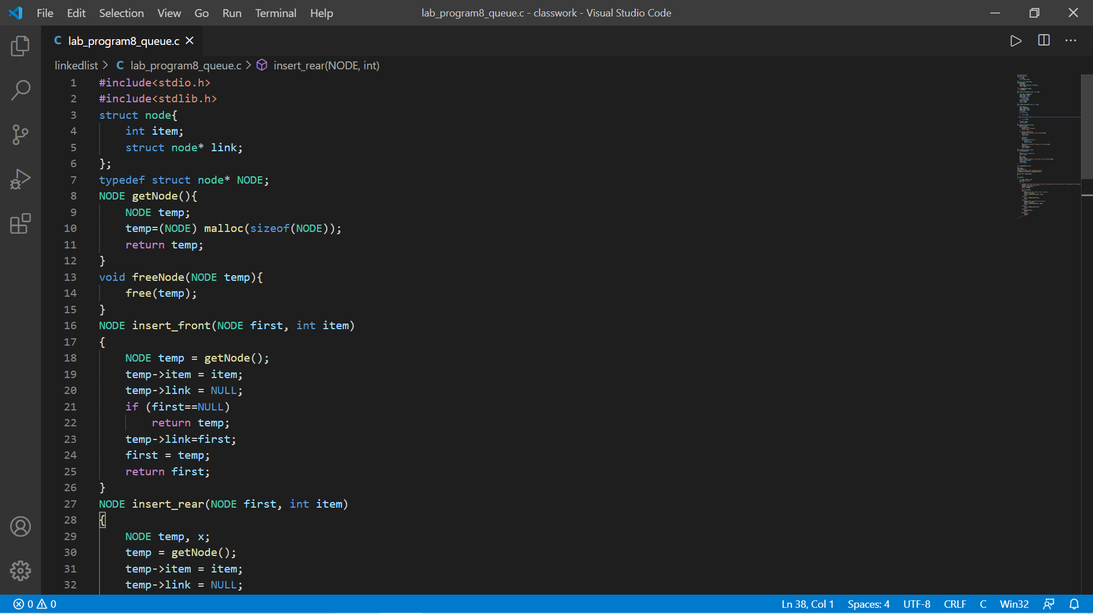

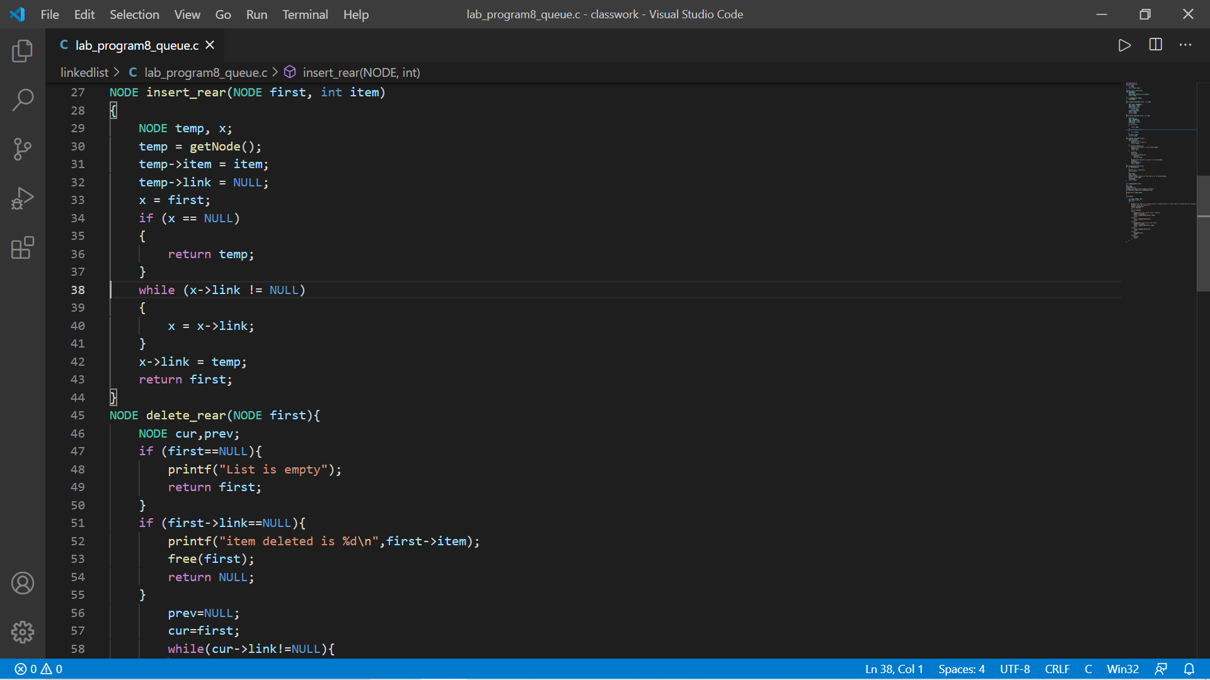

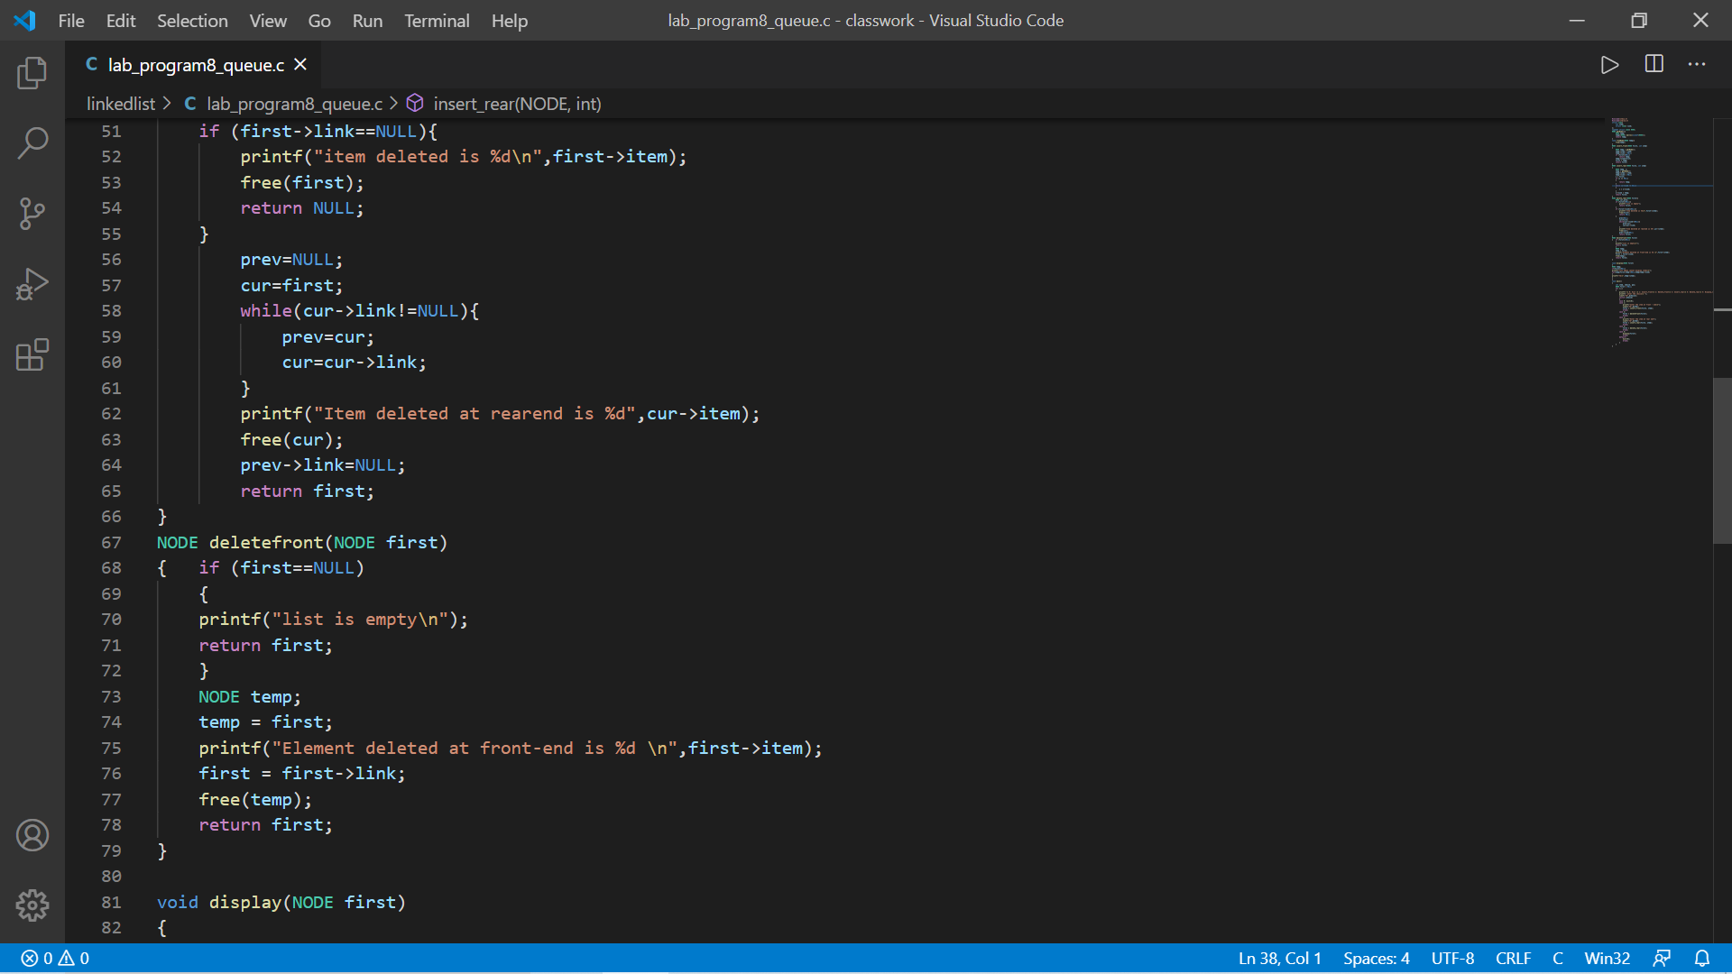

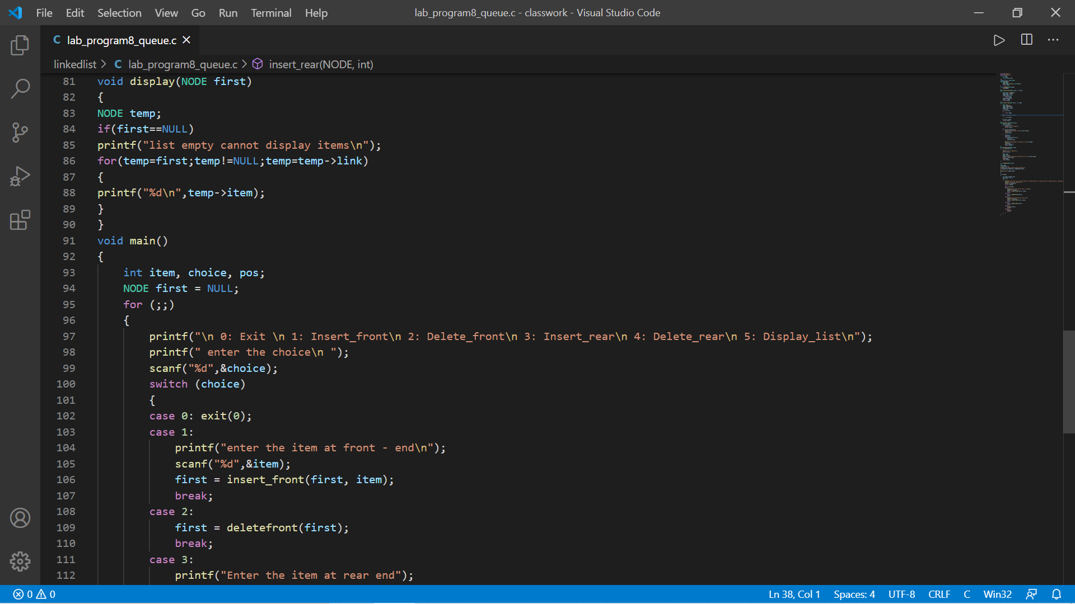

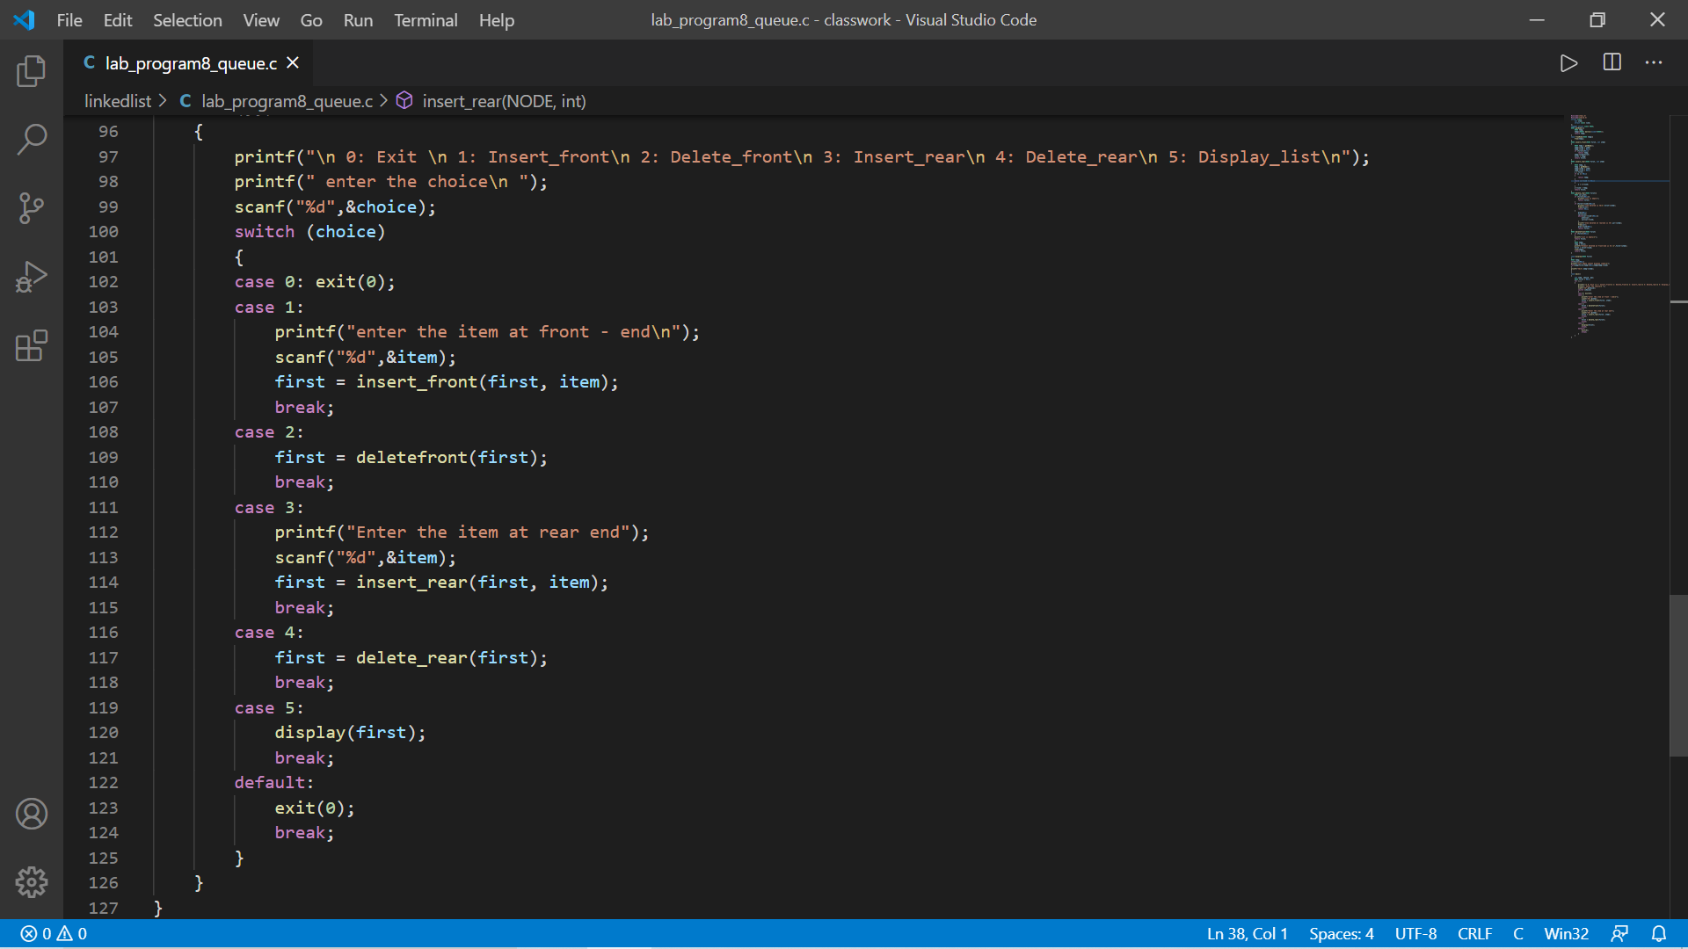

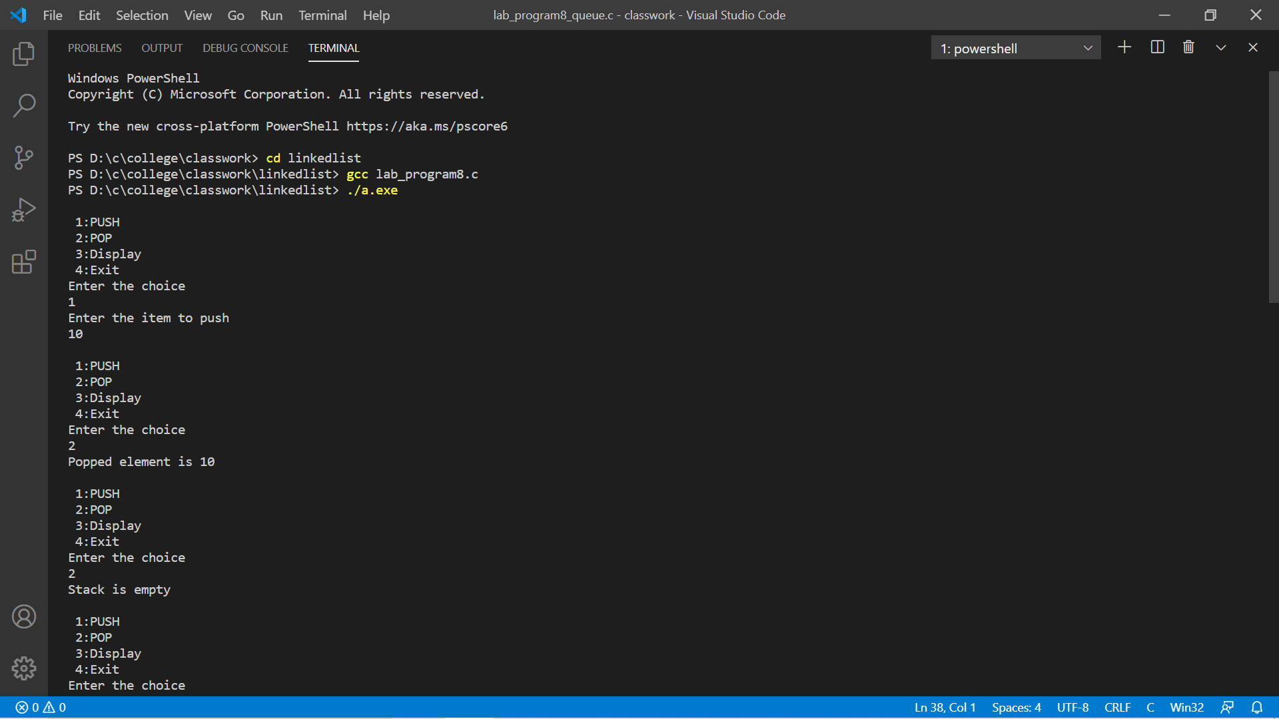

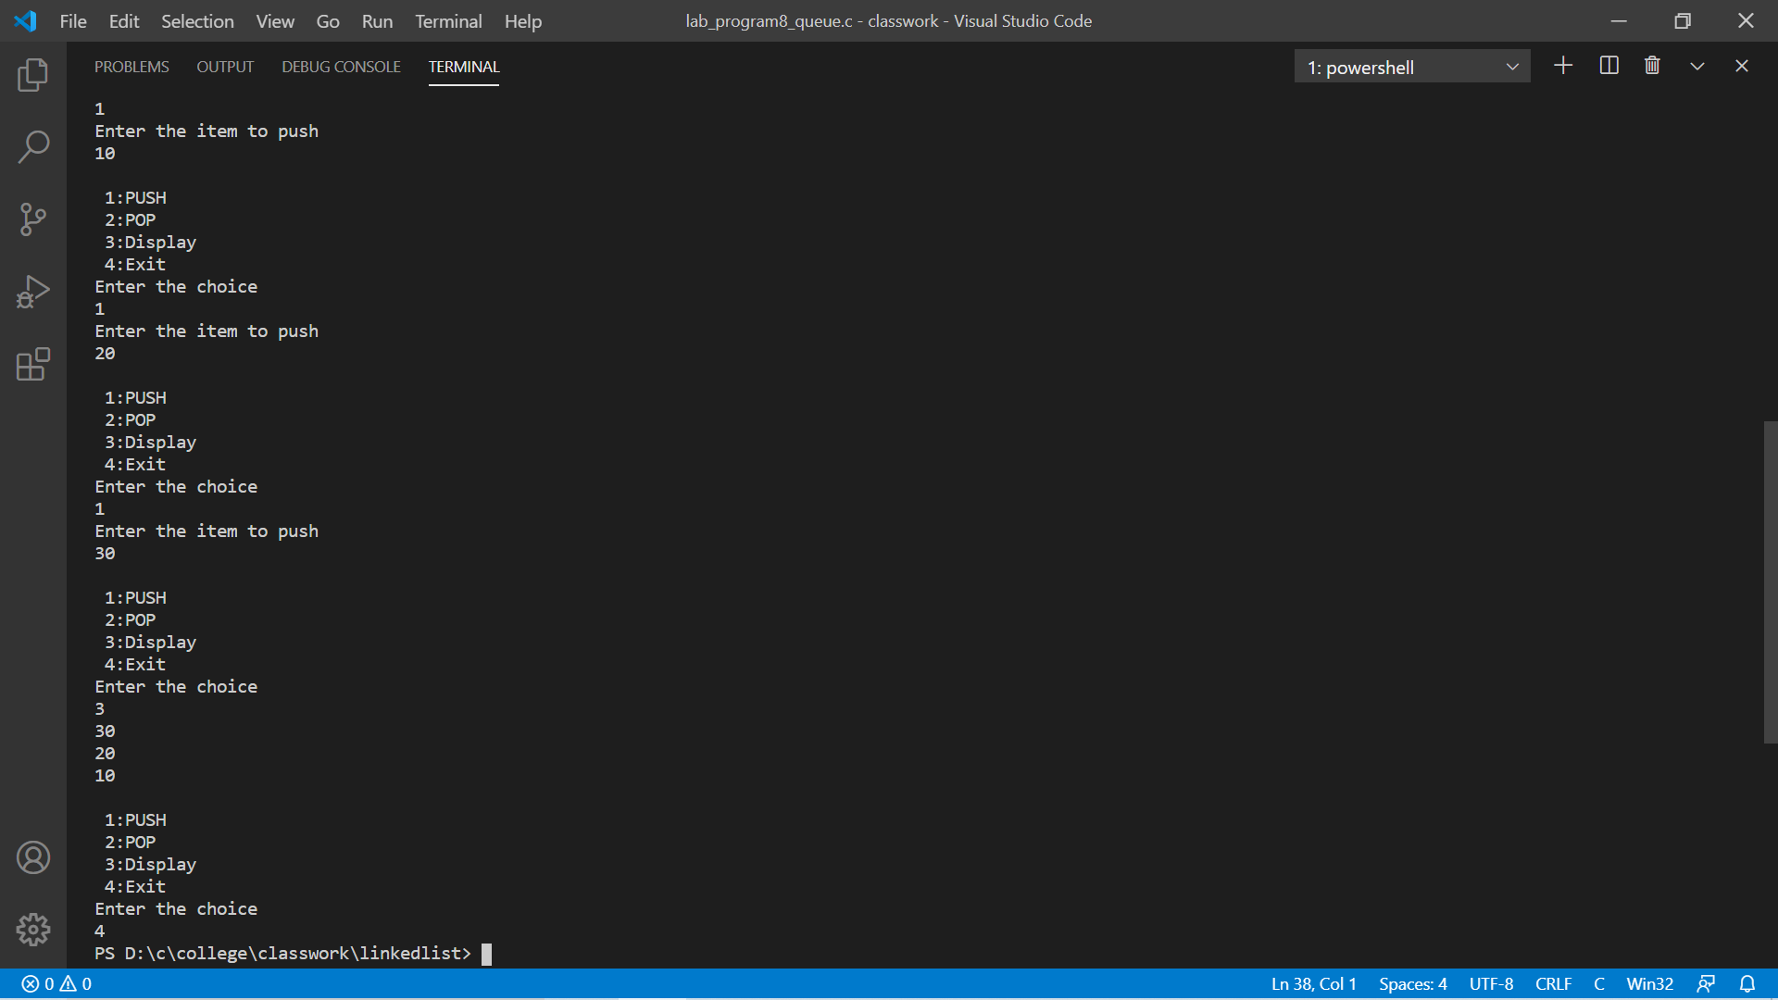

Program-9

#include <stdio.h>

#include <stdlib.h>

struct node

{

int info;

struct node *llink;

struct node *rlink;

};

typedef struct node *NODE;

NODE getnode()

{

NODE x;

x = (NODE)malloc(sizeof(struct node));

if (x == NULL)

{

printf("mem full\n");

exit(0);

}

return x;

}

void freenode(NODE x)

{

free(x);

}

NODE dinsert_front(int item, NODE head)

{

NODE temp, cur;

temp = getnode();

temp->info = item;

cur = head->rlink;

head->rlink = temp;

temp->llink = head;

temp->rlink = cur;

cur->llink = temp;

return head;

}

NODE dinsert_rear(int item, NODE head)

{

NODE temp, cur;

temp = getnode();

temp->info = item;

cur = head->llink;

head->llink = temp;

temp->rlink = head;

temp->llink = cur;

cur->rlink = temp;

return head;

}

NODE ddelete_front(NODE head)

{

NODE cur, next;

if (head->rlink == head)

{

printf("list empty\n");

return head;

}

cur = head->rlink;

next = cur->rlink;

head->rlink = next;

next->llink = head;

printf("the node deleted is %d", cur->info);

freenode(cur);

return head;

}

NODE ddelete_rear(NODE head)

{

NODE cur, prev;

if (head->rlink == head)

{

printf("list empty\n");

return head;

}

cur = head->llink;

prev = cur->llink;

head->llink = prev;

prev->rlink = head;

printf("the node deleted is %d", cur->info);

freenode(cur);

return head;

}

void display(NODE head)

{

NODE temp;

if (head->rlink == head)

{

printf("list empty\n");

return;

}

printf("contents of list\n");

temp = head->rlink;

while (temp != head)

{

printf("%d\n", temp->info);

temp = temp->rlink;

}

printf("\n");

}

NODE insert_leftpos(int item, NODE head)

{

NODE temp, cur, prev;

if (head->rlink == head)

{

printf("list empty\n");

return head;

}

cur = head->rlink;

while (cur != head)

{

if (item == cur->info)

break;

cur = cur->rlink;

}

if (cur == head)

{

printf("key not found\n");

return head;

}

prev = cur->llink;

printf("enter towards left of %d=", item);

temp = getnode();

scanf("%d", &temp->info);

prev->rlink = temp;

temp->llink = prev;

cur->llink = temp;

temp->rlink = cur;

return head;

}

NODE delete_all_key(int item, NODE head)

{

NODE prev, cur, next;

int count;

if (head->rlink == head)

{

printf("LE\n");

return head;

}

count = 0;

cur = head->rlink;

while (cur != head)

{

if (item != cur->info)

cur = cur->rlink;

else

{

count++;

prev = cur->llink;

next = cur->rlink;

prev->rlink = next;

next->llink = prev;

freenode(cur);

cur = next;

}

}

if (count == 0)

printf("key not found\n");

else

printf("key found at %d positions and are deleted\n", count);

return head;

}

void main()

{

NODE head, last;

int item, choice;

head = getnode();

head->rlink = head;

head->llink = head;

for (;;)

{

printf("\n1:insert front\n2:insert rear\n3:delete front\n4:delete rear\n5:display\n6:Insert left pos \n7:delete all key \n8:exit\n");

printf("enter the choice\n");

scanf("%d", &choice);

switch (choice)

{

case 1:

printf("enter the item at front end\n");

scanf("%d", &item);

last = dinsert_front(item, head);

break;

case 2:

printf("enter the item at rear end\n");

scanf("%d", &item);

last = dinsert_rear(item, head);

break;

case 3:

last = ddelete_front(head);

break;

case 4:

last = ddelete_rear(head);

break;

case 5:

display(head);

break;

case 6:

printf("enter the key\n");

scanf("%d", &item);

last = insert_leftpos(item, head);

break;

case 7:

printf("enter the key to delete \n");

scanf("%d", &item);

last = delete_all_key(item, head);

display(last);

break;

default:

exit(0);

}

}

}

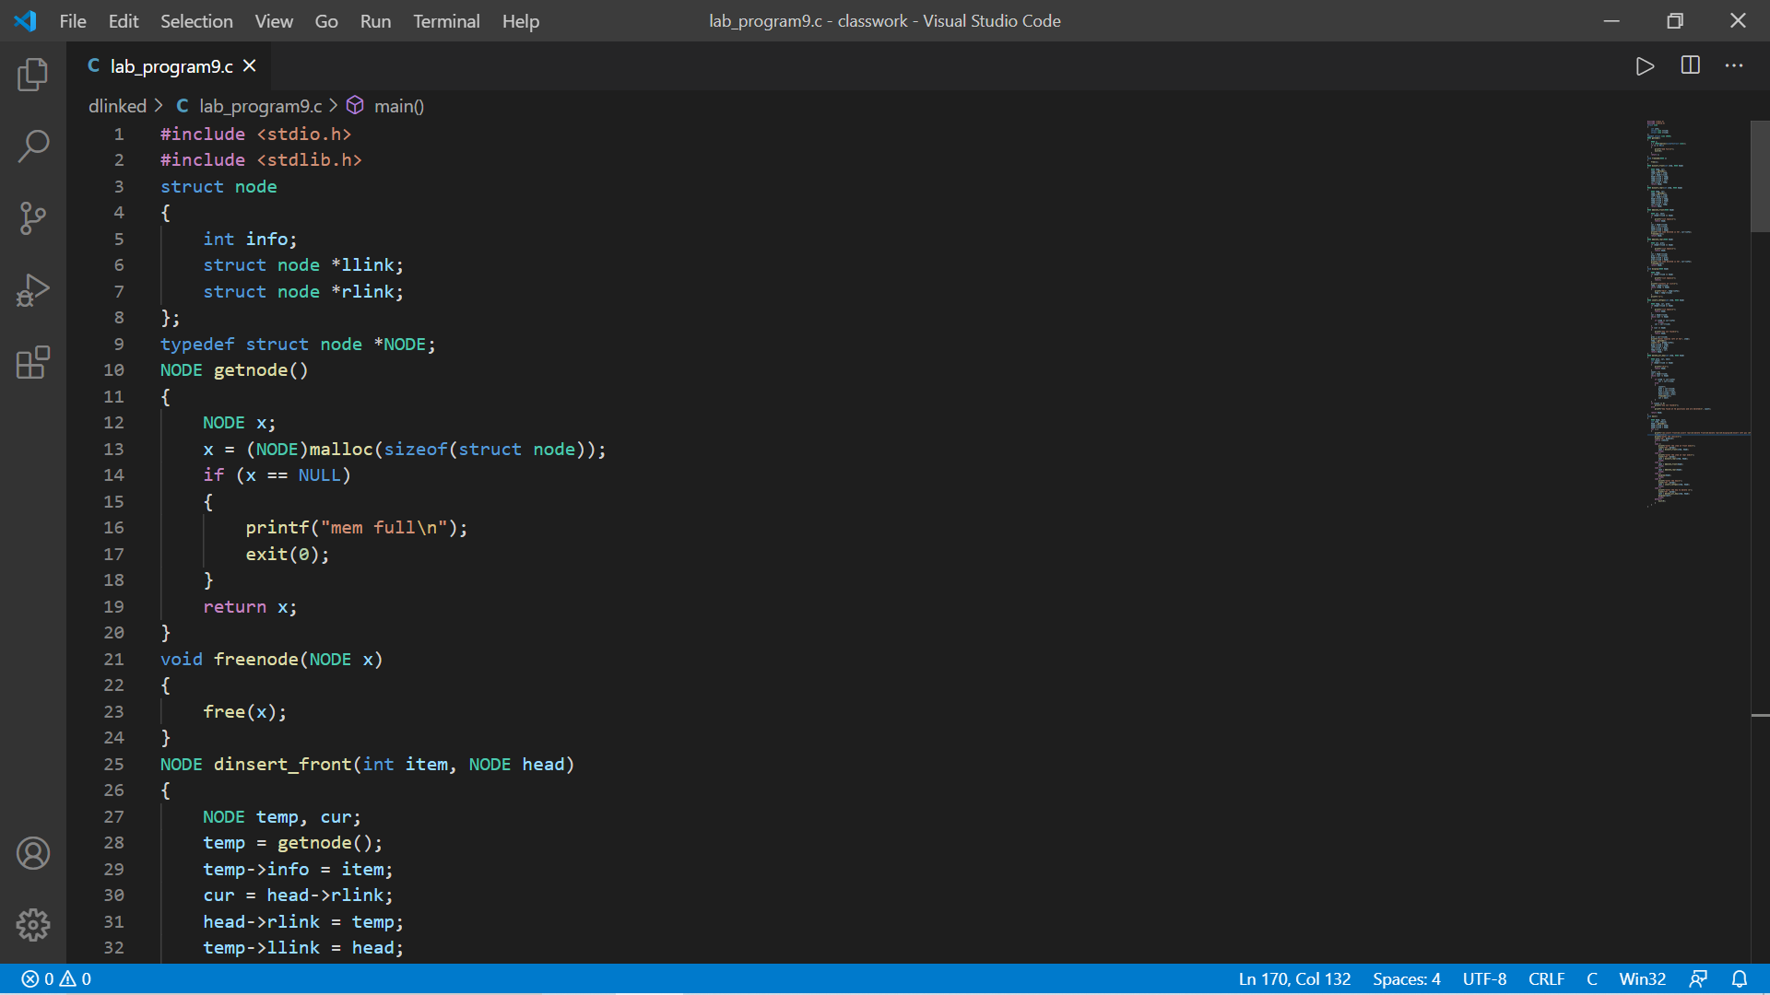

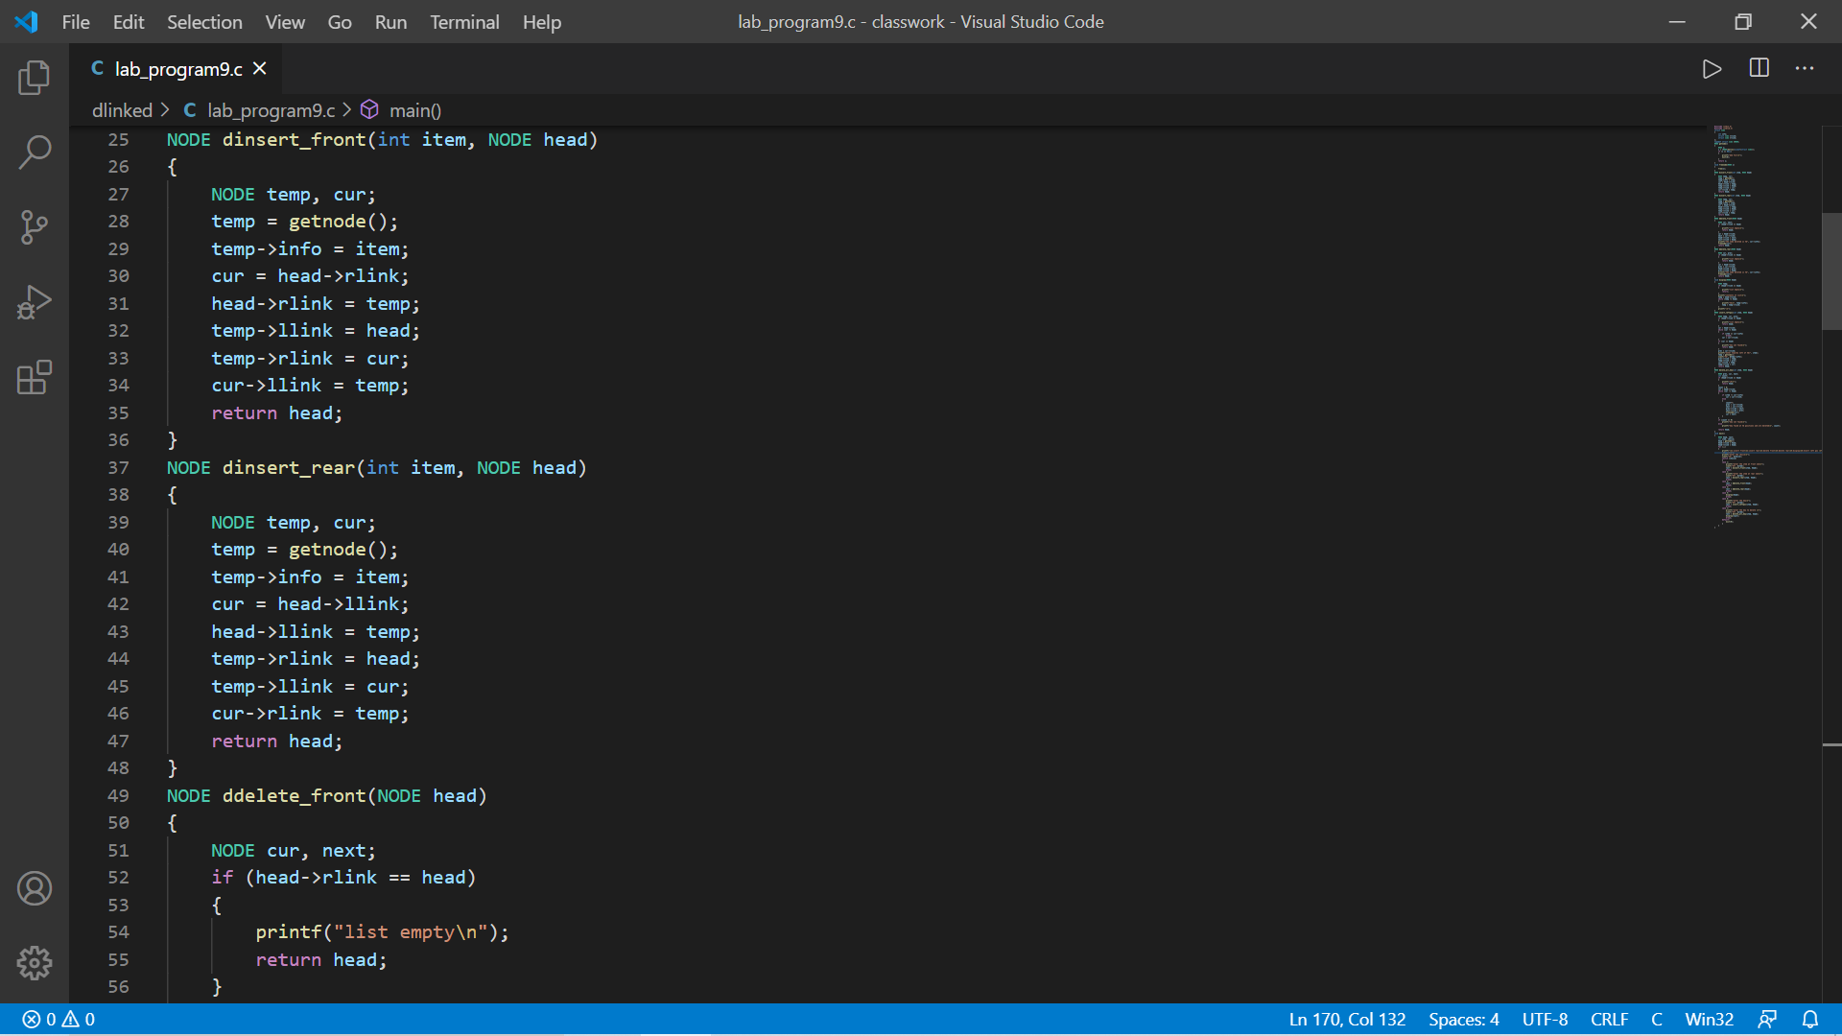

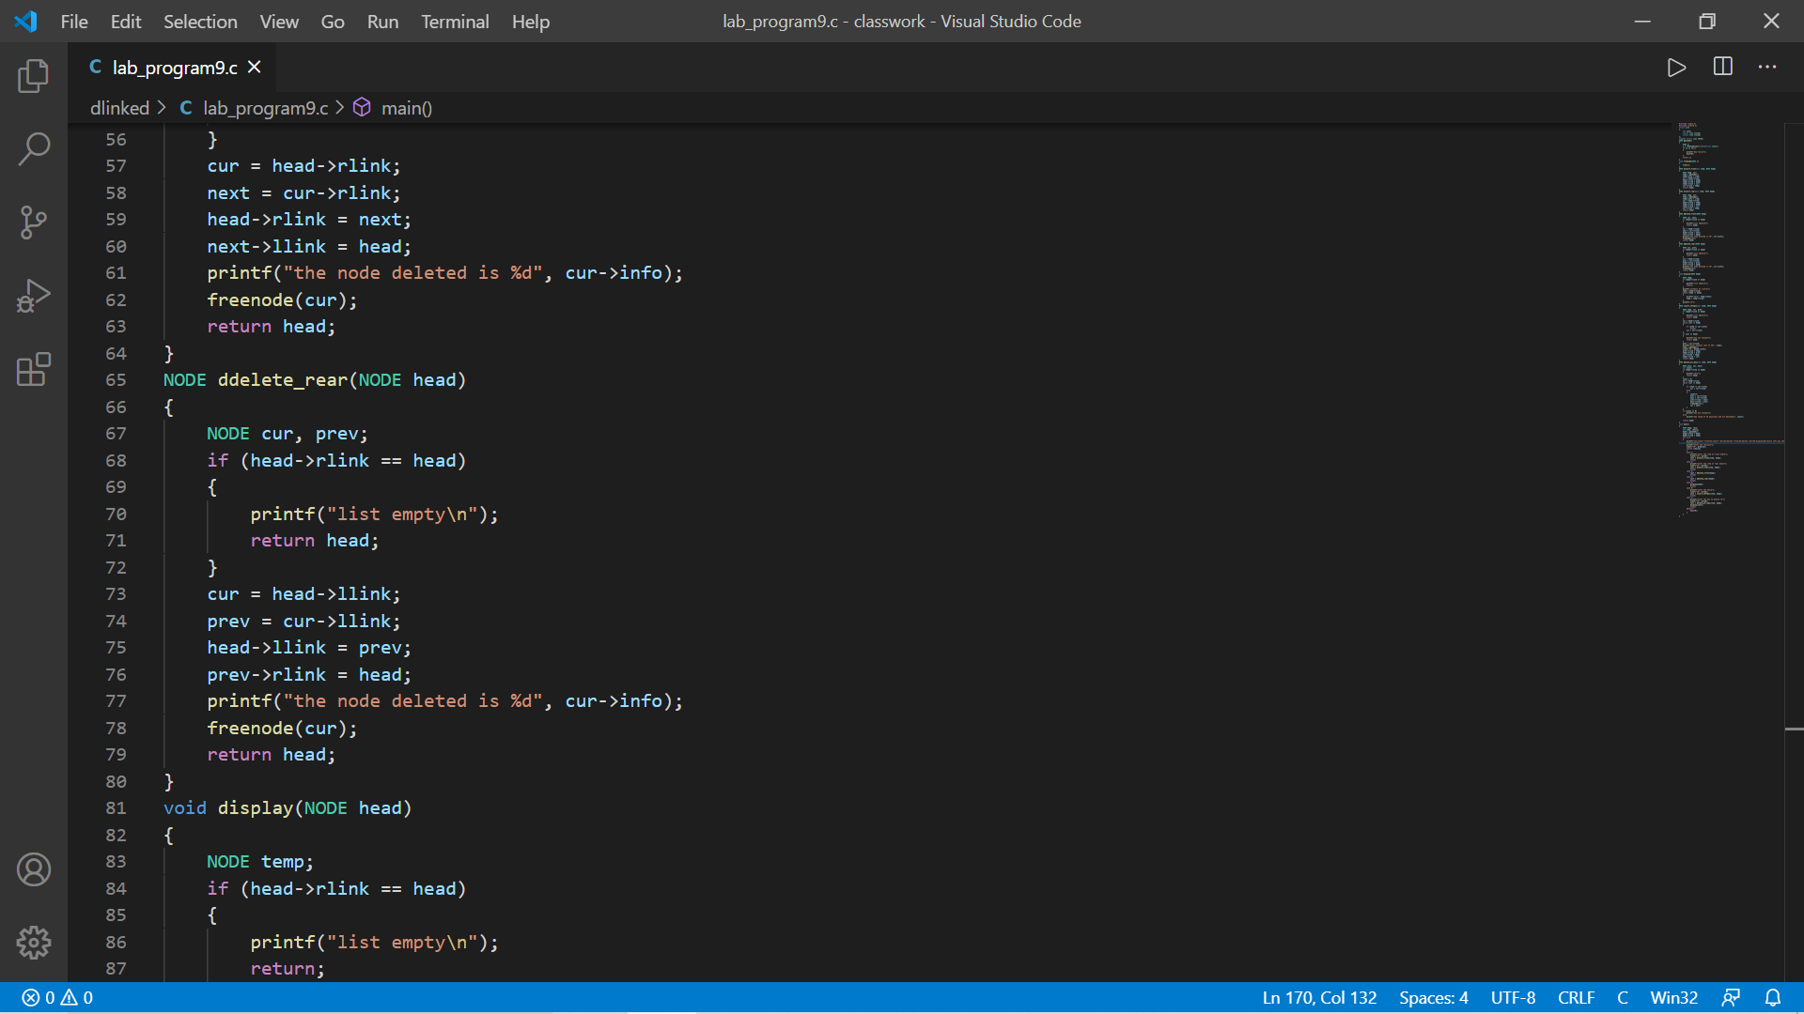

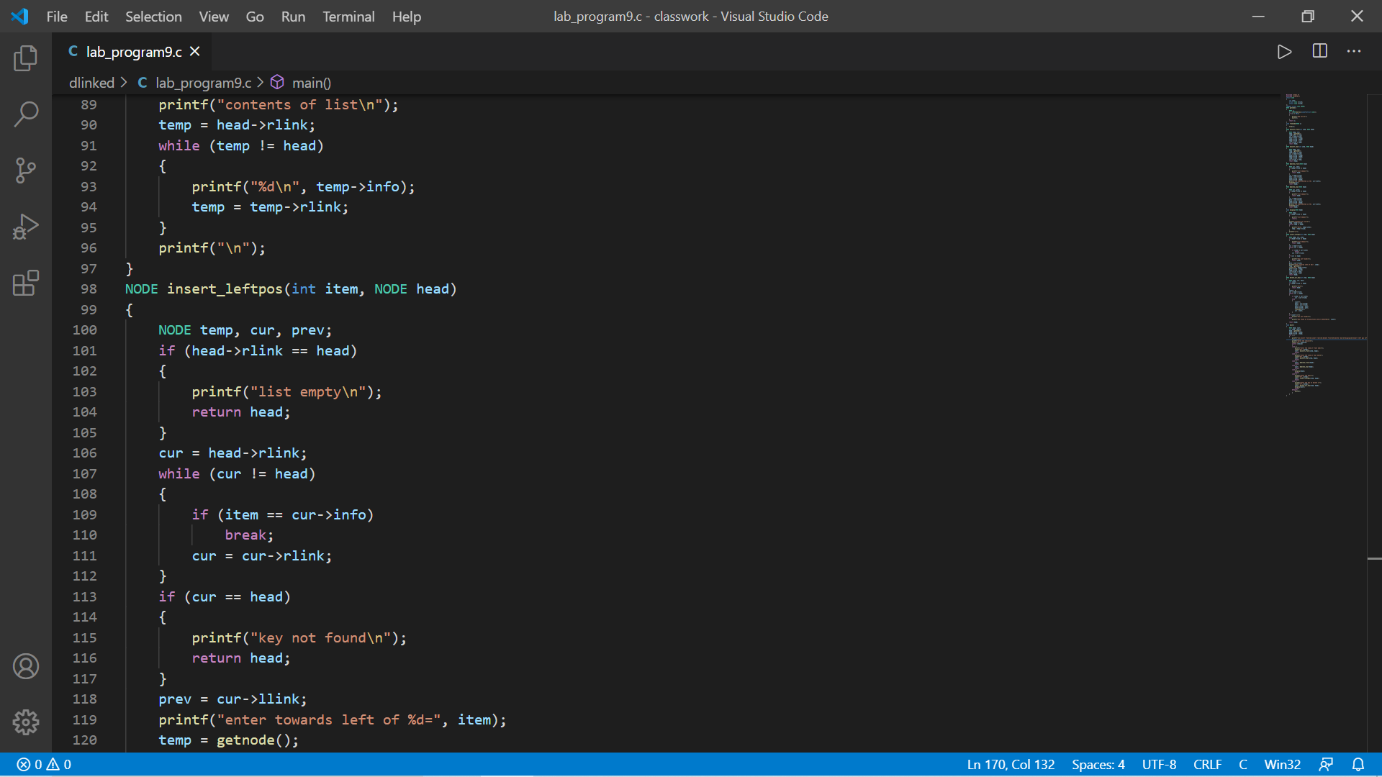

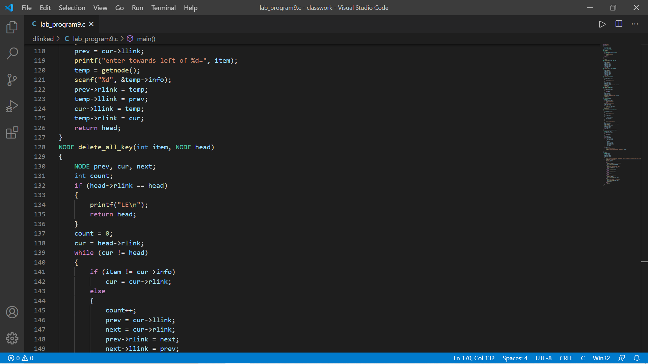

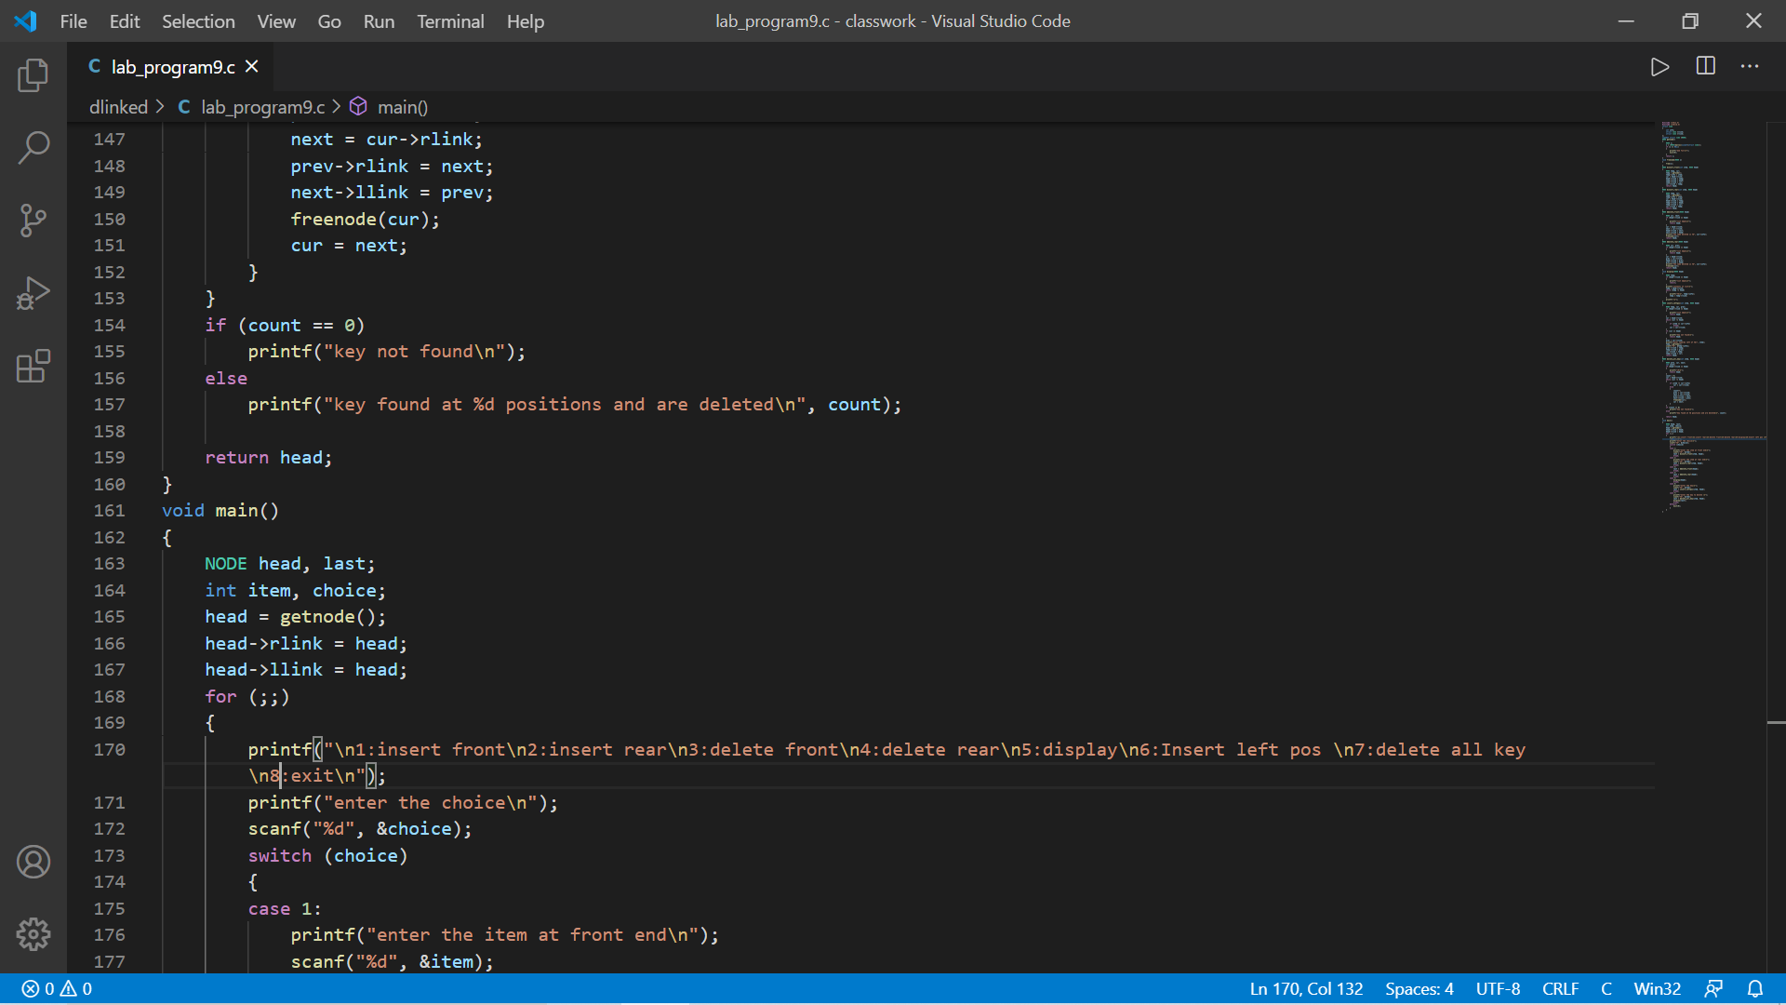

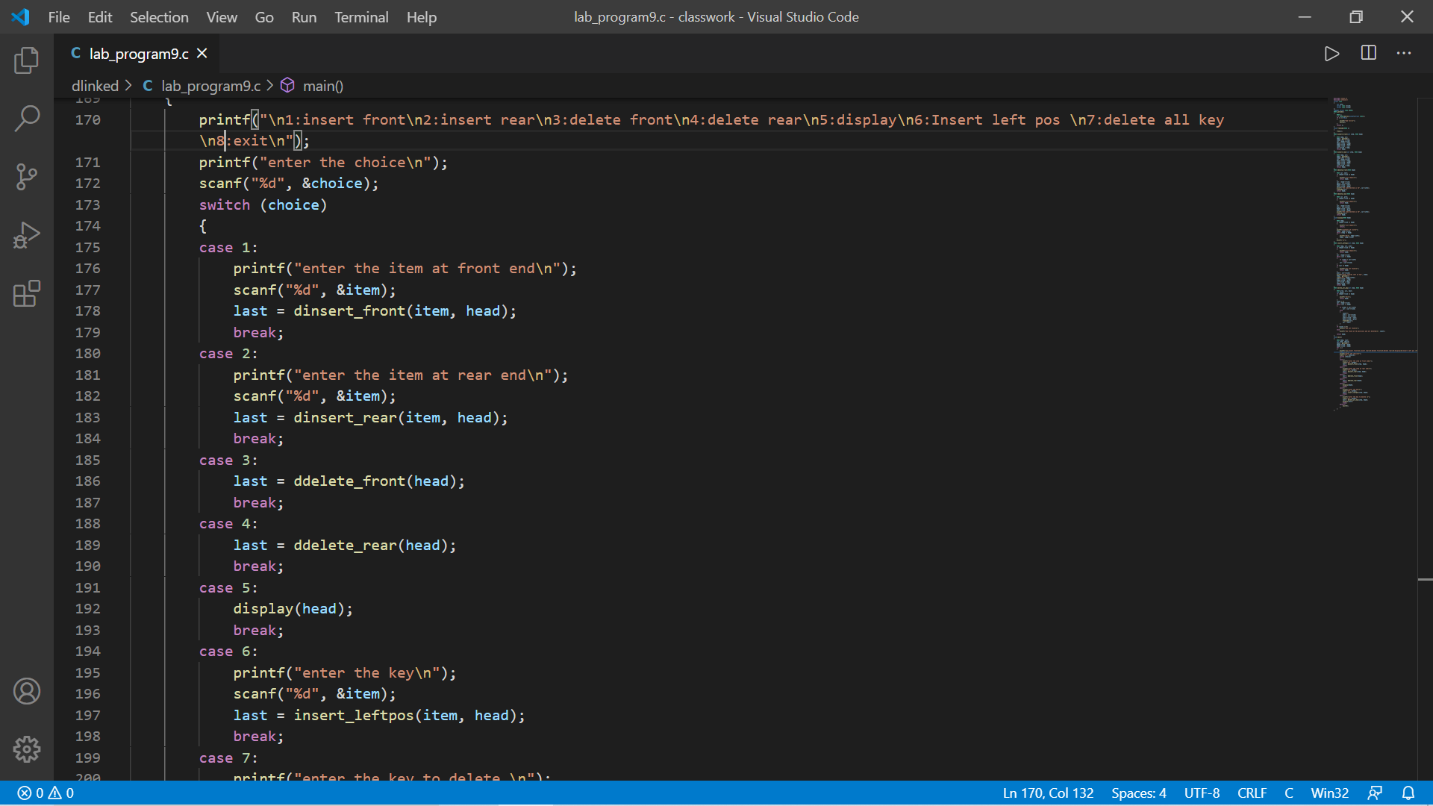

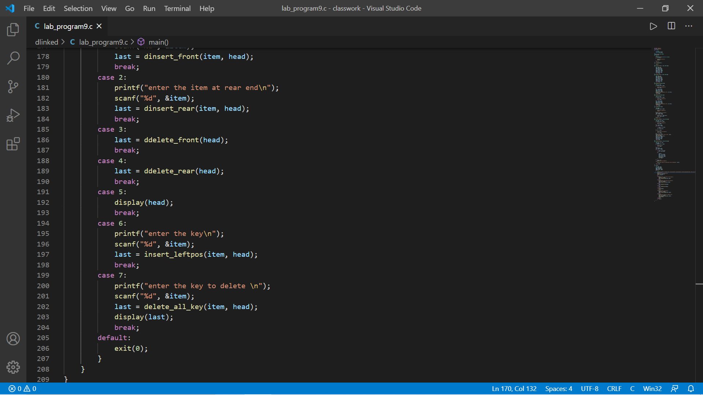

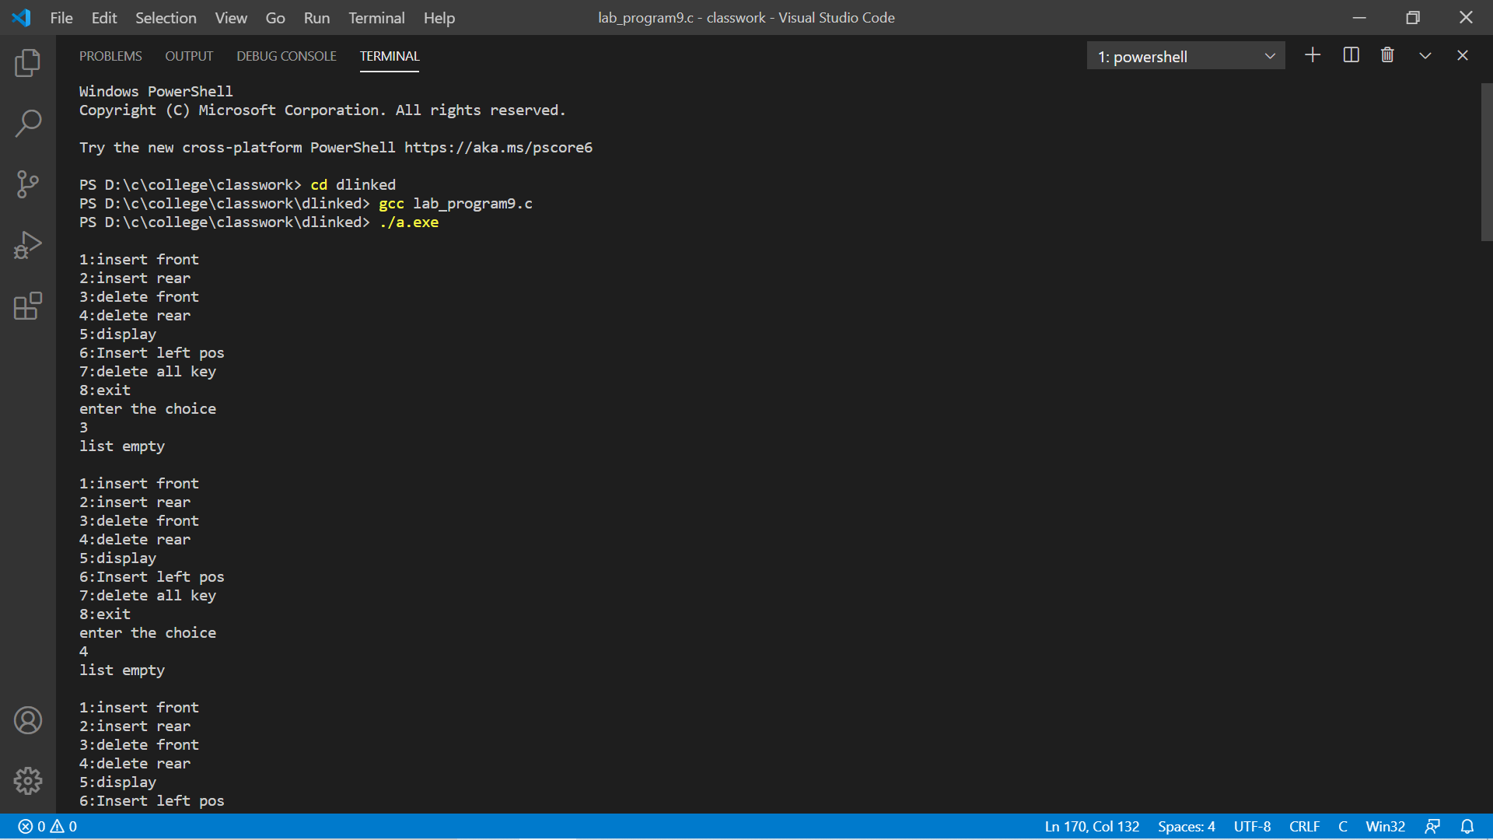

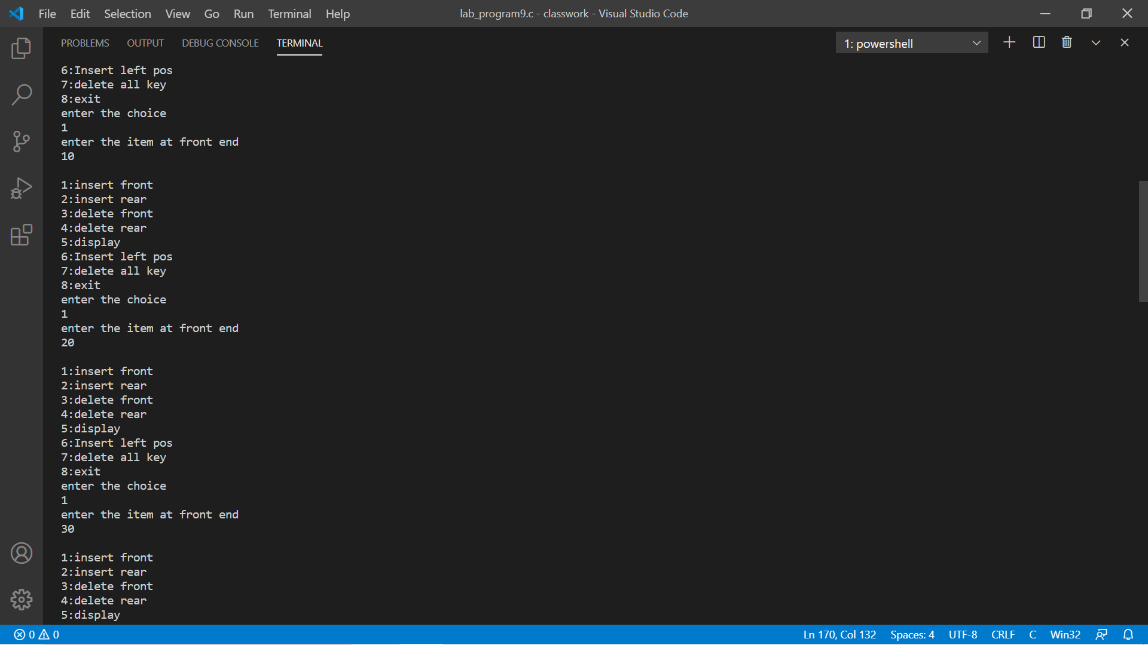

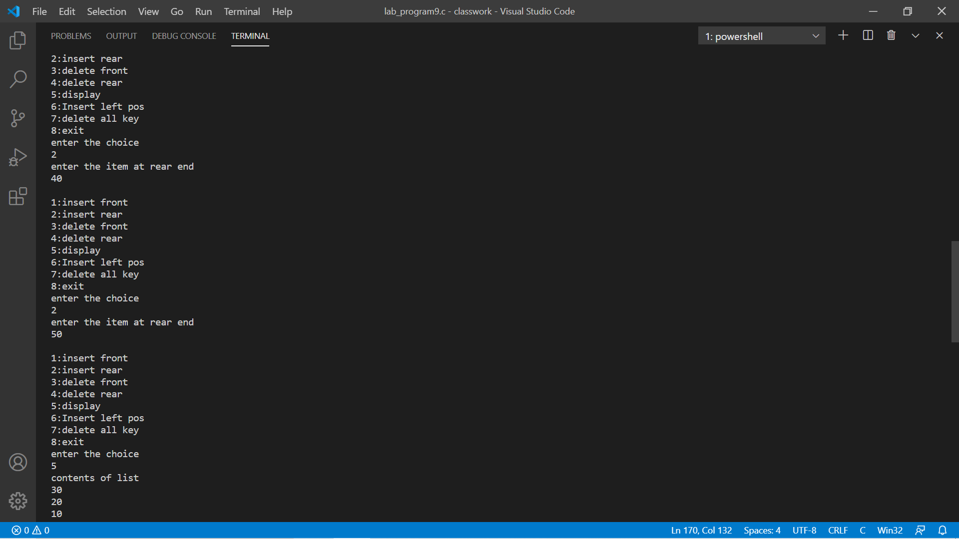

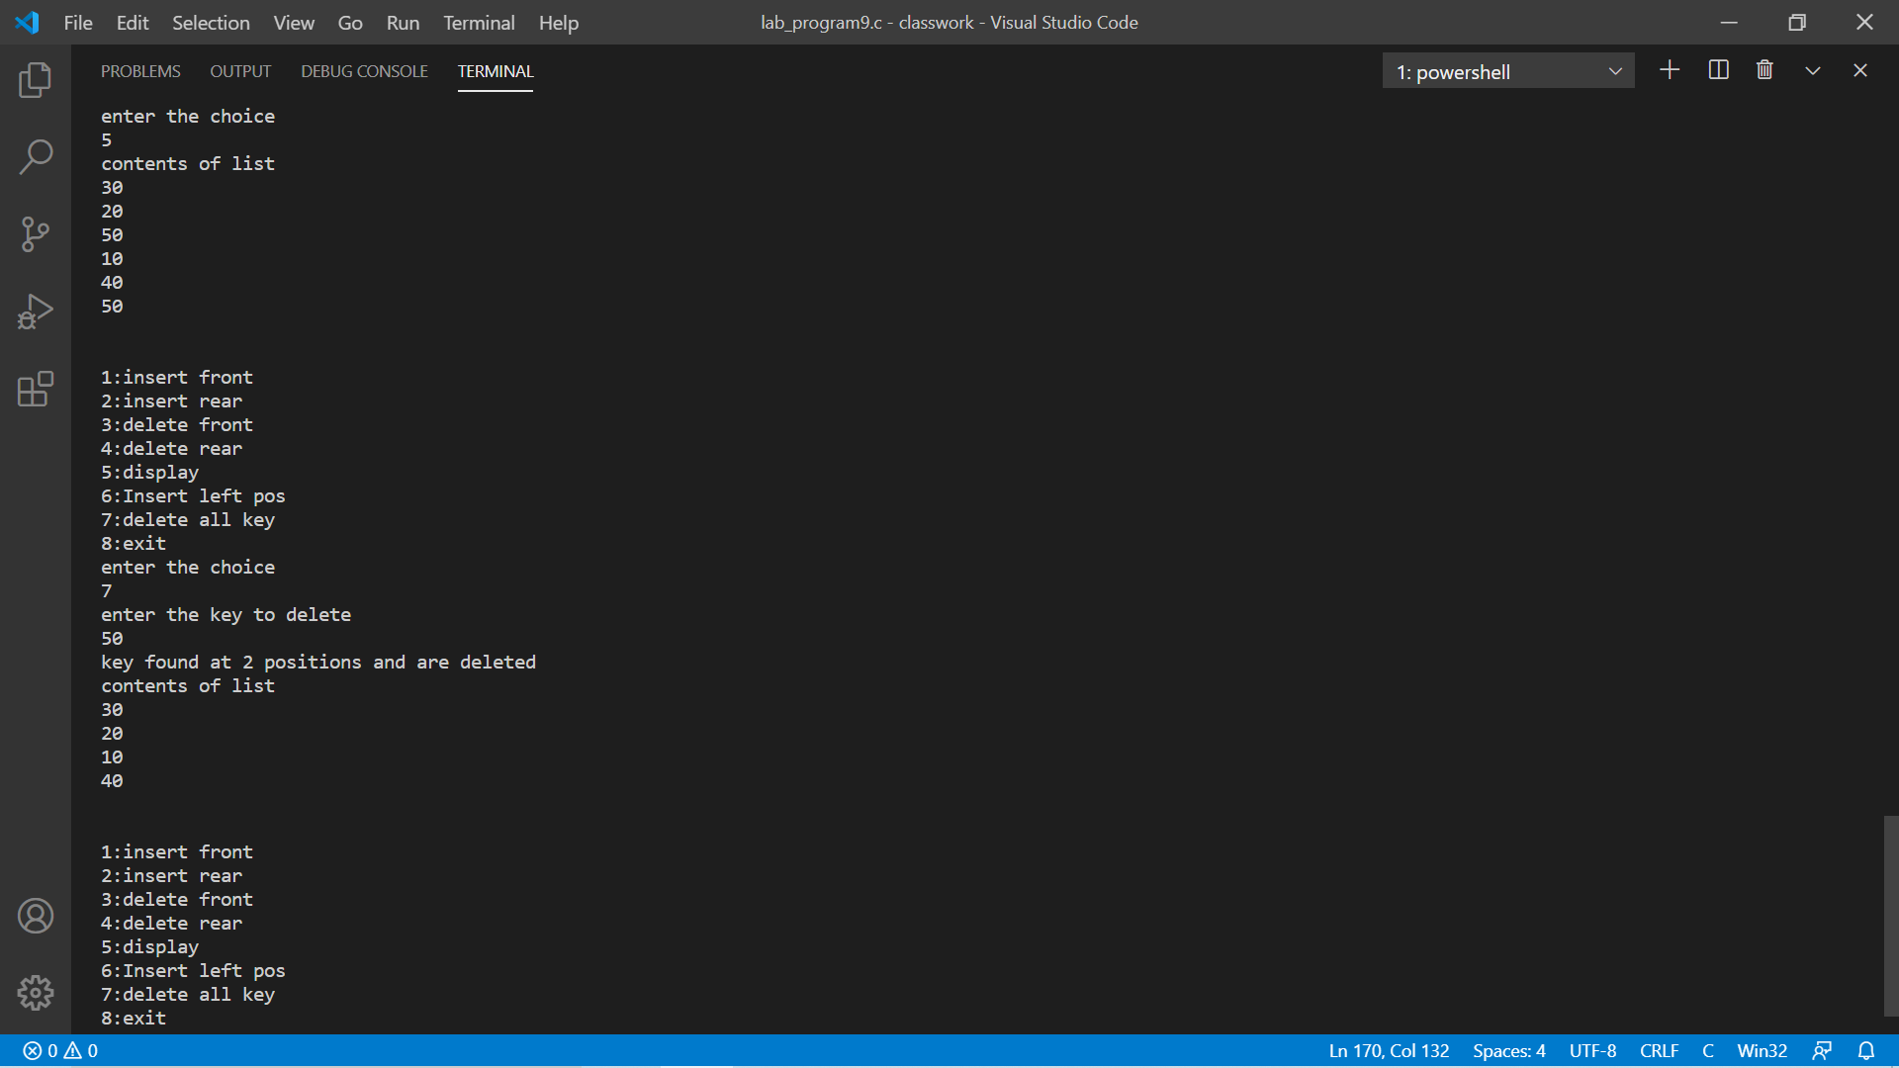

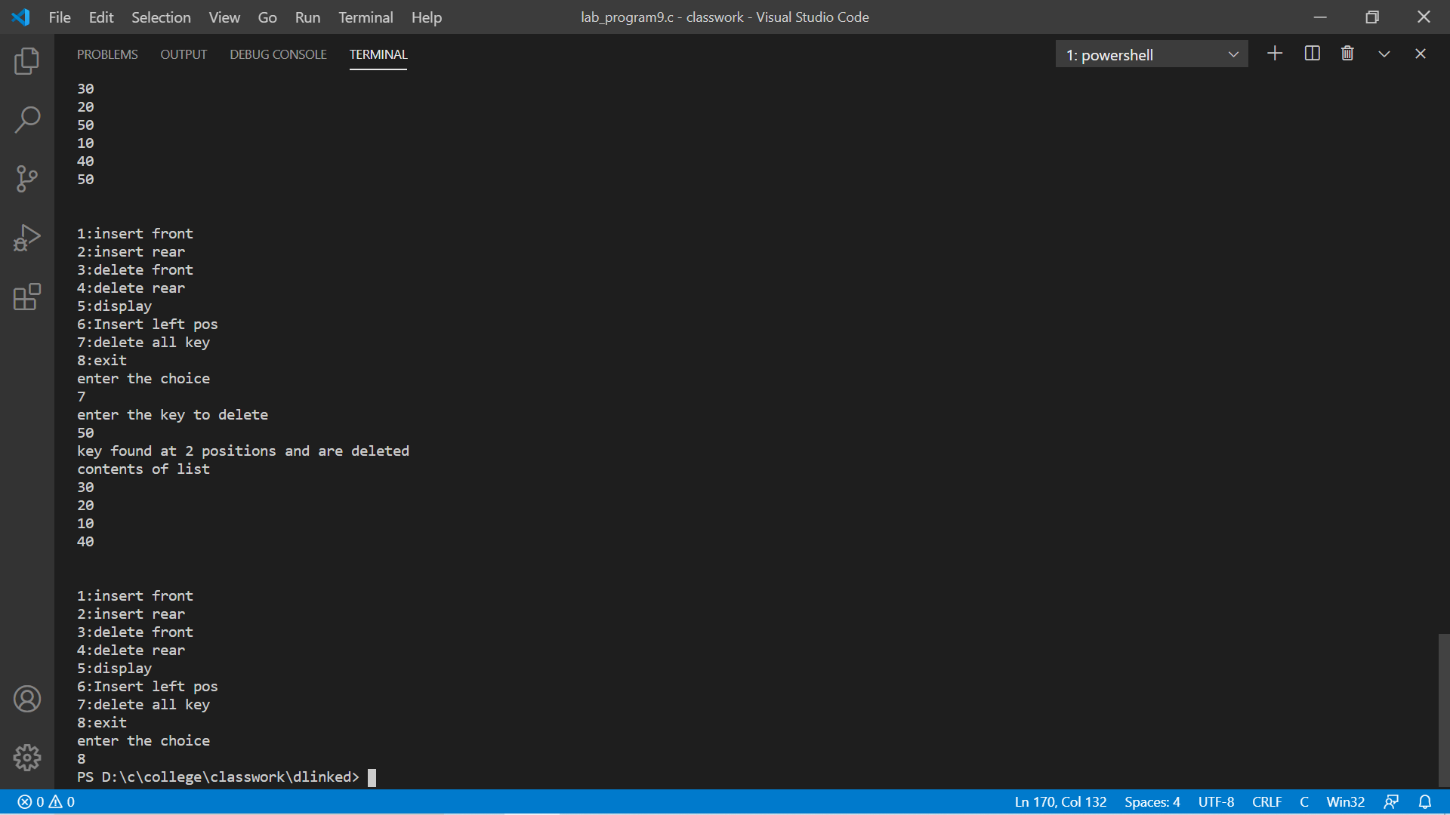

Program-10

#include <stdio.h>

#include <stdlib.h>

struct Node

{

int item;

struct Node *rlink;

struct Node *llink;

};

int count = 0;

int leaf_count = 0;

typedef struct Node *NODE;

NODE getNode()

{

NODE temp = (NODE)malloc(sizeof(struct Node));

if (temp == NULL)

{

printf("Memory full");

}

return temp;

}

void freeNode(NODE x)

{

free(x);

}

NODE insert(NODE root, int item)

{

NODE temp = getNode();

temp->item = item;

temp->llink = NULL;

temp->rlink = NULL;

if (root == NULL)

{

return temp;

}

NODE cur, prev;

cur = root;

while (cur != NULL)

{

prev = cur;

cur = (item > cur->item) ? cur->rlink : cur->llink;

}

if (item > prev->item)

prev->rlink = temp;

else

prev->llink = temp;

return root;

}

NODE delete (NODE root, int item)

{

if (root == NULL)

printf("Root is empty\n");

NODE cur, parent, s, q;

parent = NULL;

cur = root;

while (cur != NULL && cur->item != item)

{

parent = cur;

cur = (item > cur->item) ? cur->rlink : cur->llink;

}

if (cur == NULL)

printf("Item is not in the list\n");

if (cur->llink == NULL)

q = cur->rlink;

else if (cur->rlink == NULL)

q = cur->llink;

else

{

s = cur->rlink;

while (s->llink != NULL)

s = s->llink;

s->llink = cur->llink;

q = cur->rlink;

}

if (parent == NULL)

return q;

if (parent->llink == cur)

parent->llink = q;

else

parent->rlink = q;

freeNode(cur);

return root;

}

void inorder(NODE root)

{

if (root != NULL)

{

inorder(root->llink);

printf("%d\n", root->item);

inorder(root->rlink);

}

}

void preorder(NODE root)

{

if (root != NULL)

{

printf("%d\n", root->item);

preorder(root->llink);

preorder(root->rlink);

}

}

void postorder(NODE root)

{

if (root != NULL)

{

postorder(root->llink);

postorder(root->rlink);

printf("%d\n", root->item);

}

}

void display(NODE root, int j)

{

if (root != NULL)

{

display(root->rlink, j + 1);

for (int i = 0; i < j; i++)

printf(" ");

printf("%d\n", root->item);

display(root->llink, j + 1);

}

}

void main()

{

int item, choice;

NODE root = NULL;

for (;;)

{

printf("0.exit\n1.insert\n2.display\n3.pre\n4.post\n5.in\n6.delete\n");

printf("enter the choice\n");

scanf("%d", &choice);

switch (choice)

{

case 0:

exit(0);

break;

case 1:

printf("enter the item\n");

scanf("%d", &item);

root = insert(root, item);

break;

case 2:

display(root, 0);

break;

case 3:

preorder(root);

break;

case 4:

postorder(root);

break;

case 5:

inorder(root);

break;

case 6:

printf("enter the item\n");

scanf("%d", &item);

root = delete (root, item);

break;

default:

printf("Invalid Input \n");

}

}

}

